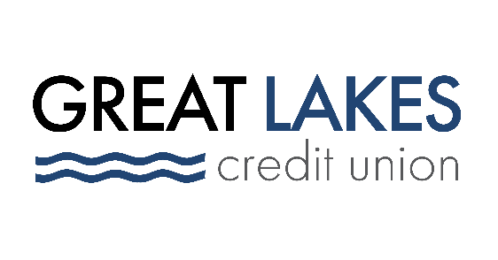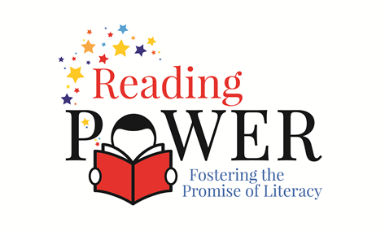

www.glcu.org | readingpowerinc.org
FOR IMMEDIATE RELEASE | media@glcu.org  (847) 578-7324

Great Lakes Credit Union Commits $3K to Supporting
Children’s Literacy in Lake County

Bannockburn (IL) August 23, 2021 – Great Lakes Credit Union (GLCU) has donated $3,000 to Lake County-based Reading Power, a nonprofit organization with a mission to accelerate children’s literacy learning and to develop in them a love of reading and writing through one-to-one tutoring in North Chicago, Waukegan, and Zion schools.

The donation was made on behalf of Bertine A. “Bunny” Nixon, GLCU’s first Emeritus Board Member and a passionate supporter of children’s literacy, during a lobby dedication ceremony at GLCU’s Waukegan branch on August 14. The lobby was dedicated to Bunny Nixon at that event.

“I am honored with the lobby dedication, and I’m excited that GLCU chose to support Reading Power on my behalf,” said Nixon. “Children’s literacy is a cause near and dear to my heart, and I’m proud to support the work that Reading Power is doing in the community.”

Lisa Bulzoni, Executive Director of Programs and Operations, for Reading Power, was grateful to receive the $3,000 donation. "Support from community members like GLCU allows Reading Power to continue to extend, expand, and enhance our programming to meet the needs of more students. We thank GLCU for their support and generous donation."

GLCU is committed to empowering people in the communities it serves through financial education for youth and adults, housing counseling, and giveback programs that address things like food and housing insecurity.

“Reading Power believes that all children deserve to reach their full intellectual potential, which aligns perfectly with GLCU’s belief that everyone deserves financial empowerment,” said Steve Bugg, President and CEO of Great Lakes Credit Union. “Literacy and financial education are cornerstones of a bright future for our children, which is why we’re proud to support this organization.”

To learn more about GLCU’s commitment to its members and communities, visit glcu.org/about-us.

About Great Lakes Credit Union
Founded in 1938, GLCU continues to be a growing staple in our communities. As a not-for-profit financial cooperative, chartered by the State of Illinois and insured by the NCUA, we are guided by a dedicated volunteer Board of Directors and seasoned leadership team and are proud to serve more than 80,000 members with over $1 billion in assets. We are headquartered in Northern Illinois and have 12 branch locations and more than 170 fee-free ATMs locally. GLCU also belongs to the CO-OP Shared Branching Network. Members can access accounts nationwide at over 5,600 institutions with thousands of locations in 50 states, and at any of their 30,000 surcharge‐free CO‐OP ATMs. All 200+ employee-owners pride ourselves on building lifelong relationships with our member-owners and providing them with financial education during all life stages. Learn more at glcu.org

About Reading Power
Reading Power provides literacy tutoring to children in prekindergarten through second grade in North Chicago, Waukegan, and Zion, Illinois. More than 250 professionally trained volunteers provide one-to-one tutoring for children, helping them accelerate their literacy gains, develop confidence, and embrace a love of reading and writing that lasts a lifetime.

