Affinity Plus Federal Credit Union
175 West Lafayette Frontage Road
St. Paul, MN 55107

For Immediate Release Contact: Hillary Kline
Senior Public Relations Specialist
hkline@affinityplus.org
920-570-2761

Special Olympics Minnesota Names Dave Larson 2022 Board Chair
Larson’s legacy includes expansion of Polar Plunge fundraiser

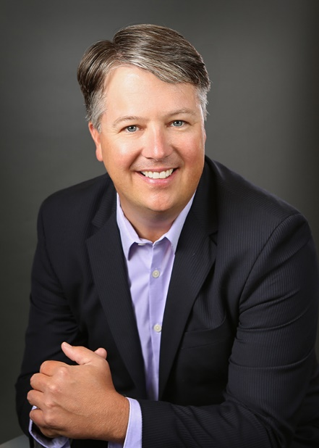
ST. PAUL, MINN. (Feb. 3, 2022) – Affinity Plus Federal Credit Union (Affinity Plus) is pleased to announce that President and CEO, Dave Larson, was named 2022 Board Chair of Special Olympics Minnesota.
“I’m so excited Dave will be leading our Board of Directors as the Board Chair,” said Special Olympics Minnesota President & CEO Dave Dorn. “Dave brings an impressive list of awards and recognitions for his outstanding leadership and with his help, Affinity Plus has become one of our most active and dedicated corporate partners. We are fortunate to have Dave use his commitment to inclusion and exemplary leadership skills to lead and grow our organization, strengthen our team, expand our reach for the future and fulfill our mission in Minnesota!”
Special Olympics Minnesota’s Board of Directors is comprised of up to 20 members of business leaders, disability advocates, and Special Olympics Minnesota athletes. The role of the Board of Directors is to be the primary force pressing and motivating Special Olympics Minnesota to fulfill its mission. Board members fulfill their duties by attending quarterly meetings, volunteering at events, fundraising and participating in the Polar Plunge.
Special Olympics Minnesota empowers athletes with intellectual disabilities to transform themselves and their communities by providing year-round athletic, health and leadership opportunities. Special Olympics Minnesota is a part of a global movement founded in 1968 by Eunice Kennedy Shriver. Through this movement, people with intellectual disabilities realize their potential, develop physical fitness, demonstrate courage and experience joy and friendship. To learn more, visit somn.org.

Dave has volunteered in fundraising and leadership roles with Special Olympics Minnesota for nearly 14 years, including helping reenergize the Polar Plunge fundraiser the past two years by partnering with Affinity Plus to provide seed donations for new and returning plungers – as well as encouraging alternative ways to “plunge” virtually during the pandemic. This year, the first 1,000 plungers who use promo code AFFINITYPLUS at registration will receive a $50 donation toward the required $75 fundraising minimum: www.plungemn.org/affinityplus

As CEO of Affinity Plus, Larson led the turnaround effort to strengthen and rebuild the credit union. The success and organizational culture built at Affinity Plus led to Larson’s 2018 and 2020 recognition by the Star Tribune as “Top CEO” among large companies. He was also named to Minnesota 500 list of “Most Powerful Business Leaders in Minnesota” the past four years. In 2019, Larson was honored as a Minnesota Credit Union “Outstanding Professional of the Year.” Under his leadership, Affinity Plus has been named a “Top Workplace” by Star Tribune and designated a “Best In-State Credit Union” by Forbes four years in a row. Larson has a genuine care for the employees, the credit union’s members, and the communities that Affinity Plus serves.

To learn more about Affinity Plus, please visit www.affinityplus.org.

###
About Affinity Plus Federal Credit Union
Based in St. Paul, Minn., Affinity Plus Federal Credit Union is a not-for-profit, financial cooperative that puts people first above profits. Members of Affinity Plus receive maximum value through competitive rates, minimal fees, and unique, member-centric products and programs. Established in 1930, Affinity Plus has 28 branches located throughout Minnesota and is owned by more than 230,000 members. Affinity Plus has more than $3.5 billion in assets. Additional information is available at www.affinityplus.org or by calling (800) 322-7228.

