CONTACT: Julia Winant / 631 838 0054 / julia@austinwilliams.com
FOR IMMEDIATE RELEASE

OCEAN FINANCIAL FEDERAL CREDIT UNION APPOINTS LISA C. MCGUINNESS AS FIRST FEMALE CHAIR OF THE BOARD

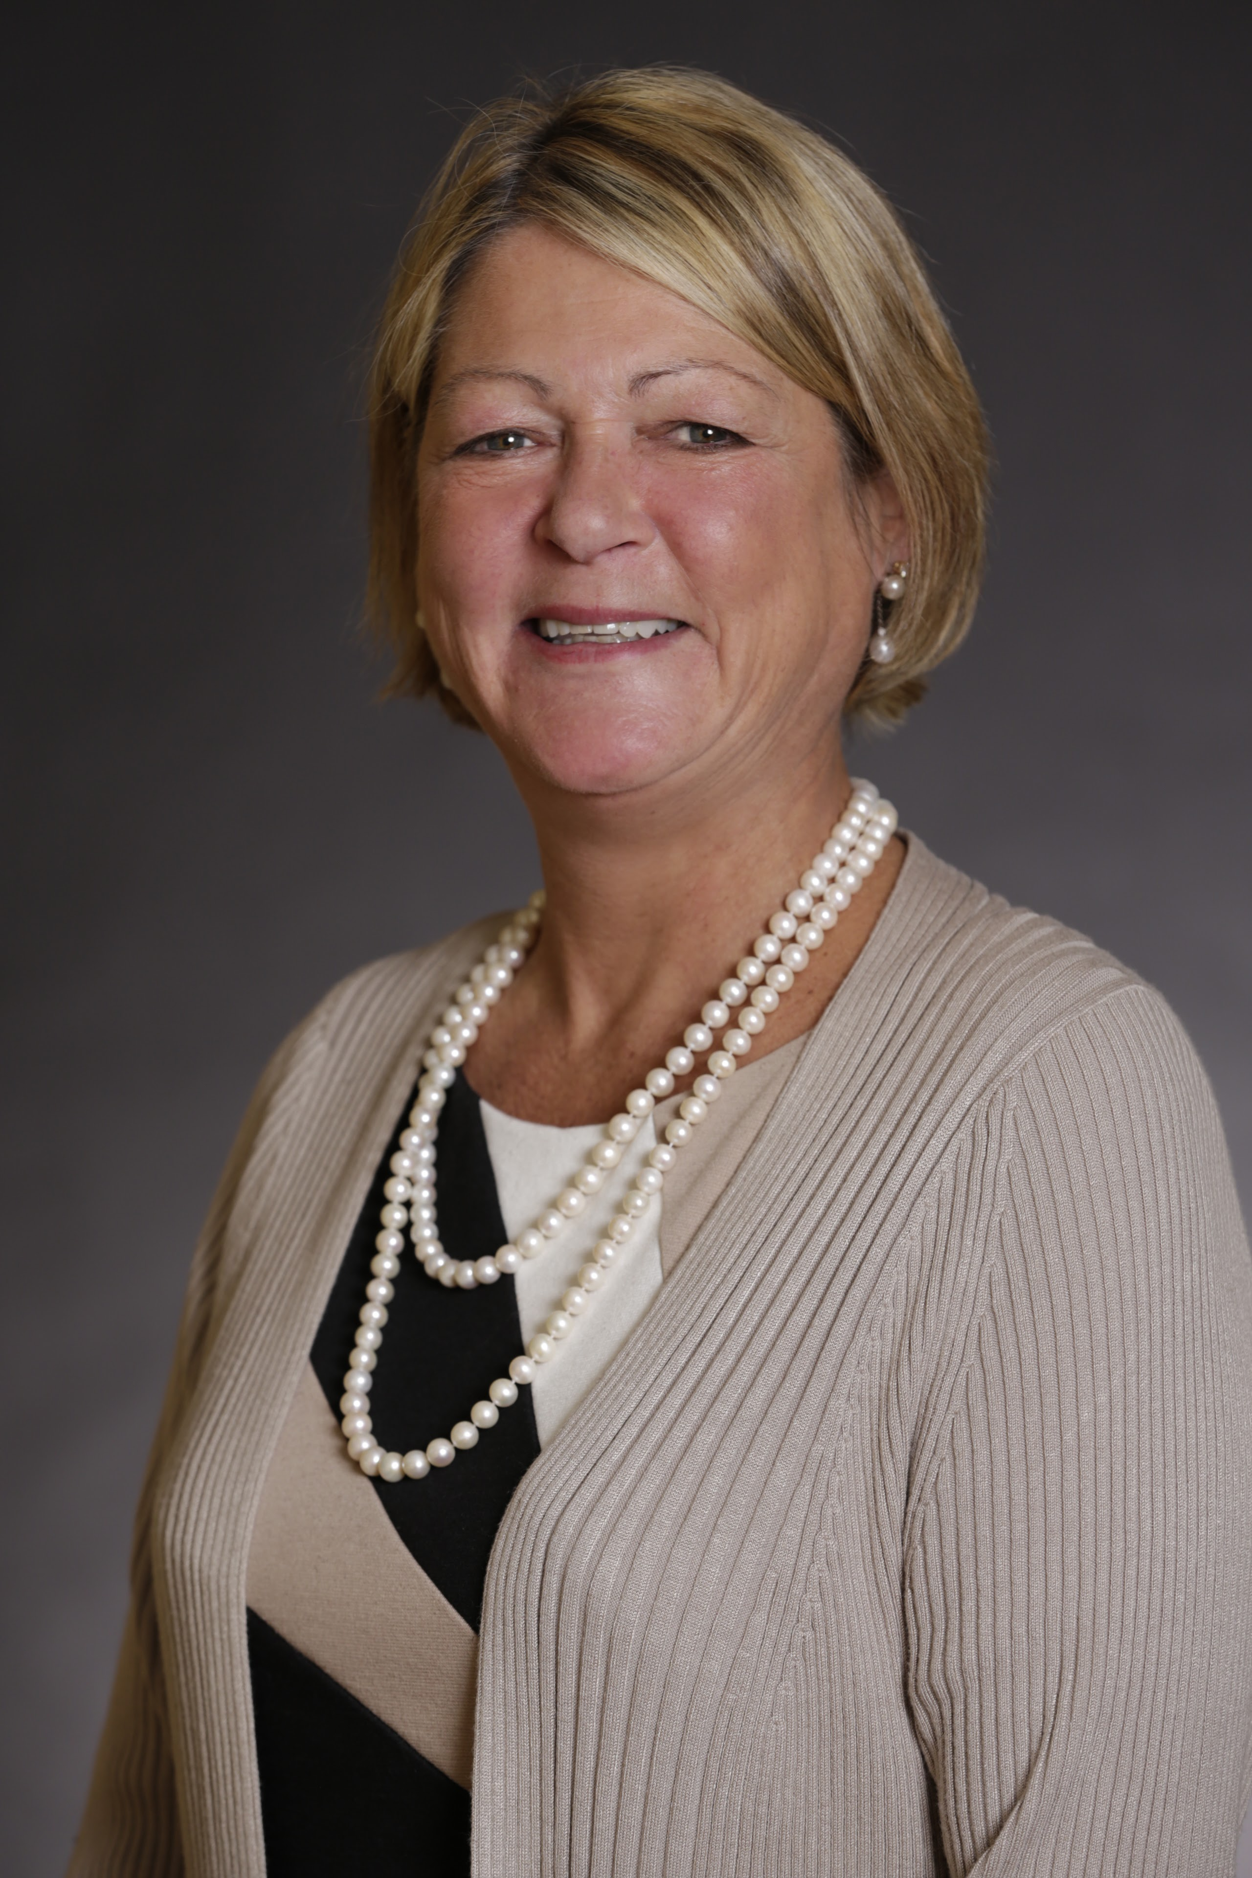

Oceanside, NY (September 21, 2022) – Ocean Financial Federal Credit Union (OFFCU) announced the appointment of Lisa C. McGuinness as Chair of its Board of Directors, the first woman to hold the position. Ms. McGuinness has served as a member of the Board of Directors for approximately seven years, first as a Volunteer for the Supervisory Committee then as a board director starting in 2019.

Ms. McGuinness graduated from Sacred Heart Academy and earned her bachelor’s degree at SUNY Genesco. She began her career at Dime Savings Bank where she assisted in the programming of their first ATM Machines. She later held executive leadership roles at Estée Lauder, as Executive Director of the IT Risk and Compliance Division, followed by Senior Manager of Global Risk Management and Compliance at Avon, and at Cole Haan leading the IT Risk Management and Compliance practice. Ms. McGuinness has been recognized as a leader in the information technology industry for more than two decades, having left a lasting impression on the organizations that she has served.

Ms. McGuinness is a long-time resident of Oceanside, where she raised her family with her husband. She is a member of St. Anthony’s parish, volunteering for several committees. She is a past President of the Ladies Auxiliary at the Fr. Joseph O’Connell Knights of Columbus Council #3481.

“I am humbled and honored to have such trust placed in me,” said Ms. McGuinness. “I was taught the importance of leadership at an early age from my parents and teachers. My family has been account holders since the formation of the credit union. I have personally witnessed Ocean Financial evolve under the leadership of Joseph Tedesco to prioritize its mission of supporting the Catholic community by providing it’s members with financial well-being and sustainable growth options. I look forward to overseeing the traditions inspired by the Catholic values of Ocean Financial not just in Oceanside, but across all members of the Catholic Community.”

“Lisa will play an important role in making sure that values and policies of Ocean Financial stay in place, both internally and externally. Her extensive background aligns with our Four Pillars and throughout her term, Lisa will ensure that safety & security, advice, value and ease & simplicity will be delivered to our members. Lisa is a great addition, and we look forward to her leaving her mark as the first Chairwoman of Ocean Financial,” said Joseph Tedesco, President and CEO of Ocean Financial Federal Credit Union.

Photo attached, credit Ocean Financial Federal Credit Union.

About Ocean Financial Federal Credit Union
Ocean Financial Federal Credit Union was formed in 1969 by a group of Father Joseph O’Connell Knights of Columbus members looking to provide financial services to Brother Knights and their families. Over the years, the credit union has evolved in name and in field of membership, while maintaining ties to their Catholic roots. Today, Ocean Financial has grown to over $382 million in assets, serving members of the Knights of Columbus in New York State, the Diocese of Rockville Centre, and any Catholic interested in the credit union. Inspired by their Catholic values, Ocean Financial provides exceptional products and services to the Catholic community. The credit union takes pride in having catholic values you can bank on. Ocean Financial promotes these values through the entire organization, down to the logo. To learn more, visit https://www.oceanfinancial.org

