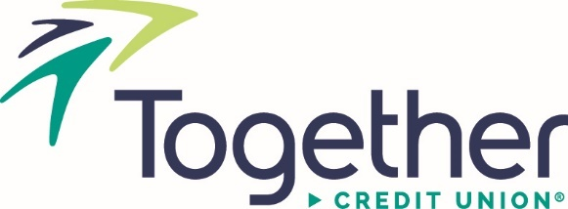
Announcement | Contact: Julie Linder
For Immediate Release  9/26/2022 | (573)268-0639  JLinder@TogetherCU.org
Harvey Brandvein named Best Wealth Manager-Top Finalist
Saint Louis, MO – St. Louis Small Business Monthly has named Harvey Brandvein, Vice President of Wealth Management at Together Credit Union, a Best Wealth Manager-Top Finalist in the publication’s 2022-23 Best in Business, Business Owners’ Guide.

Brandvein, who joined the credit union in 2018, is responsible for the credit union’s wealth management vision and strategy, including the positioning of wealth management and insurance products and services in the market. He also drives new product development and wealth management initiatives, and administers the financial products portfolio available to the credit union’s membership. Before joining the credit union, he served as the Chief Revenue Officer for First Bank. He holds a Bachelor of Science in Business from the University of Missouri.

St. Louis Small Business Monthly’s annual Best in Business, Business Owners’ Guide is compiled by readers, who nominate and vote for the “Best of” in select categories. Brandvein is the only credit union wealth manager recognized in the St. Louis Metro area as a Best Wealth Manager and Best Wealth Manager-Top Finalist.

For more information regarding this announcement, please contact Julie Linder by calling 573-268-0639 or emailing jlinder@togethercu.org.

###

About St. Louis Small Business Monthly
St. Louis Small Business Monthly (SBM) is St. Louis' locally owned business publication, bringing business tips, strategies and analysis to the presidents, CEOs, owners and top executives of 24,000 businesses in the St. Louis Metropolitan region

