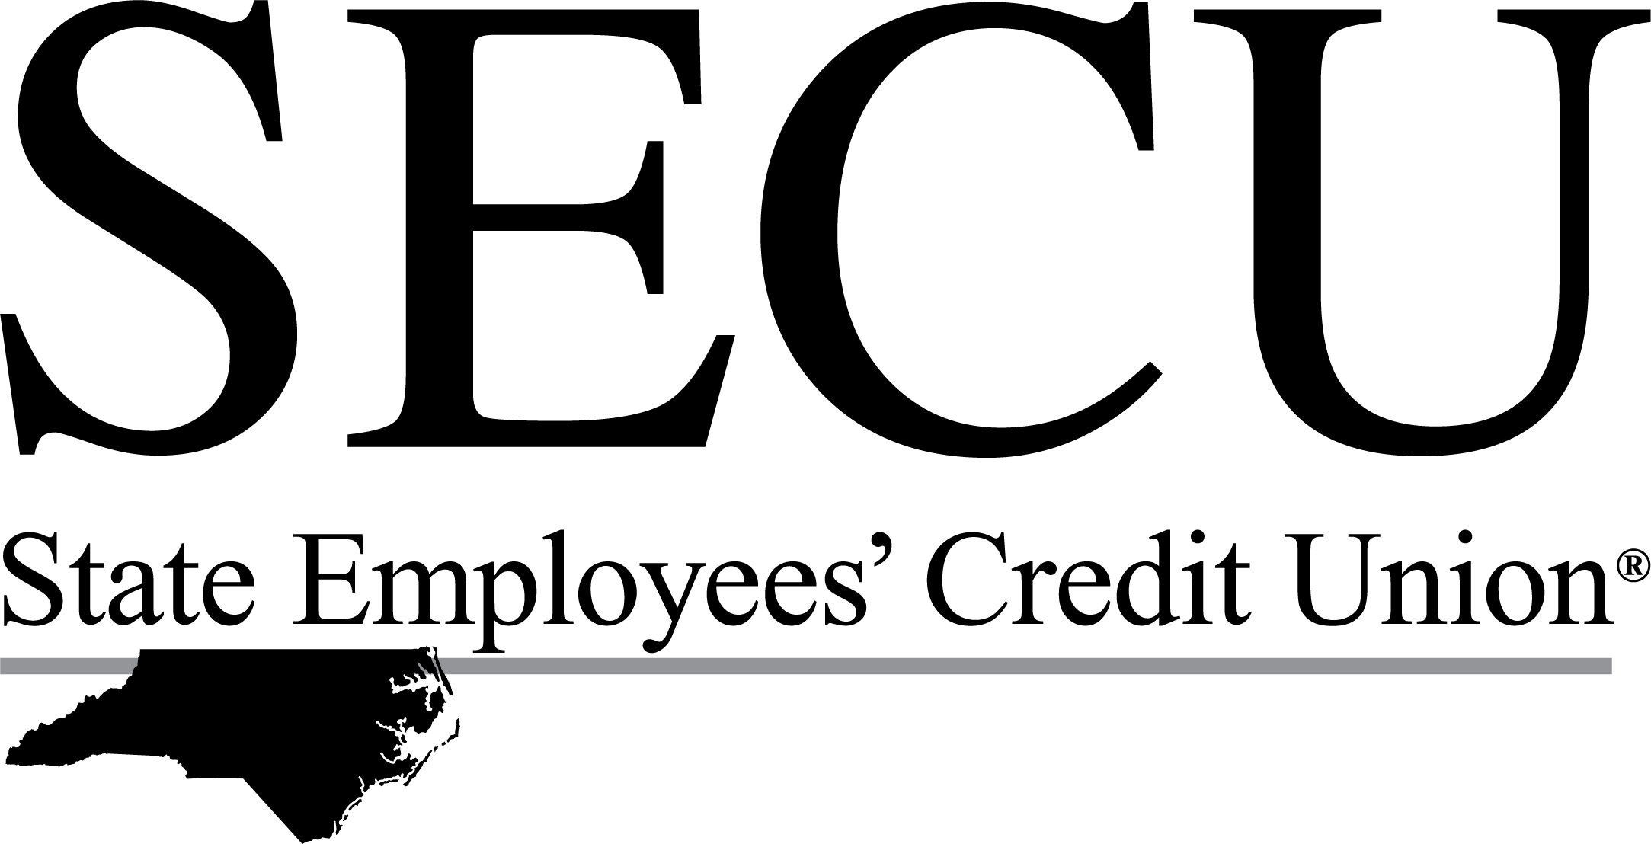FOR IMMEDIATE RELEASE

September 23, 2022
Contact: Sandra Jones, SVP – Communications
Office: 919-508-8773 | sandra.jones@ncsecu.org

SECU Sponsors Sold Out STEM Education Event for Girls and Women in Charlotte Area 14 Local Students Awarded Scholarships Made Possible by SECU Funding
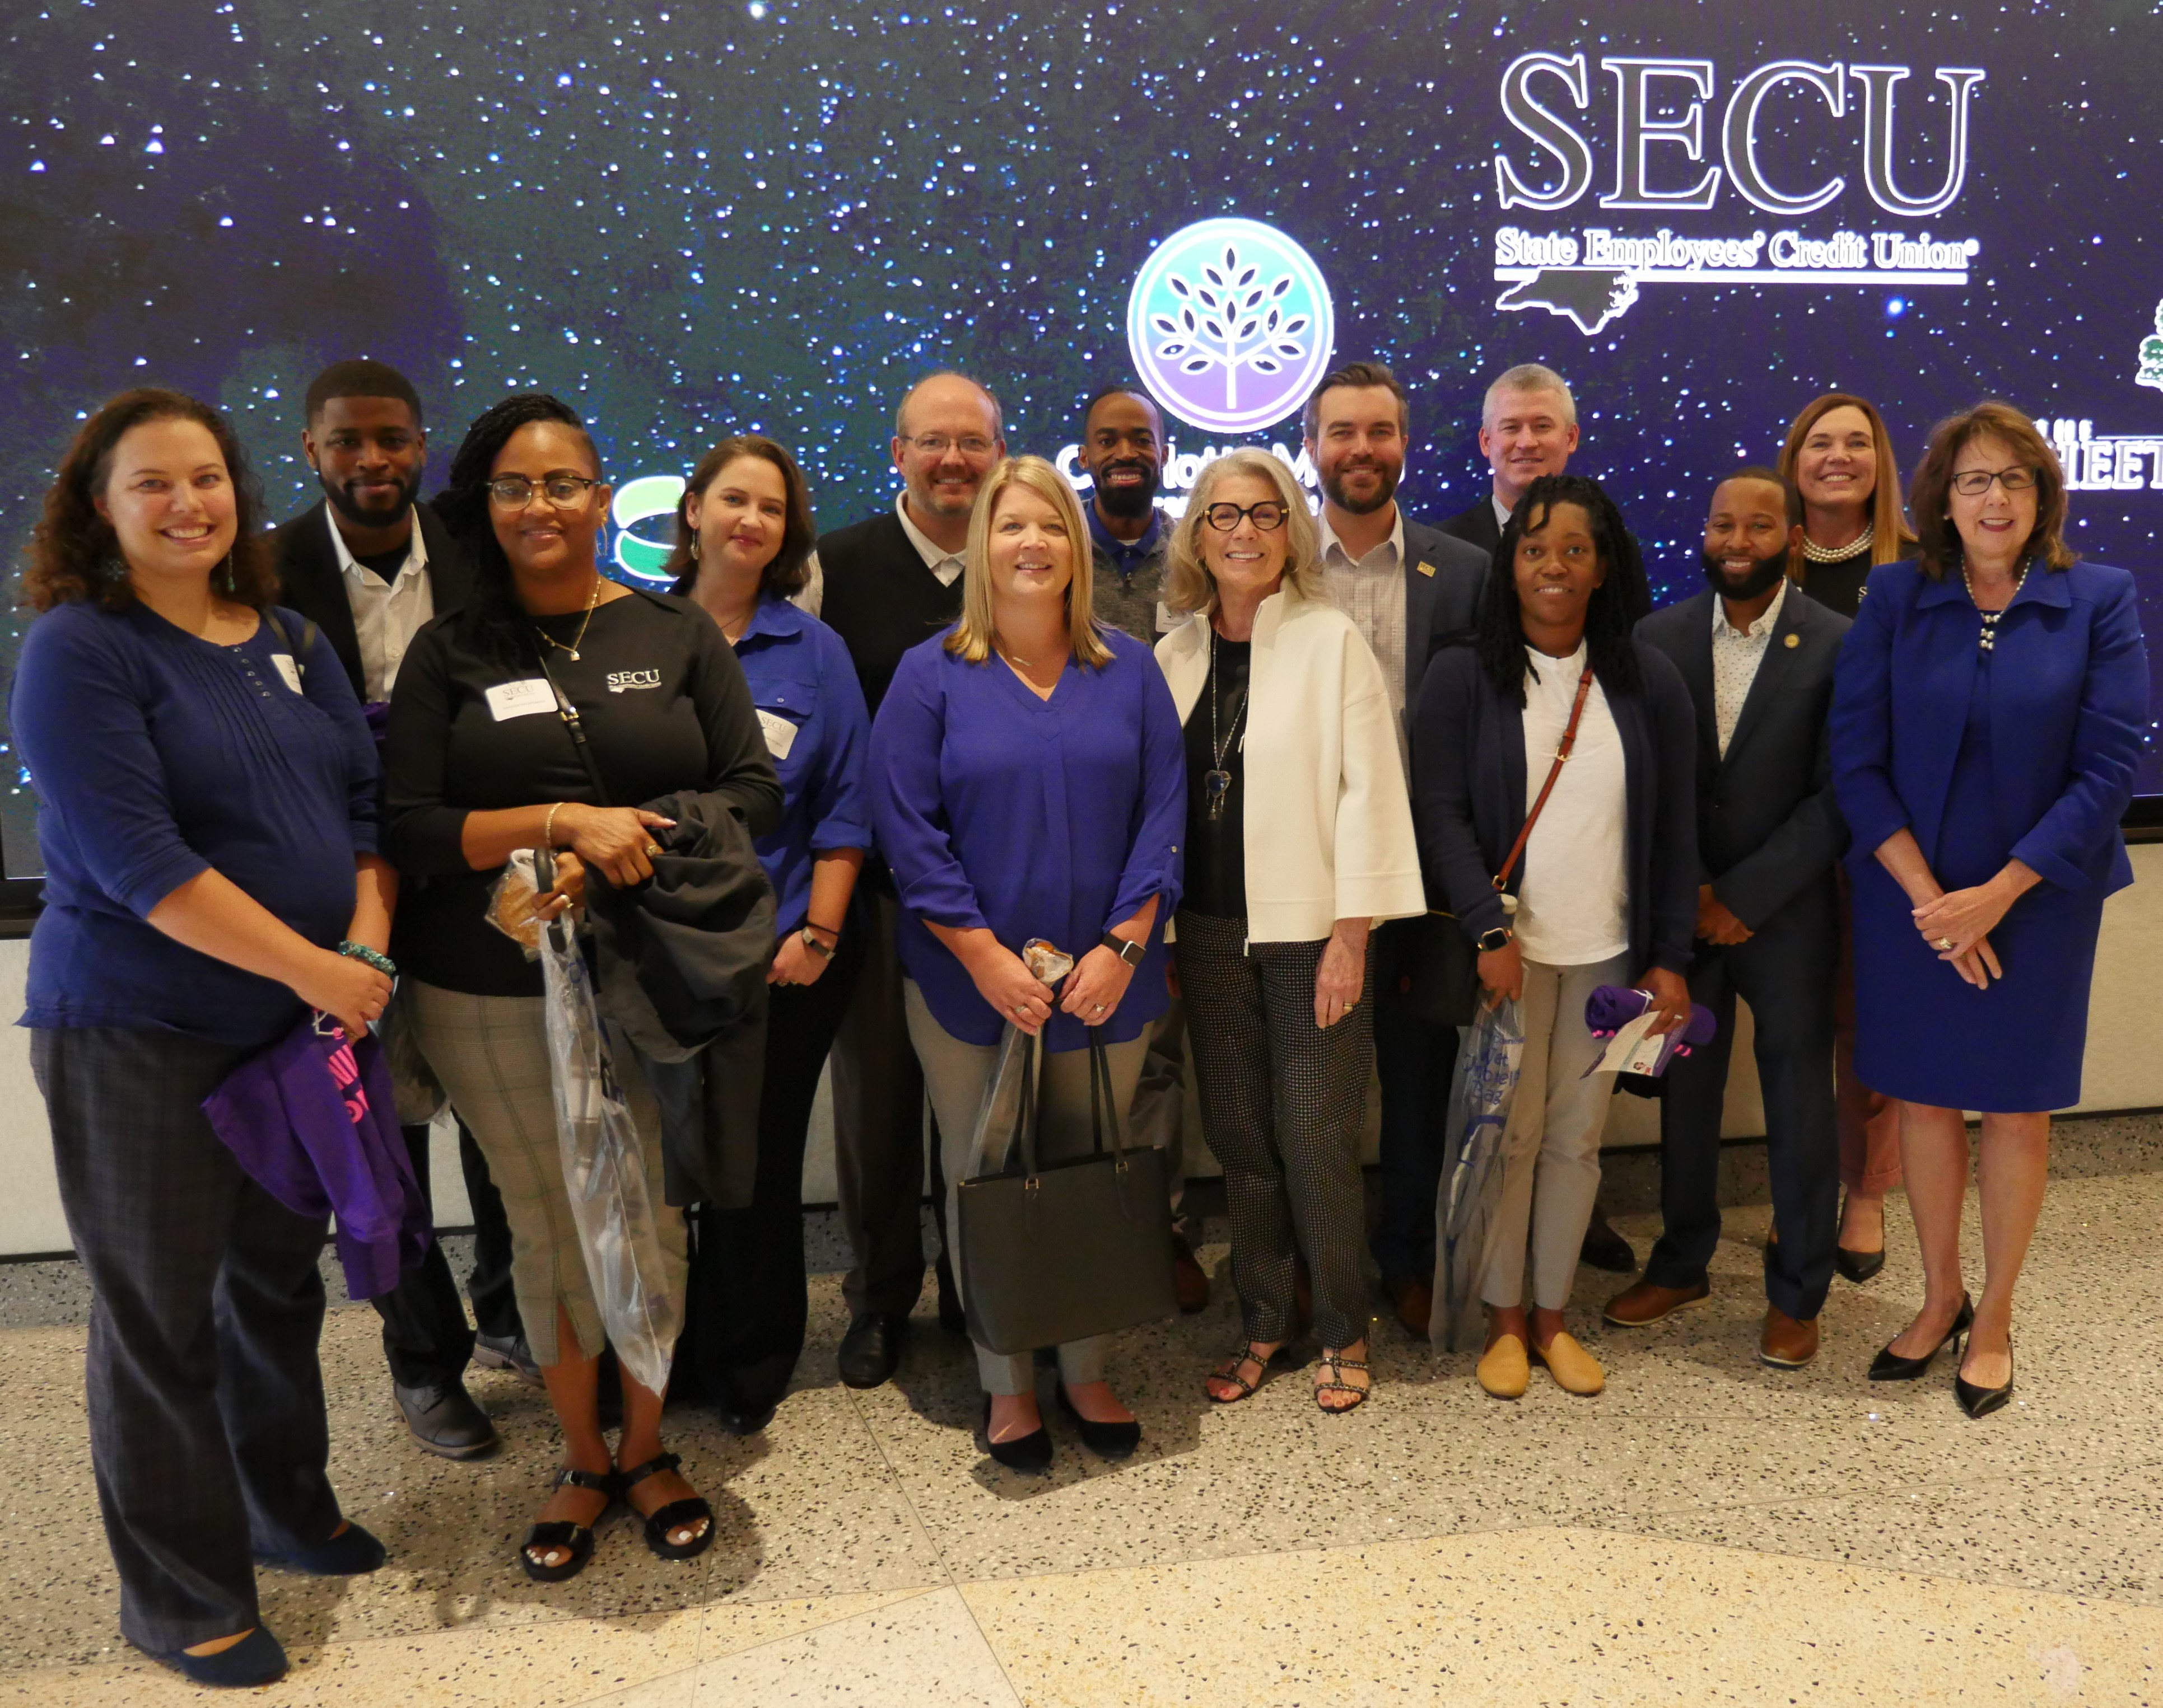CHARLOTTE, N.C. – State Employees’ Credit Union (SECU) was pleased to be the presenting sponsor for a Voices: Voces Speaker Series hosted by BFB Foundation and Central Piedmont Community College (CPCC). The event was held to promote education and career fields in science, technology, engineering, and mathematics (STEM) for girls and women in the Charlotte Metro area. SECU’s financial support enabled BFB Foundation to award 14 local scholarships to deserving STEM students for Fall 2022.
Chris Burns-Fazzi, BFB Foundation’s founder and board chair (first row, center right), and Leigh Brady, SECU’s chief operating officer (first row, far right), surrounded by local SECU branch representatives.

The event, held at CPCC’s new Theater in the Parr Center, sold out well in advance, receiving an overwhelming response from STEM educators, student families, and the public to hear keynote speaker Shayla Rivera, a former rocket scientist with NASA and lifelong champion of science and education. Rivera shared her personal journey and the educational opportunities and exciting career possibilities in STEM-related fields.

Leigh Brady, SECU’s chief operating officer, provided opening remarks before introducing Rivera to the crowd. “We are so pleased to sponsor this important event, knowing it will serve a great purpose in helping fund scholarships to support BFB Foundation’s mission of strengthening communities through education-focused initiatives for girls. The Credit Union has a strong community presence throughout North Carolina, along with a diverse workforce composed primarily of women. As such, we have a strong commitment to programs like this.”

Before closing, Brady added, “To all the students in the audience today, please seize every opportunity to listen, to learn, and to be inspired throughout your journey. All that you gain will be building blocks to strengthen your foundation for an incredibly bright future.”

“It is a special honor that SECU is the presenting sponsor for BFB Foundation’s Voices: Voces Speaker Series. Since 1937, SECU has served the state and educational employees of North Carolina with financial services and products and has continuously provided financial education in North Carolina schools and communities,” said Christine Burns-Fazzi, founder and board chair of BFB Foundation. “They truly believe that we make our communities and lives better through education.”

About SECU and SECU Foundation
A not-for-profit financial cooperative owned by its members, SECU has been providing employees of the state of North Carolina and their families with consumer financial services for 85 years. SECU is the second largest credit union in the United States with $53 billion in assets and serves over 2.6 million members through 273 branch offices, over 1,100 ATMs, 24/7 Member Services via phone, www.ncsecu.org and a Mobile App. The SECU Foundation, a 501(c)(3) charitable organization funded by the contributions of SECU members, promotes local community development in North Carolina primarily through high impact projects in the areas of housing, education, healthcare, and human services. Since 2004, SECU Foundation has made a collective financial commitment of over $235 million for initiatives to benefit North Carolinians statewide.

