United Federal Credit Union – Press Release
September 26, 2022

Contact: Diana Wake
Phone: (888) 982-1400 ext. 6891
Email: dwake@UnitedFCU.com
United Federal Credit Union, 150 Hilltop Road, St. Joseph, Michigan, 49085

United Federal Credit Union Promotes Brook Sweeting to Senior Relationship Development Manager
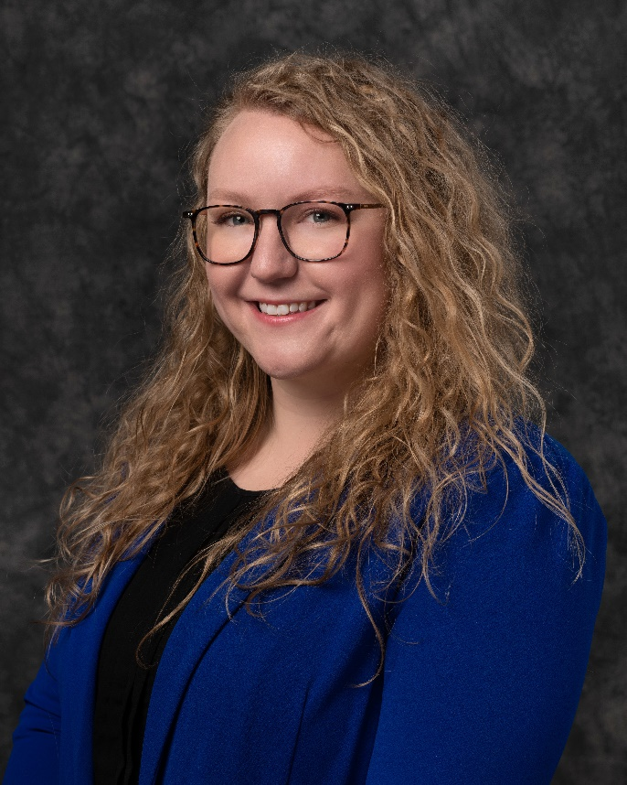
Brook Sweeting, Senior Relationship Development Manager

RENO, Nev. – United Federal Credit Union (United) is pleased to announce the promotion of Brook Sweeting to Senior Relationship Development Manager serving the Nevada region.

“I am thrilled to have this opportunity in our amazing Nevada region,” said Sweeting. “Partnering with our communities while enriching and deepening United’s presence is my passion. I am excited to share positivity, build relationships, and help others grow and develop. In this position, my goal is to help re-energize, enhance, and expand United’s established relationships and develop new opportunities around northern Nevada.

As Senior Relationship Development Manager, Sweeting will be responsible for results-driven business development while promoting corporate member engagement, business and consumer membership and loan growth, and positive public relations. As part of this objective, Sweeting will identify and recruit new members in new and existing markets as well as develop and maintain existing corporate memberships.

Sweeting brings 10 years of banking and financial experience to her new role. She has spent more than a year working as branch manager at United’s Carson City North location. She studied business finance at Kirkwood Community College.

She lives the credit union philosophy of ‘people helping people’ not only through member service, but also community involvement. Sweeting is a participant of the Carson City Chamber Leadership Institute for 2023, and is connected with the Carson City Parks, Recreation and Open Space, and is a volunteer with the non-profit FISH (Friends In Service Helping) in Carson City. She also runs the Nevada region skill builder workshops for United.
____________
About United
United Federal Credit Union has served its Members since 1949 by helping them to build a sound financial future. United consists of more than 191,000 Member/owners worldwide and manages assets in excess of $3.8 billion. Its corporate office and main branch are in St. Joseph, Mich., with additional branches in Arkansas, Indiana, Michigan, Nevada, North Carolina, and Ohio. Federally insured by NCUA. Equal opportunity lender. Equal housing lender. For more information visit UnitedFCU.com

# # #

