**FOR IMMEDIATE RELEASE:**



September 20, 2022

Contact: Cheryl Sclater

(810) 600-2529

cheryl.sclater@elgacu.com

**ELGA Credit Union’s Executive Vice President Cuts His Hair for the Children**

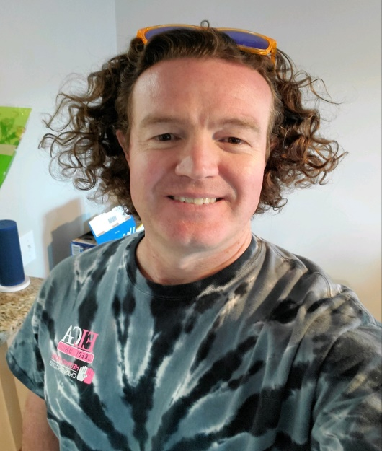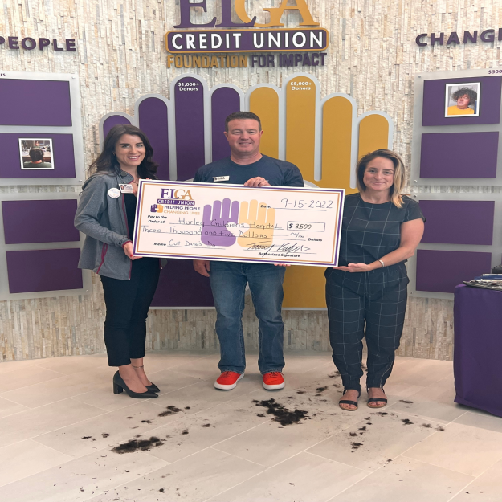

**Grand Blanc, Mich**- Employees at ELGA Credit Union donated money for a chance to cut the hair of their Executive Vice President, David Brandt. Proceeds will benefit Hurley Children’s Miracle Network Hospital through ELGA’s Raise the Purse event. Dave’s hair was donated to Children with Hair Loss, a non-profit who customizes human hair replacements and care kits for children. The owner of Don Franco Salon, Cari Cobb, was on site to provide the tools and help assist the winning associate in the cutting of Dave’s new “do”.

“Growing my hair started as a request from my daughter Sammi to see where her curls came from”, said David Brandt, Executive Vice President of ELGA Credit Union. “As my hair grew, the idea to reach a length where it could be donated came up. I thought donating my hair to provide a child with a wig and to support our local CMN Children’s Hospital was a win – win for the kids”. The fundraiser CUT DAVE’S DO raised $3,500.00.

The mission of Children with Hair Loss is “Covering Young Heads to Heal Young Hearts!” Hair loss in children can be caused by cancer treatments, Alopecia, Trichotillomania, burns and more. Those wishing to help children or families in need can visit Children with Hair Loss at <http://www.childrenwithhairloss.us/> or Hurley Children’s Miracle Network Hospital at <https://www.hurleymc.com/services/childrens-hospital/>

**About ELGA Credit Union**

Serving members since 1951, ELGA Credit Union is a not-for-profit cooperative; formed, owned and operated with a single purpose: Members Helping Members. Simply put, anyone who lives, works, worships, volunteers, or attends school within Michigan are eligible to join. To learn more about ELGA Credit Union, visit www.ELGACU.com.