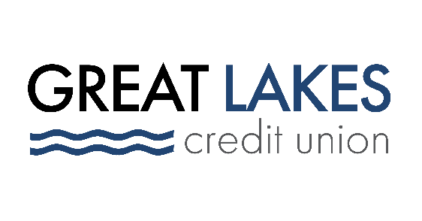

www.glcu.org
FOR IMMEDIATE RELEASE | Contact: Media Department  media@glcu.org  (847) 578-7324
Great Lakes Credit Union’s Promotional 18-month Certificate Offers Competitive APY, Provides Members Low-risk Means to Multiply their Funds

BANNOCKBURN, IL (September 1, 2022) – Great Lakes Credit Union (GLCU) is expanding its empowering portfolio of deposit products and offering members a competitive 18-month certificate, available from September 1, 2022, for a limited time. With the promotional offering, GLCU is providing members with yet another convenient way to predictably grow their savings and see stable returns on their money. The product’s APY is higher than industry-standard rates for certificates with the same term length, making it an especially attractive offer for members interested in multiplying their money quickly without the high risks of playing the stock market.

“With inflation and rising daily costs affecting the communities we serve, we are proud to provide a competitive 18-month certificate that can enable our members to see their money work harder for them. The high APY on this product is an especially great feature for members and potential members consciously shopping for the best rates and who are interested in a low-risk way to grow their funds,” said Steve Bugg, GLCU CEO & President.
“GLCU offers a range of attractive certificates, and with the addition of the 18-month promotion, members can choose from an even greater selection of certificate options and term lengths in order to open a certificate that best serves their needs.”
The 18-month certificate, now available, will be offered until an undetermined date. Members who are newly opening a certificate, rather than renewing one, can benefit from an attractive 2.750% APY when they take advantage of the 18-month promotion – this applies to members who already have opened one or more certificates, if their current certificates are not expiring. GLCU certificate holders who are renewing an expiring certificate will receive the still competitively high 2.500% if they renew with the 18-month special offer.
As with checking accounts, savings accounts, CDs, money market accounts, and certain other accounts offered by credit unions, the 18-month certificate is federally insured up to $250,000, by the NCUA, providing peace of mind for certificate holders.
About Great Lakes Credit Union
Founded in 1938 and headquartered in Northern Illinois, GLCU is committed to financial empowerment for you. As a not-for-profit financial cooperative with over $1 billion in assets, GLCU is proud to serve more than 80,000 members in the Chicagoland and surrounding areas. Learn more about GLCU’s accounts, educational initiatives and community development programs at glcu.org

