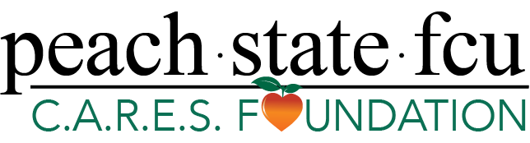

Contact: Kristen Patton
SVP, Marketing
770.580.6015 | kpatton@peachstatefcu.org

Peach State FCU C.A.R.E.S. Foundation Pledges $20,000 to
Walker County School System

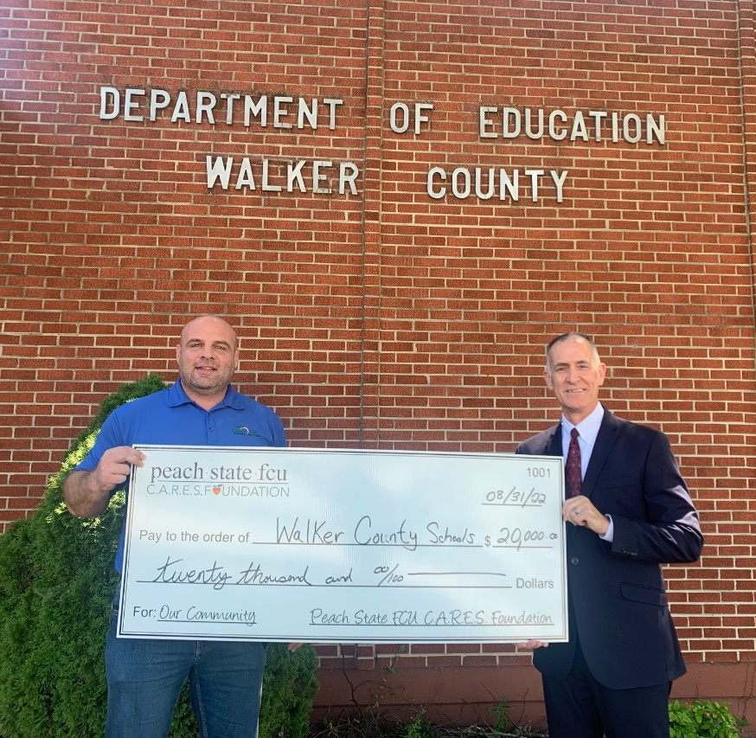

Pictured (left to right): Elijah Parker, Peach State Business and Development and Damon Raines, Walker County Superintendent.

Lawrenceville, GA (September 15, 2022) – The Peach State FCU C.A.R.E.S. Foundation recently announced a $20,000 pledge to the Walker County school system on behalf of their 60th anniversary honoring their roots in education. The pledge will be fulfilled over five years and will assist Walker County School students with access to higher education.

“The Walker County School System appreciates the partnership with Peach State Federal Credit Union and their willingness to support our mission and vision. We are grateful for their recent donation of $20,000 to provide scholarships for graduating seniors at both LaFayette and Ridgeland High Schools. This investment in our students will have a positive impact on our collective community now and into the future," said Damon Raines, Walker County Schools Superintendent.

This pledge is one of many that demonstrates Peach State’s ongoing commitment to supporting education. “Peach State Federal Credit Union was founded by a group of educators over 60 years ago with a mission to provide financial solutions to empower other likeminded individuals into leading a fulfilling life. Today, we have expanded this principle through our C.A.R.E.S. Foundation which supports the education system and their students who aspire to further their education to live a more rewarding life,” said Peach State’s President/CEO, Marshall Boutwell.

About the Peach State FCU C.A.R.E.S. Foundation
Peach State Federal Credit Union’s passion for helping their members and community guided them to create the Peach State FCU C.A.R.E.S. Foundation. The Foundation is funded by the credit union’s Visa Debit Card program and private donors. Since the inception of the Peach State C.A.R.E.S. Visa Debit Card program in July 2019, Peach State has donated more than $1.8 million to charitable organizations, school systems and the arts in the communities that we serve. The C.A.R.E.S. program was created to put these contributions on a sustainable path for the future. To learn more about how Peach State cares, visit peachstatefcu.org/CARES. Peach State is an $835 million not-for-profit financial cooperative that serves more than 75,000 members in Georgia and South Carolina with a mission to provide quality financial services that meet the needs and exceed the expectations of its member-owners. For more information about products and services, visit peachstatefcu.org.
###

