CONTACT
Laticia Duman
Communications Content Specialist
541.681.5285
LDuman@MyOCCU.org

Date: 9.2.2022
For immediate release

OCCU secures naming rights to
Family Zone in Oregon State’s Reser Stadium

New OCCU Family Zone to include interactive, educational experiences for Oregon State football fans on game days.

Eugene, Oregon 9.1.2022 – OCCU has secured naming rights for the Family Zone in Reser Stadium in Corvallis, Oregon.

The OCCU Family Zone will provide new educational and interactive elements inside the football stadium starting this season. On football game days, families will have an elevated experience through various additions including an OCCU Coin Scavenger Hunt for kids to redeem prizes; giveaways for the first 200 fans each home game; and installation of a “dream station,” providing fans the opportunity to be awarded a jumpstart to reaching a financial goal.

Additionally, OCCU’s sponsorship provides for a nursing station in the stadium concourse, and OCCU will donate four football season tickets annually to an area nonprofit organization in collaboration with the OCCU Foundation.

OCCU secured the naming rights through Oregon State University Athletics and its multimedia rightsholder, LEARFIELD’s Beaver Sports Properties.

”OCCU is thrilled to partner with OSU to bring new and exciting interactive experiences to Reser Stadium through the OCCU Family Zone,” said Ron Neumann, OCCU’s president and CEO. “As we join the Corvallis community, we believe that our partnership can help to enhance the game day experience and foster a deeper connection with financial wellness within Beaver Nation.”

OCCU has also announced plans to open a 2,500-square-foot, full-service branch in Corvallis in 2023.

“We are proud to be adding an interactive and educational activation in the OCCU Family Zone,” said Sara Elcano, Oregon State’s senior associate athletic director. “Creating a family-friendly atmosphere in Reser Stadium continues to be a point of emphasis for us, and OCCU is the ideal partner to continue forward on this important initiative.

“This partnership allows us to enhance the family zone by adding giveaways each game, a nursing station pod and interactive activities that educate the youngest Beaver fans on the topic of financial literacy.”

About OCCU
OCCU was founded in 1956 in Eugene, Oregon. Today, as a not-for-profit financial cooperative, OCCU has more than $3 billion in assets, and its more than 250,000 members are served through digital channels and 12 Oregon branches in Eugene, Junction City, Keizer, Salem, Springfield and Wilsonville. Most members live in Oregon and the state of Washington. Others reside throughout the United States and even abroad, keeping their membership active through online and mobile banking. Learn more at MyOCCU.org.

Beaver Sports Properties is LEARFIELD’s local team dedicated to Oregon State overseeing the OCCU relationship. The team works alongside the entire athletics administration in management of the overall multimedia rights relationship and corporate partner platform.
# # #
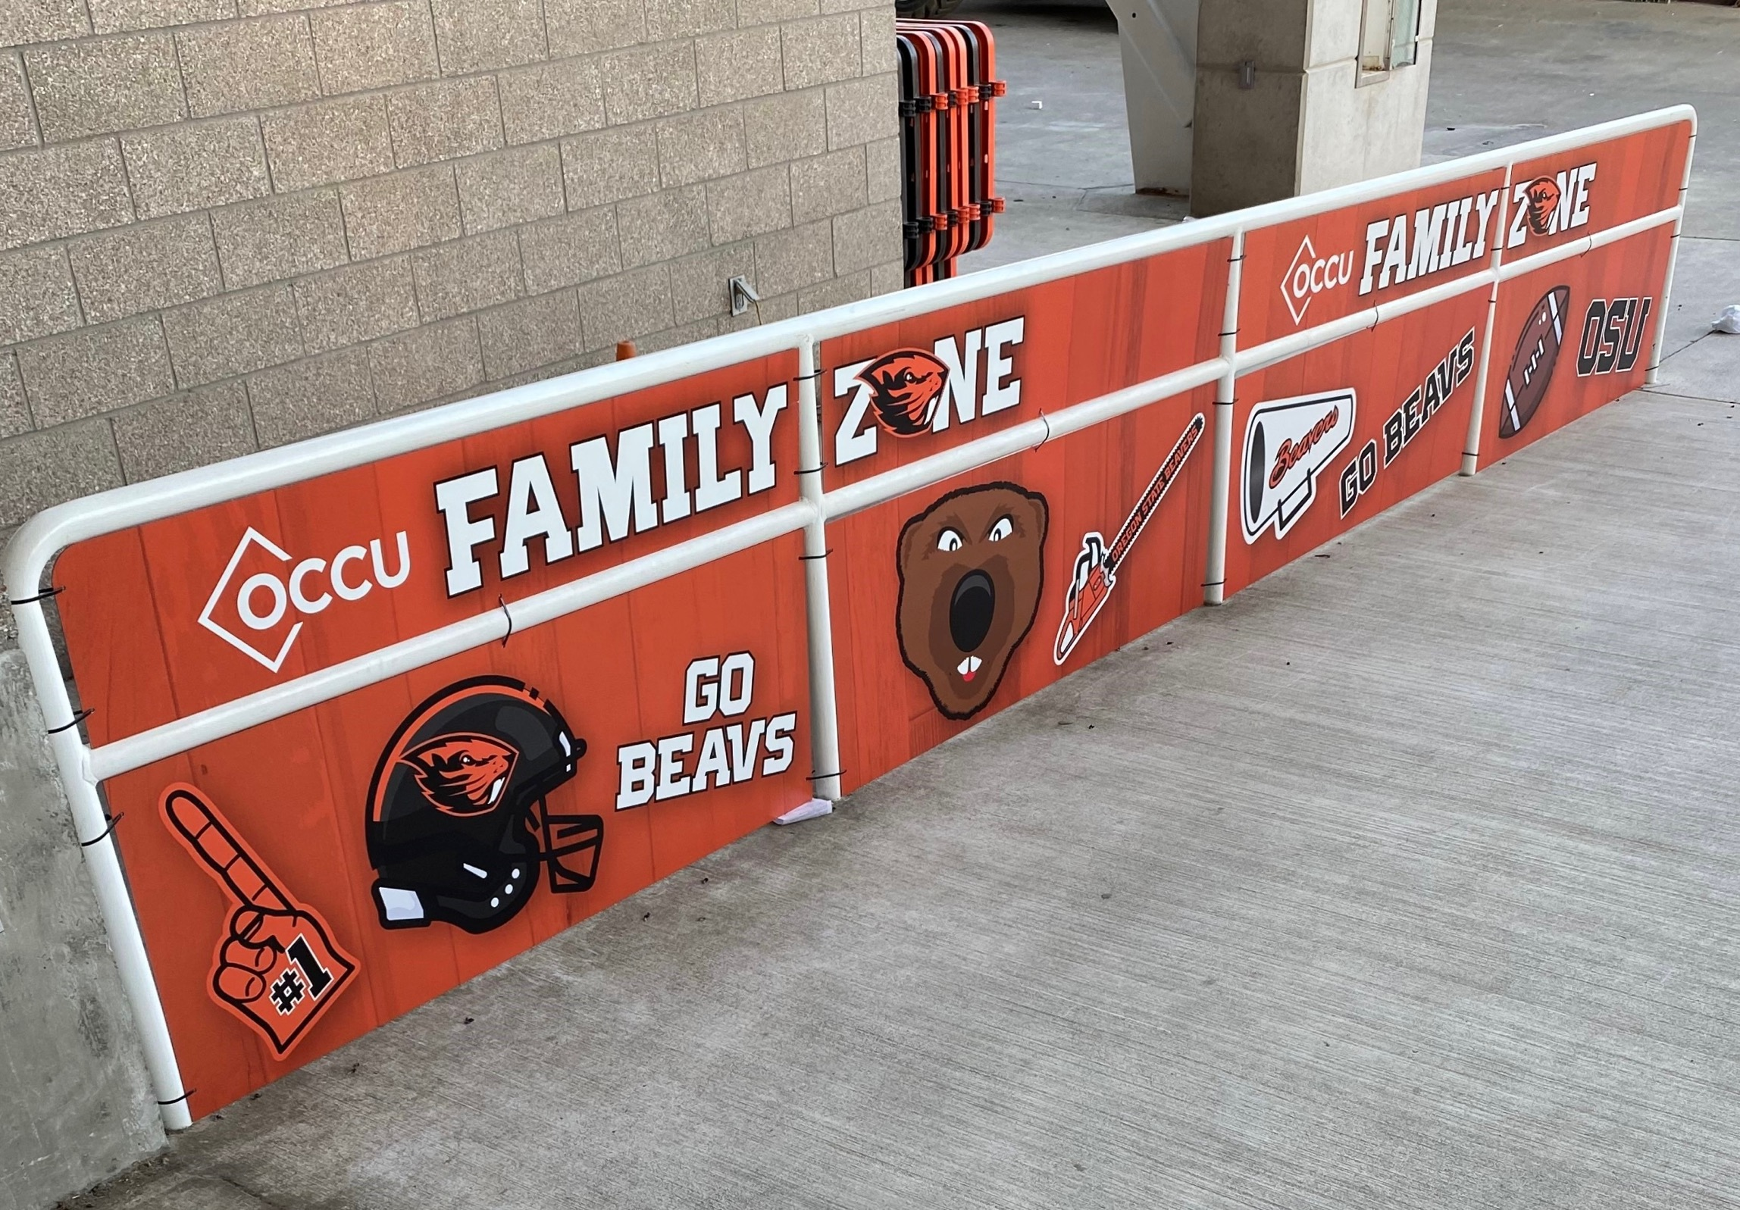
Family zone railing.
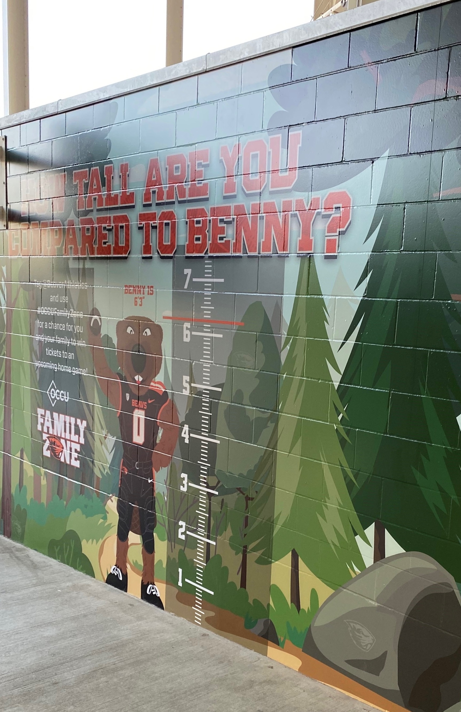
Family zone tunnel.

