PRESS RELEASE
FOR IMMEDIATE RELEASE

Contact: August 25, 2022

Carla Bagley

Phone: 866-56-TOWER, ext. 7144

Email: carla.bagley@towerfcu.org

TowerCares Foundation Awards $75K in College Scholarships

Fifteen college-bound students studying STEM-related fields each received a $5,000 scholarship from the TowerCares Foundation. Over half have parents who are currently serving or have served in the U.S. Military.

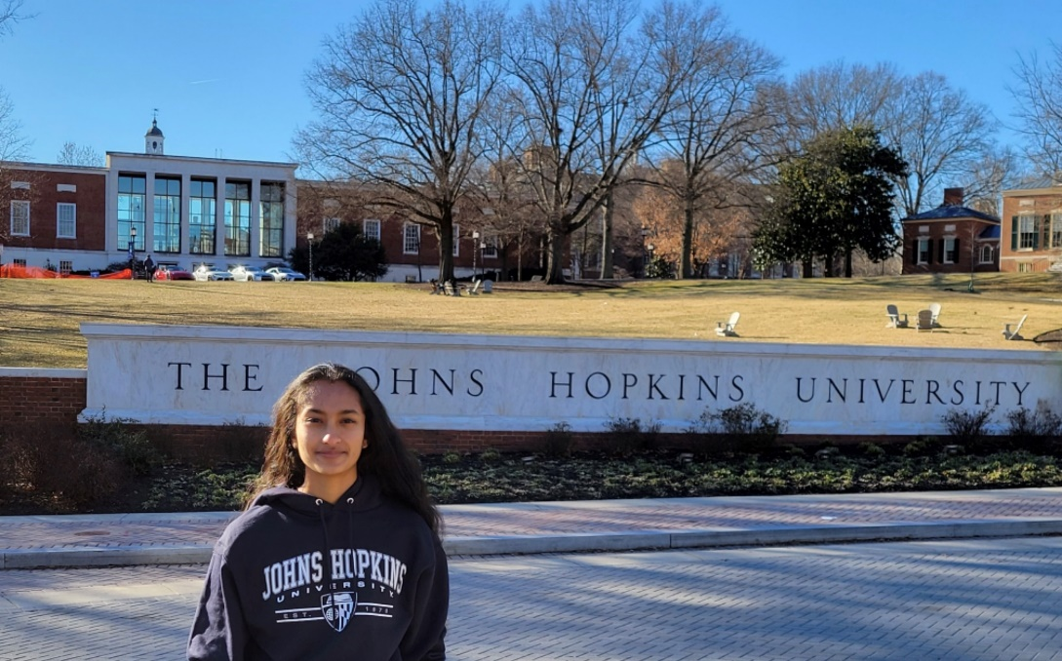
TowerCares Foundation scholarship winner Imani Ghoush of Boyds, Md., is excited to pursue her dream of becoming a doctor.
“The scholarship will assist me in graduating with a degree that I can use to benefit the world…and pursue my dream of becoming an orthopedic surgeon and serving in underprivileged communities,” she said. ‘Affording a private institution is not easy, and this scholarship offers me a stepping stone to getting there.”
Ms. Ghosh is entering her freshman year at Johns Hopkins University in Baltimore and plans to major in Biology. She is one of 15 TowerCares Foundation Scholarship Program winners for the 2022-23 school year.
This year, the Foundation expanded the program from ten to 15 $5,000 scholarships. Since 2018, TowerCares has awarded $200,000 in college scholarships to 40 students.
Over half of this year’s winners have parents who currently serve or have served in the U.S. Military. Scholarship winner Stella Szostak of Chevy Chase, Md. said: “Growing up a military kid has not only made me the person I am today, but it has inspired my love for engineering and foreign language. It is such an honor to be able to continue pursuing these fields with the help of the TowerCares Foundation, an organization that supports [military] families like mine. I am so grateful to receive this award, and I’m so excited for the opportunities ahead that it’s helped to provide!”
Ms. Szostak is entering her freshman year at Princeton University with a major in Mechanical Engineering. Her father is a U.S. Air Force Veteran.
Meet the other 2022-23 scholarship winners:
Dylan Bradford, a freshman at Massachusetts Institute of Technology, planning to study Computer Engineering. His parents currently serve or have served in the U.S. Air Force.
Lily Gaston, a freshman at Johns Hopkins University in Maryland, planning to study Public Health. One of her parents currently serves or has served in the U.S. Air Force.
Courtney Kim, a freshman at Northwestern University in Illinois, planning to study Environmental Science.
Sofia Konkolics, a freshman at Quinnipiac University in Connecticut, studying to be a Physician’s Assistant.
Natalie Mangen, a freshman at Savannah College of Art and Design in Georgia, planning to study Architecture. One of her parents is a U.S. Army Veteran.
Olivia Preston, a freshman at University of North Carolina–Chapel Hill, planning to study Biology. One of her parents currently serves or has served in the U.S. Air Force.
Janet Ruan, a freshman at University of Maryland–College Park, planning to study Biology.
Colby Snyder, a freshman at the University of Pennsylvania, planning to study Chemical Engineering.
Alexander Tong, a freshman at University of California-Berkeley, planning to study Chemical Engineering.
Morgan Trechter, a junior at Catholic University of America in Washington, D.C., studying Civil Engineering. Both of her parents currently serve or have served in the U.S. Air Force.
Margaret Tyson, a freshman at California State Polytechnic University, planning to study Architecture. Both of her parents currently serve or have served in the U.S. Navy.
Lauren Weaver, a freshman at the University of Pittsburgh in Pennsylvania, planning to study Biology.
Kaitlyn Williams, a freshman at Duke University in North Carolina, planning to study Environmental Science. Both of her parents currently serve or have served in the U.S. Marine Corp.
The annual scholarship program starts in April and is open to all current high school seniors and college freshmen, sophomores and juniors who are studying STEM or Foreign Language Linguistics majors. Winners are selected by an independent judging organization based upon academic performance, leadership and participation in school/community activities, work experience and career/educational goals and objectives.
Additional consideration is given to children/dependents of active duty military and Veterans from all branches of the Armed Forces, including Reserve and Guard units.
“Once again, I am impressed by all of our scholarship winners and how much these exceptional young men and women have achieved,” said Richard Stafford, President of the TowerCares Foundation. “The Foundation knows how expensive higher education can be, and we also recognize the importance of supporting our military families, and students pursuing STEM and foreign language linguistics fields. We are thrilled that we were able to expand the program this year to help even more of our country’s future leaders achieve their academic goals.”
To learn more about the TowerCares Foundation, please visit towercaresfoundation.org.

About the TowerCares Foundation
Headquartered in Laurel, Md., the mission of the TowerCares Foundation is to support children in need as well as brave and heroic individuals who have sacrificed while protecting our freedom. TowerCares creates programs and supports well-vetted charities that are in alignment with our mission. The TowerCares Foundation is a 501(c)(3) charitable organization, and a participating charity in the Combined Federal Campaign (#23594) and Maryland Charitable Campaign (#47-4164006). Donations are tax-deductible. For more information, visit towercaresfoundation.org.

###

