

**United Federal Credit Union – Press Release**

September 7, 2022

Contact: Diana Wake

Phone: (888) 982-1400 ext. 6891

Email: [dwake@unitedfcu.com](mailto:dwake@unitedfcu.com)

United Federal Credit Union, 150 Hilltop Road, St. Joseph, Michigan, 49085

**United Federal Credit Union Names Mike Mondin   
Mortgage Advisor in Fletcher, North Carolina**

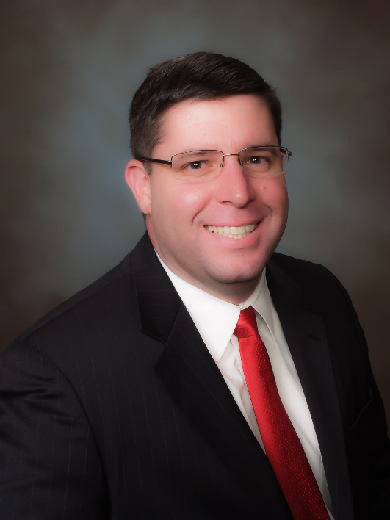

*Mike Mondin, Mortgage Advisor in Fletcher, North Carolina.*

**FLETCHER, N.C. –** United Federal Credit Union (United) is pleased to announce the appointment of Mike Mondin to Mortgage Advisor in North Carolina. Mondin will be based at United’s branch at 3674 Hendersonville Road in Fletcher.

Mondin will use his expertise to provide a quality real estate lending experience through financial counseling and product awareness to credit union members regarding their real estate financing needs and generate investment quality mortgage loans.

With over 20 years of banking and mortgage lending experience, from mortgage consultant to branch manager, and various senior-level lending positions, Mondin pairs his industry knowledge with a passion to help people find the right mortgage option for their new home.

He holds a bachelor of science degree in business administration with an emphasis on finance from the University of Central Florida in Orlando, Florida and also attended the RMA Commercial Lending School at East Carolina University in Greenville, North Carolina.

**____________**

**About United**

United Federal Credit Union has served its Members since 1949 by helping them to build a sound financial future. United consists of more than 191,000 Member/owners worldwide and manages assets in excess of $3.8 billion. Its corporate office and main branch are in St. Joseph, Mich., with additional branches in Arkansas, Indiana, Michigan, Nevada, North Carolina, and Ohio. Federally insured by NCUA. Equal opportunity lender. Equal housing lender. For more information visit [UnitedFCU.com](http://www.unitedfcu.com)

# # #