

**United Federal Credit Union – Press Release**

September 6, 2022

Contact: Diana Wake

Phone: (888) 982-1400 ext. 6891

Email: [dwake@UnitedFCU.com](mailto:dwake@UnitedFCU.com)

United Federal Credit Union, 150 Hilltop Road, St. Joseph, Michigan, 49085

**United Federal Credit Union Continues Growing Mortgage Advisor Team in Summerlin, Nevada**

**SUMMERLIN, Nev. –** United Federal Credit Union (United) is growing its mortgage operation in the greater Las Vegas area. It has added two new mortgage advisors to its current mortgage team in the Summerlin area.

The mortgage advisors will help members find the best option to finance their homes as well as assist with virtual account access through United’s online and mobile banking services.

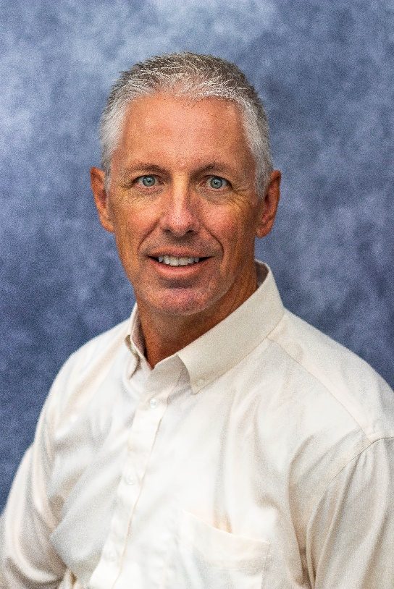

*Ethan Swenson, Mortgage Advisor*

Ethan Swenson brings more than 21 of mortgage lending experience to his new role. He is familiar with the opportunities and challenges of the local housing market. Swenson will use his extensive local industry knowledge to help people find the right mortgage option for their new home, and give step-by-step guidance throughout the entire process.

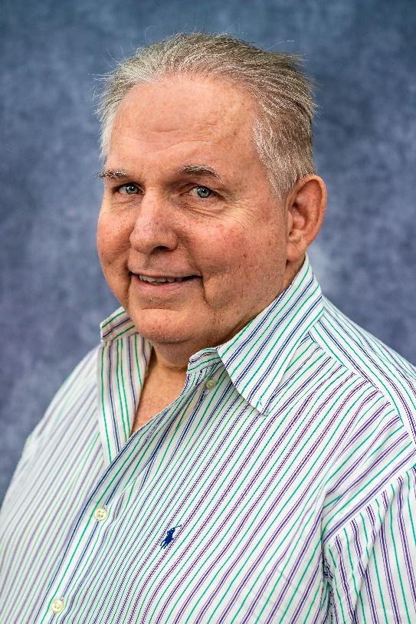

*Greg Meyer, Mortgage Advisor*

Greg Meyer has more than 20 years of lending, customer service and sales experience. He will use his expertise to guide members through the home buying process and assist them with their real estate financing needs to generate investment quality mortgage loans.

United plans to open a Mortgage Loan Office in Summerlin by the end of 2022. It plans to open a Mortgage Loan Office in Henderson this month.

United has been in the Nevada market since 2009. It currently has branches in northwest Nevada in Reno, Sparks, and Carson City, as well as a loan production office in Fernley.

**____________**

**About United**

United Federal Credit Union has served its Members since 1949 by helping them to build a sound financial future. United consists of more than 191,000 Member/owners worldwide and manages assets in excess of $3.8 billion. Its corporate office and main branch are in St. Joseph, Mich., with additional branches in Arkansas, Indiana, Michigan, Nevada, North Carolina, and Ohio. Federally insured by NCUA. Equal opportunity lender. Equal housing lender. For more information visit [UnitedFCU.com](http://www.unitedfcu.com)

# # #