United Federal Credit Union – Press Release
September 22, 2022

Contact: Diana Wake
Phone: (888) 982-1400 ext. 6891
Email: dwake@UnitedFCU.com
United Federal Credit Union, 150 Hilltop Road, St. Joseph, Michigan, 49085

United Federal Credit Union Adds Two Mortgage Advisors to Team in Summerlin, Nevada

SUMMERLIN, Nev. – United Federal Credit Union (United) is adding staff to its mortgage operation in the greater Las Vegas area. Todd Hernandez and Michael Quinn have been appointed mortgage advisors in the Summerlin area.

Hernandez and Quinn will help members find the best option to finance their homes as well as assist with virtual account access through United’s online and mobile banking services.

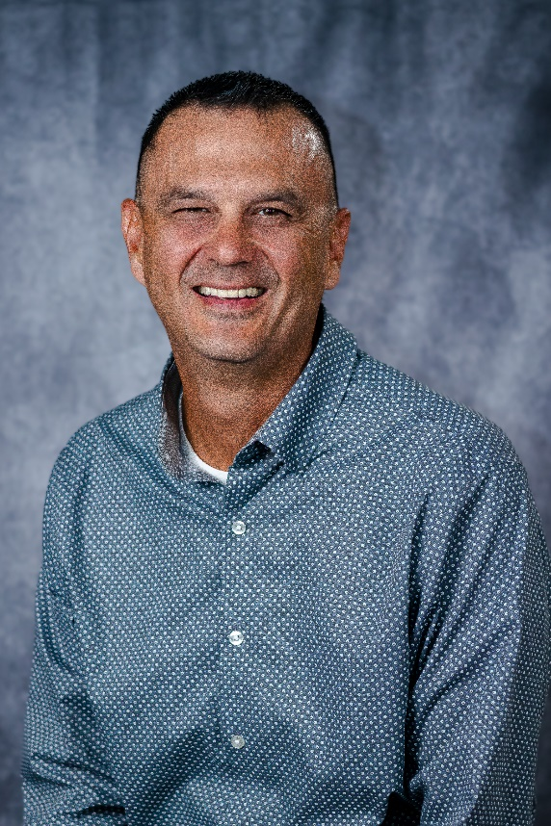
Todd Hernandez, Mortgage Advisor

Hernandez has spent his entire career helping people in the Las Vegas area. He brings more than 20 years of mortgage lending and financial experience to his new role. He has worked the last 10 years to help people find their dream home.

Hernandez is familiar with the opportunities and challenges of the local housing market. He will use his extensive local industry knowledge to help people find the right mortgage option for their new home, and give step-by-step guidance throughout the entire process.

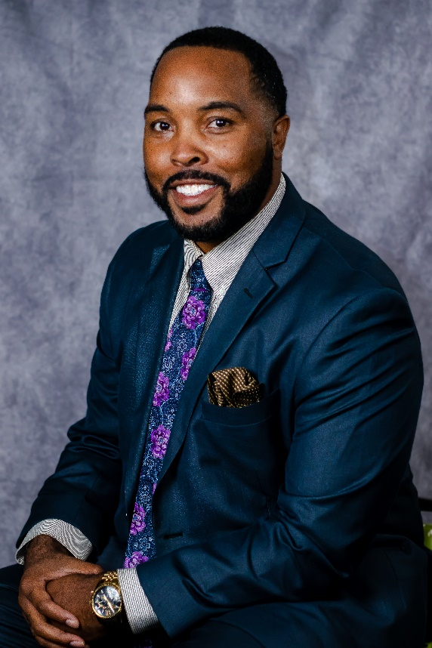
Michael Quinn, Mortgage Advisor

Quinn brings more than 15 years of mortgage lending and customer service experience in the Las Vegas area. He has a passion for providing quality real estate lending advice and will use his expertise to guide members through the home buying process.

Quinn has a bachelors degree in business administration from Nevada State College. In the community, he volunteers with Volunteer Income Tax Assistance (VITA)/Tax Counseling for the Elderly (TCE).

United plans to open a Mortgage Loan Office in Summerlin by the end of 2022. It plans to open a Mortgage Loan Office in Henderson this month.

United has been in the Nevada market since 2009. It currently has branches in northwest Nevada in Reno, Sparks, and Carson City, as well as a loan production office in Fernley.

____________
About United
United Federal Credit Union has served its Members since 1949 by helping them to build a sound financial future. United consists of more than 191,000 Member/owners worldwide and manages assets in excess of $3.8 billion. Its corporate office and main branch are in St. Joseph, Mich., with additional branches in Arkansas, Indiana, Michigan, Nevada, North Carolina, and Ohio. Federally insured by NCUA. Equal opportunity lender. Equal housing lender. For more information visit UnitedFCU.com

# # #

