Texas Trust Credit Union Unveils San Angelo’s
Newest Sheep Sculpture at its New Branch

San Angelo, Texas – Oct. 31, 2022 – Texas Trust Credit Union is now in full operation at its newly remodeled building at the corner of West Twohig Avenue and US-277 following an extensive renovation. The new facility is also home to San Angelo’s newest sheep sculpture, which Texas Trust commissioned as a tribute to the city’s sheep industry heritage.

One side of the fiberglass sculpted sheep is painted with a bald eagle soaring through the sky. The eagle represents Cash, the Texas Trust mascot. The other side of the sheep pictures a cowboy, his horse, and a border collie overlooking the horizon at dusk. The artwork is meant to symbolize the trust between the rancher and his animals and a quiet moment of rest at the end of a busy day. It is also symbolic of the trust between Texas Trust Credit Union and its members.

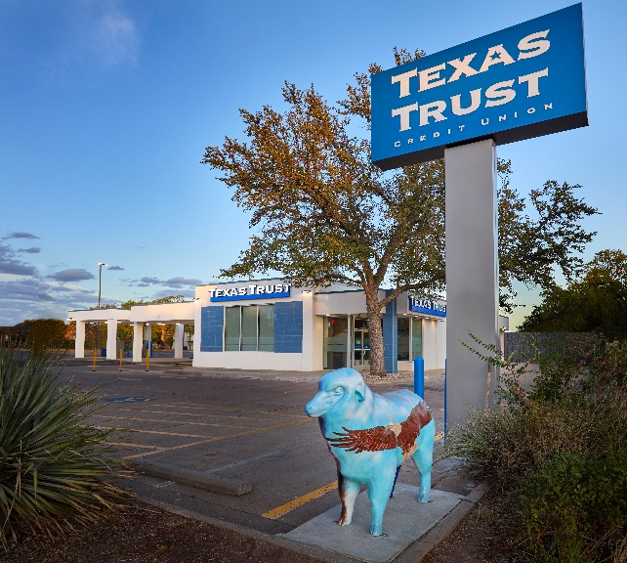
The sheep, which is named True Bl-ewe, is on full display outside the branch underneath the Texas Trust sign and is part of the Downtown San Angelo Sheeptacular Art project. The sheep was painted by Scott Sustek, a local artist and teacher at Central High School. This is the 11th sheep Sustek has painted in San Angelo.

The 3,094-square-foot branch offers an open floor concept that creates a collaborative working environment offering more personal and member-centric interaction. It features free-standing universal teller stations that allow members to conduct all of their financial business with a single teller. In addition, there is a self-serve station that members can use to review their transaction histories, print statements, and check their balances. The station offers an express teller option for members with simple transactions.

The new full-service branch of the $2 billion Texas Trust offers a full array of financial services for every stage of life. The branch is managed by Victoria Chappa, who formerly managed the credit union’s downtown location.

“We invite residents of San Angelo to stop by and have their picture taken next to True Bl-ewe and then come in and visit us,” said Brett Nikolauk, Vice President of Operations at Texas Trust Credit Union. “We are here to help those who call San Angelo home build brighter financial futures.”

A high resolution picture of True Bl-ewe can be downloaded here.

About Texas Trust Credit Union
Texas Trust Credit Union has been helping build brighter financial futures since its modest beginning in 1936. Today, the full-service credit union serves more than 133,000 members. With assets of more than $2 billion, Texas Trust is the 6th largest credit union in North Texas and the 17th largest in Texas. With a focus on the community, Texas Trust is creating a legacy of giving through generous financial donations that support local school programs and activities, non-profit organizations, and student scholarships; and by providing volunteer resources through its Community Unity team, which supports scores of charitable events each year. For more information, visit TexasTrustCU.org or follow us on Facebook at facebook.com/texastrustcu or Twitter at @texastrustcu.

###

