Children to Receive New Beds Built by Texas Trust Employees

Arlington, Texas – November 2, 2022 – More than 340 Employees of Texas Trust Credit Union spent a day building beds for the Fort Worth chapter of Sleep in Heavenly Peace.

To celebrate being able to hold its all-hands employee rally for the first time since the pandemic began, Texas Trust employees enjoyed a day of camaraderie while building 50 hand-made beds that will be donated to local children. The idea is that “no kid sleeps on the floor.”

The event was held under large tents in the parking lot of the Texas Trust CU Theatre at Grand Prairie, which gave employees plenty of room to spread out and work. Employees worked in groups at several assembly stations to build the hand-crafted beds.

Sleep in Heavenly Peace provided the materials and tools along with training and supervision. In addition to their work, Texas Trust employees donated comforters, sheet sets, and pillows that each child will receive when the new bed and mattress are delivered.

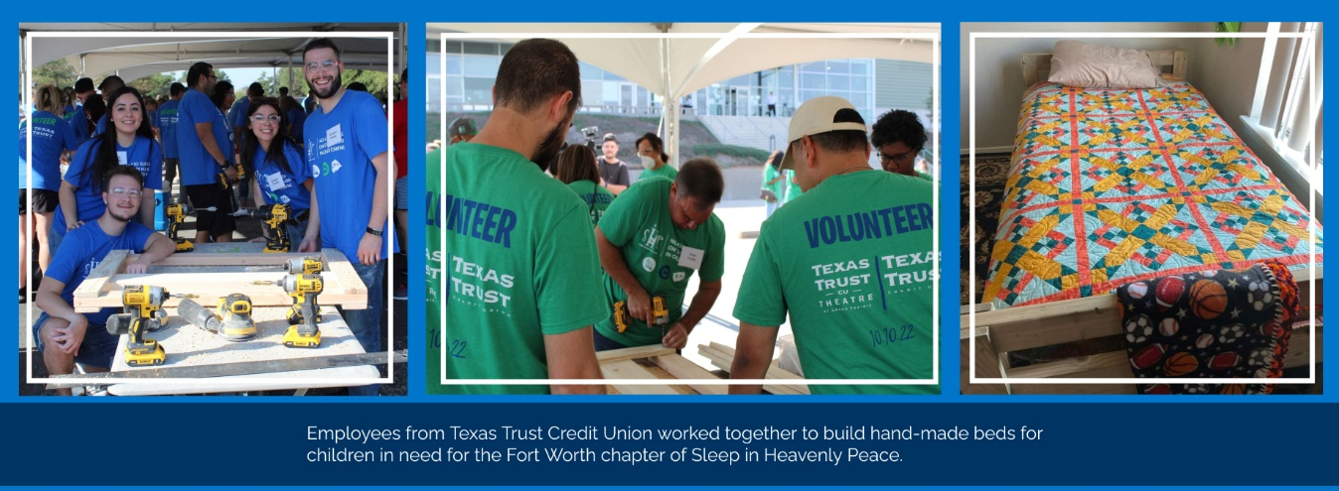

“This event helped us realize that there are children in our community who really don’t have a comfortable place to sleep each night,” said Jim Minge, CEO of Texas Trust Credit Union. “A comfortable bed is a basic need that most of us take for granted.”

Minge added, “Building these beds gave all of our employees an opportunity to put our people helping people philosophy to work and provide a meaningful service to our community.”

Video footage from the Texas Trust volunteer project for Sleep in Heavenly Peace is available to share and download here. High resolution images shown above can be downloaded here.

About Texas Trust Credit Union
Texas Trust Credit Union has been helping build brighter financial futures since its modest beginning in 1936. Today, the full-service credit union serves more than 133,000 members. With assets of more than $2 billion, Texas Trust is the 6th largest credit union in North Texas and the 17th largest in Texas. With a focus on the community, Texas Trust is creating a legacy of giving through generous financial donations that support local school programs and activities, non-profit organizations, and student scholarships; and by providing volunteer resources through its Community Unity team, which supports scores of charitable events each year. For more information, visit TexasTrustCU.org or follow us on Facebook at facebook.com/texastrustcu or Twitter at @texastrustcu.

###

