Texas Trust Gives Foundation Donates $7,500 to Toys for Tots
in Honor of Organization’s 75th Anniversary

ARLINGTON, Texas – Dec. 1, 2022 – For 75 years the Marine Corp Reserves have provided toys to children in need at Christmas throughout the U.S. As a proud supporter of Toys for Tots and in honor of the 75th anniversary, the Texas Trust Gives Foundation gave $7,500 to the organization.

The donation was delivered at the annual toy drive held at the Dr. Jim Vaszauskas Center for the Performing Arts in Mansfield.

For 11 years Texas Trust has partnered with Mansfield ISD and Toys for Tots to provide toys for Christmas to families in need. Along with the cash donation, Texas Trust delivered more than 200 toys that it collected through the credit union’s branches from employees, members, and the community, plus $2,000 worth of bikes provided by the foundation.
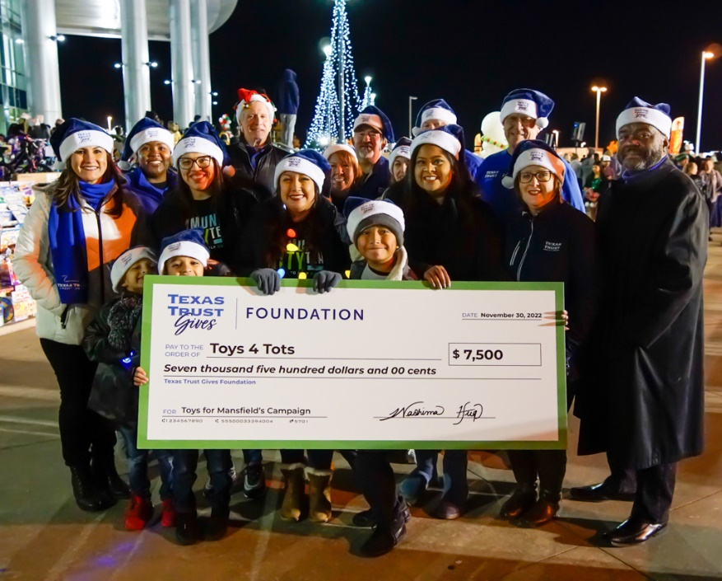
The annual toy drive at the performing arts center is a favorite holiday event with food, live performances, and musical entertainment for the entire family.

“With the cost of everyday things skyrocketing there are a growing number of families having to make tough financial decisions,” said Washima Huq, Executive Director of the Texas Trust Gives Foundation. “Toys for Tots helps those families meet their children’s Christmas wishes by ensuring every child has a special toy with their name on it under the tree.”

Huq added, “Texas Trust has been blessed by the loyal support of its members. Giving to Toys for Tots is one way we are able to share that blessing through the foundation.”

A high resolution picture of the Texas Trust Gives Foundation presenting a $7,500 check to the U.S Marine Corps Reserve for its 2022 Toys for Tots campaign can be downloaded here.

About Texas Trust Gives Foundation
The Texas Trust Gives Foundation is a 501(c)(3) nonprofit dedicated to touching hearts and changing lives. It is the charitable arm for Texas Trust Credit Union, a $2 billion financial institution. The foundation provides scholarships to local high school students, awards charitable grants, and organizes volunteer efforts through the Community Unity Team for local community events.

###

