**Texas Trust Breaks Ground for New Branch in San Angelo**

**SAN ANGELO, Texas – May 22, 2023** – [Texas Trust Credit Union](http://www.TexasTrustCU.org) broke ground on a new facility to serve its growing membership in San Angelo. The new facility will be located on FM 2288 and Sherwood Way in the H-E-B shopping center.

The branch will be nearly 4,000 square feet and will offer a member-friendly design with free-standing universal teller stations and private and semi-private spaces that will allow members to meet with branch personnel to manage all of their financial needs, including mortgage and auto loans, investments and insurance services, credit cards and more.

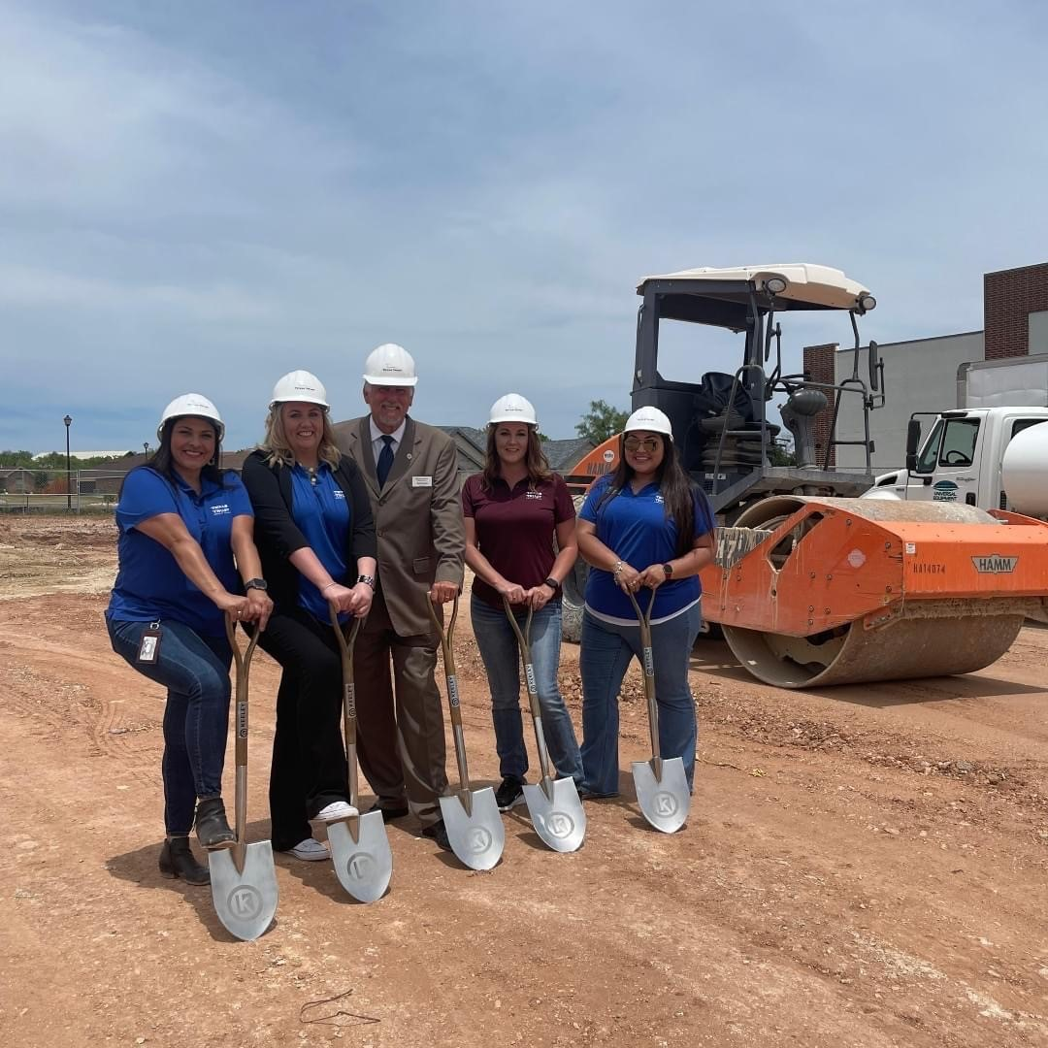There will be three oversized drive-thru lanes to accommodate members’ vehicles, along with a freestanding ATM canopy for 24/7 convenient access for routine transactions.

The building will have a modern take on traditional Texas style. It will feature Austin limestone and weathered wood. The interior will be designed with warm and welcoming wood tones, an abundance of natural light, and a bright, airy lobby. The outside of the facility will feature shading louvers and roof overhangs and be xeriscaped with native plants.

Texas Trust worked with Oculus, Inc., to design the branch, which will be constructed by [L. Keeley Construction](https://www.lkeeley.com/) of St. Louis.

“We are excited to expand our footprint in the San Angelo community,” said Jim Minge, CEO of Texas Trust Credit Union. “This branch will offer a fresh new design and a more convenient location for members who want or need to visit with us in person versus online.”

The branch, scheduled to open in early 2024, will be managed by Heather Collier. It will provide residents of San Angelo and Tom Green County a range of financial products and services designed to help them achieve a brighter financial future. The branch will have a number of bilingual employees to serve Spanish speaking members.

Once this new branch is open the location at the 306 Loop and Blue Ridge Trail will close.

High resolution pictures from the ground breaking can be downloaded [here](https://www.texastrustcu.org/news/texas-trust-breaks-ground-for-new-branch-in-san-angelo/).

**About Texas Trust Credit Union**

Texas Trust Credit Union has been helping build brighter financial futures since its modest beginning in 1936. Today, the full-service credit union serves more than 137,000 members. With assets of more than $2 billion, Texas Trust is the 7th largest credit union in North Texas and the 18th largest in Texas. With a focus on the community, Texas Trust is creating a legacy of giving through generous financial donations that support local school programs and activities, non-profit organizations, and student scholarships; and by providing volunteer resources through its Community Unity team, which supports scores of charitable events each year. For more information, visit [TexasTrustCU.org](http://www.TexasTrustCU.org) or follow us on Facebook at [facebook.com/texastrustcu](http://www.facebook.com/texastrustcu) or Twitter at [@texastrustcu](http://www.twitter.com/texastrustcu).

###

**Photo captions:**

Picture above: Espy Taylor and Stephanie Sides with Texas Trust, along with Walt Koenig President/CEO of the San Angelo Chamber, and Texas Trust’s Heather Collier and Marissa Huerta stand shovel ready to break ground on the new branch on FM 2288 and Sherwood Way in the H-E-B shopping center.

Picture 2: The Mayor of San Angelo, Brenda Gunter, helped break ground with Heather Collier and Marissa Huerta of Texas Trust Credit Union.

Picture 3: Heather Collier (third from right), will manage the new Sherwood branch when it opens. Other members of the retail support team pictured include Marissa Huerta, Espy Taylor, and Stephanie Sides.