
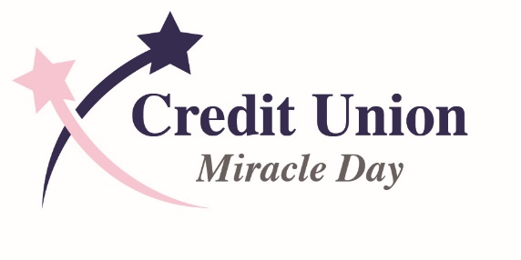

PRESS RELEASE

Contacts:

Leigh Philibosian

Cell: 717-439-1576

Direct: 443.325.0768

info@miracleday.org

Credit Unions Raise $506,230 for CMN Hospitals at

Credit Union Cherry Blossom 10 Mile & 5K
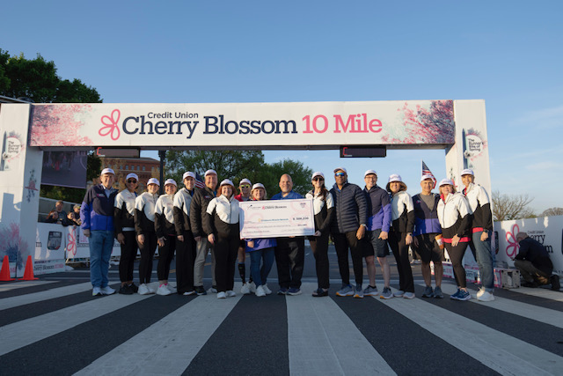
Washington, D.C. (April 12, 2026) – Credit Unions and industry partners presented a $506,230 donation from Credit Union Miracle Day to Children’s Miracle Network Hospitals at the Credit Union Cherry Blossom 10 Mile in Washington, DC on April 12, 2026. Over $200,000 of the donation was raised directly by runners, their families, and friends who participated in the race.

The contributions highlight the dedication of credit unions nationwide to supporting the health and well-being of children and families in their communities.
“We are thrilled to celebrate our 24th year as title sponsor of this iconic Washington tradition,” said John Bratsakis, Chair of Credit Union Miracle Day. “The generosity of credit unions, runners, and volunteers is truly inspiring. We would like to express special thanks to our Presenting Sponsors, Velera and TruStage, Supporting Sponsor, Visa and the hundreds of credit union volunteers who contribute their time and energy to make race weekend a success.”
Since becoming the title sponsor of the Credit Union Cherry Blossom Run in 2002, Credit Union Miracle Day has helped raise over $12.5 million for CMN Hospitals nationwide. These funds directly benefit local children’s hospitals, funding critical research, treatments, and medical equipment.
The annual Capitol Hill Competition, sponsored by Congressional FCU, United States Senate FCU and America’s Credit Unions, is the race within the larger Credit Union Cherry Blossom 10 Mile. House and Senate offices form teams to compete for the Capitol Hill Cup. The team with the best race time wins the cup to display in its office. This year there were 150 teams with over 1,000 staffers competing.
The race by the numbers:
- Nearly 500 credit union volunteers helped distribute food and drinks, run baggage check, organize runners and other support activities.
- 60 credit unions from across the country contributed through sponsorships.
- Over 1,000 Congressional staffers on 83 teams competed in the race.
- 163 Members of Congress from 43 states, DC, American Samoa, Guam and the Northern Mariana Islands signed on as Honorary Race Chairs
- 18,000 ran in the 10 Mile Run on Sunday.
- 8,000 5K runners and 800 Kids Run participants ran on Saturday.

Credit Union Cherry Blossom 10 Mile & 5K

The 53nd running of the Credit Union Cherry Blossom 10 Mile took place Sunday, April 12th on the Washington Monument Grounds, Washington, D.C. The racecourse is a fast, flat route around the iconic memorials in the nation’s capital. The race is on the “bucket list” of things to do in Washington, D.C. according to the Washingtonian Magazine.

Credit Union Miracle Day

Since becoming the title sponsors of races in 2002, Credit Union Miracle Day, a collaboration of over 75 credit unions and business partners and CUSOs, has donated over $12.5 million to Children’s Miracle Network Hospitals across the country. Children’s Miracle Network Hospitals is an alliance of premier children’s hospitals which treat 10 million critically ill children annually, regardless of their ability to pay.

Credit Union Miracle Day is the 2013 proud recipient of the National Credit Union Foundation’s Outstanding Program Award.

# # #

About Credit Union Miracle Day

Credit Union Miracle Day is a partnership of credit unions, CUSOs and partner organizations united to sponsor the Credit Union Cherry Blossom 10 Mile & 5K benefitting Children’s Miracle Network Hospitals nationwide.

About the Credit Union Cherry Blossom 10 Mile & 5K

The Credit Union Cherry Blossom, sponsored by Credit Union Miracle Day, Inc, in partnership with Velera and TruStage is known as "The Runner's Rite of Spring" in the Nation's Capital. The staging area for the event is on the Washington Monument Grounds and the course passes in sight of all the major Washington, DC Memorials. The event serves as a fundraiser for the Children's Miracle Network Hospitals, a consortium of 170 premier children's hospitals across North America. About one-third of the funds raised support Washington, DC's own Children's National Medical Center. The event also contributes $5,000 to the Road Runners Club of America "RunPro Camp," a workshop for recent college graduates considering becoming professional runners.

The event is a proud member of the PRRO Circuit (www.PRRO.org), a five-race series of America’s Classic Road Races with events in Jacksonville, FL, Washington, DC, Spokane, WA, Utica, NY, and Davenport, IA, PA. The circuit is committed to a drug-free sport.

