 |  | Contact:  Nancy Loftis, VP of Marketing & PR  6400 West Main| Kalamazoo, MI 49009  844-238-4228 x1142 | www.adviacu.org  For Immediate Release – November 12, 2025
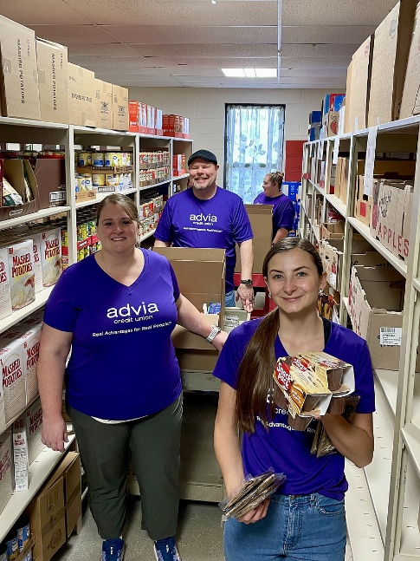
Advia Credit Union Responds to Nationwide SNAP Benefit Reductions with Community Support
Advia Credit Union is taking action to help combat food insecurity in response to the recent nationwide reductions in Supplemental Nutrition Assistance Program (SNAP) benefits. Recognizing the increased strain on local food pantries, Advia is implementing a multi-pronged approach to support the communities it serves.

In addition to local volunteerism at area food pantries, Advia is providing a $1,200 grant to local food pantries on behalf of each of its 34 branches, totaling $40,800 in support. These funds will enable pantries to purchase food in bulk at significantly reduced costs. For example, one pantry reported food costs averaging $0.63 per pound, meaning this donation could provide over 64,700 pounds of food to families in need.

“Food security is a core pillar of Advia’s social mission,” said Jeff Fielder, President and CEO of Advia Credit Union. “We’re committed to recognizing and responding to the evolving needs of our communities, not only in everyday moments, but especially during times of unexpected hardship. We’re proud to take meaningful action that helps advance lives.”

“Since the SNAP benefit cuts, we’ve seen a heartbreaking surge in families reaching out, many for the first time, desperate to put food on the table,” reported Stephanie McNees, Executive Director of Fish & Loaves in Taylor, MI. “Just last Saturday, over 100 additional families came through our drive through distribution. Advia’s generous gift will help us purchase more than 4,500 pounds of food, an essential lifeline as we work to meet this overwhelming demand. Their support is not just appreciated, it’s vital.”

Because the credit union is committed to giving back to the communities it serves, many Advia team members are using their ACTION (Advancing Community Ties in Our Neighborhoods) Hours to volunteer at area food pantries. This employee program provides team members with paid time to volunteer with charities that are meaningful to them. Annually, Advia team members volunteer over 6,000 hours locally which contributes over $200,000 in additional community impact from Advia locally.

An organization that the Advia team volunteers regularly is the Kalamazoo Loaves & Fishes food pantry within Douglass Community Center in Kalamazoo, MI. “We’ve seen the need for food continue to rise, and volunteers make all the difference in helping us keep up. Every hour someone gives to Kalamazoo Loaves & Fishes helps ensure that families in our community have access to the food they need. It’s really inspiring to see people step up to support their neighbors, and our work simply wouldn’t be possible without them. Volunteers are the backbone of our organization and we’re so grateful for Advia's continued commitment to volunteering with us. This long-standing partnership helps us in our fight against food insecurity.” stated Jill Bryant, Volunteer Coordinator of Kalamazoo Loaves & Fishes.

Members and the community may directly assist with the food insecurity facing our area by making a financial contribution to the Advia Foundation. Funds will be used to support efforts such as donations to area pantries. To donate, visit one of Advia’s local branches or visit Advia’s Foundation page online.

About Advia Credit Union: Advia Credit Union’s mission is to provide financial advantages to its members. With over $3.5 billion in assets, Advia seeks to provide quick and easy access to money and time-saving financial tools to 200,000 members in Michigan, Wisconsin, and Illinois. Advia’s team of 600 professionals delivers excellent service and innovative products at 34 locations and via digital and mobile platforms. Advia is guided by its core values: driving progress, acting with integrity, building and strengthening relationships, and keeping people at the core. Visit www.adviacu.org to learn more about how we provide Real Advantages for Real People™.

