Date: December 4, 2025

Contact: Rachel McKinley
Vice President of Marketing
207-520-2117
rmckinley@mainefamilyfcu.com

For Immediate Release

Maine Family Federal Credit Union Donates $15,000 to Support Hunger Relief in Maine

LEWISTON, ME — Maine Family Federal Credit Union is proud to announce three $5,000 donations to Good Shepherd Food Bank, High Street Food Pantry, and Seniors Plus. These contributions were made possible through funds raised as part of the credit union’s participation in the Campaign for Ending Hunger, a statewide initiative led by Maine’s Credit Unions to combat food insecurity.
“At a time when rising costs and the recent government shutdown are placing unprecedented strain on Maine families, we know that access to food is more critical than ever,” said Dan Clarke, President/CEO of Maine Family Federal Credit Union “We are honored to support these three outstanding organizations that work tirelessly to ensure our neighbors have access to nutritious meals and essential resources.”
Each organization expressed deep appreciation for the support:
High Street Food Pantry
“This generous donation from Maine Family FCU comes at a time when food insecurity is dramatically on the rise.” said Reverend Deborah Rogers Duval, Pastor at High Street Congregational Church. “Your donation will help us keep our shelves stocked so we can continue to serve our families with dignity and compassion.”
Seniors Plus
“We are incredibly grateful for this contribution,” said Betsy Sawyer-Manter, president and CEO at Seniors Plus. “Many older adults in our community are facing difficult choices between food, medication, and housing. This funding helps us ensure they don’t have to choose.”
Good Shepherd Food Bank
“Maine Family FCU’s support is a powerful example of community-driven impact,” said Heather Paquette, president at Good Shepherd Food Bank. “We are grateful for their generous donation that will help us distribute more meals across the state and reach those most affected by food insecurity.”
Representatives from the Credit Union met with each organization to personally present the donation and express their appreciation for the vital work being done across the region.
For more information about Maine Family Federal Credit Union and its community initiatives, please visit https://www.mainefamilyfcu.com/community-involvement.

###
About Maine Family Federal Credit Union
Serving the community since 1938, Maine Family Federal Credit Union has assets of approximately $272 million and serves more than 18,500 members throughout Androscoggin County. The credit union has branches in Lewiston and Auburn, Maine.
PHOTO CAPTIONS:
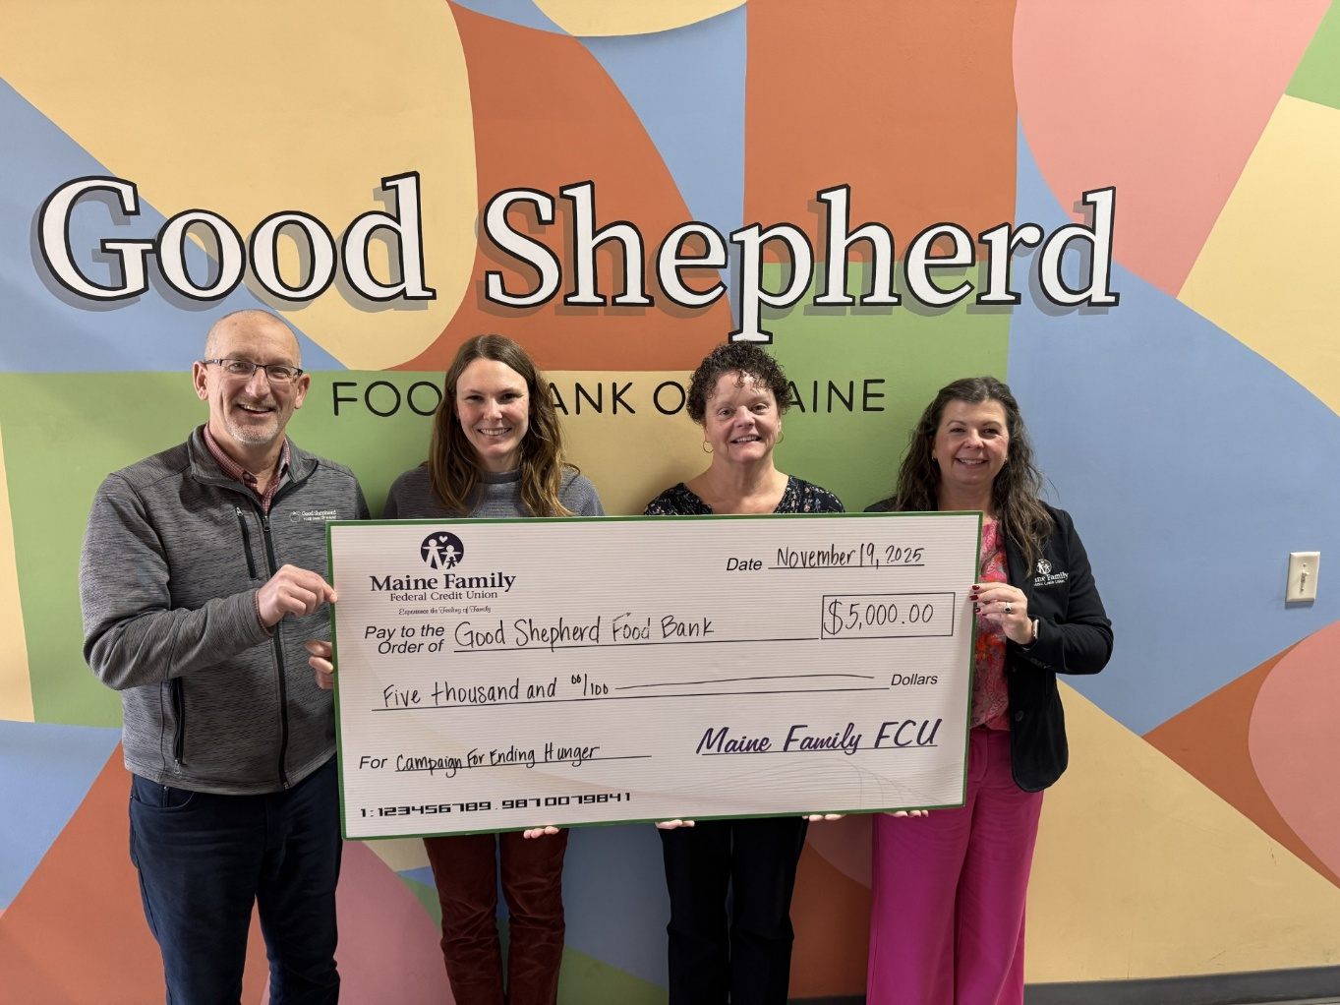
Good Shepherd Food Bank: L to R: Ethan Minton, Philanthropy Advisor and Katelyn Rice, Donor Engagement Specialist, Good Shepherd Food Bank; Christine Clabby, SVP/Chief Human Resources Officer, and Rachel McKinley, Vice President of Marketing, Maine Family Federal Credit Union.
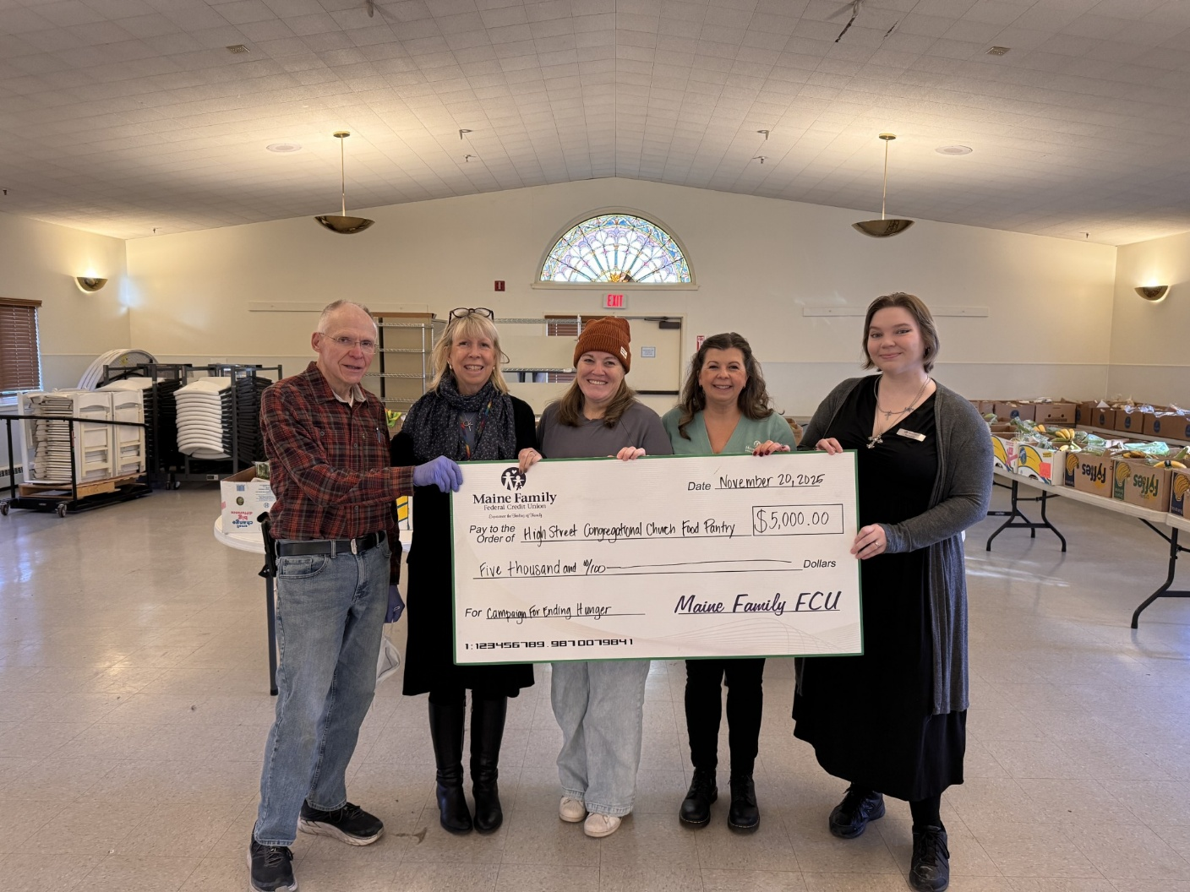
High Street Food Pantry: L to R: Don Miville, High Street Congregational Church Food Pantry Volunteer; Reverend Deborah Rogers Duval, High Street Congregational Church; Rachel McKinley, Vice President of Marketing, and Savannah Cheskawich, Member Services Specialist, Maine Family Federal Credit Union.

Seniors Plus: L to R: Rache McKinley, Vice President of Marketing, Maine Family Federal Credit Union; Betsy Sawyer-Manter, President and CEO, Seniors Plus.

