
For Immediate Release

December 18, 2025

Contact: Sandra Jones, SVP Communications, communications@ncsecu.org

SECU Contributes $125,000 to Support Hunger Relief Efforts in Western North Carolina

ASHEVILLE, N.C. – State Employees’ Credit Union (SECU) has provided a $125,000 donation to MANNA FoodBank to support hunger relief efforts in Western North Carolina, a region still recovering and rebuilding more than a year after Hurricane Helene.
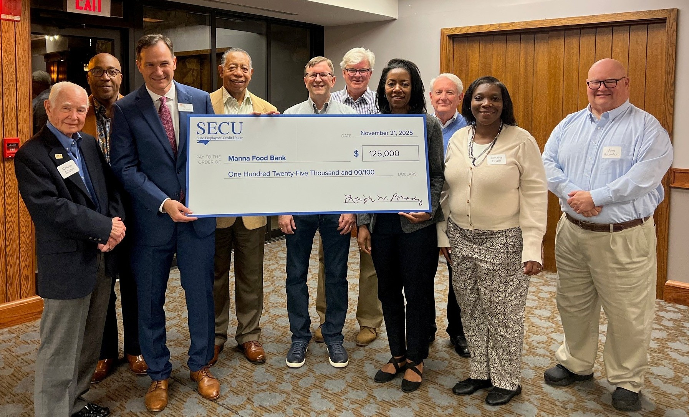
Holding the check are MANNA FoodBank Chief Development Officer Joe Beckler and SECU Board Chair Stelfanie Williams, joined by members of the SECU Board of Directors.

MANNA FoodBank played a vital role in supporting Western North Carolinians after Helene, delivering food to those who had experienced incredible hardship. The organization continues to play a critical role in disaster recovery by ensuring families have consistent access to nutritious food throughout the region.

SECU’s contribution will support food assistance across 16 counties, including the Qualla Boundary, and reflects SECU’s ongoing commitment to making a positive impact on the friends, families, and neighbors in the communities it serves.

“State Employees’ Credit Union’s contribution will make a meaningful difference for thousands of North Carolinians,” said MANNA FoodBank CEO Claire Neal. “As our region continues to recover from Hurricane Helene, and with many resources cut or reduced, our team at MANNA FoodBank is working tirelessly to ensure that our neighbors do not have to worry about where their next meal will come from or when that will be. We could not do that without the support from organizations like SECU.”

For every dollar donated, MANNA FoodBank provides four meals to individuals facing food insecurity. Through its alliance of more than 200 partner agencies – including food pantries, shelters, care centers, and other human service organizations – MANNA FoodBank distributes over 50,000 pounds of food each day and now serves an estimated 130,000 people monthly.

“We are grateful to be able to support the integral work MANNA FoodBank is doing to serve the people of Western North Carolina,” said SECU Board Chair Stelfanie Williams. “They have been a force for good in the area for more than 40 years, including an incredible effort after Hurricane Helene that continues to the present. We are honored to support this work which embodies our credit union philosophy of People Helping People®.”

###

About SECU
As a not-for-profit financial cooperative owned by its members and federally insured by the National Credit Union Administration (NCUA), SECU has been providing employees of the state of North Carolina and their families with consumer financial services for 88 years. SECU is the second largest credit union in the United States with $58 billion in assets. It serves more than 2.9 million members through 275 branch offices, 1,100 ATMs, Member Services Support via phone, www.ncsecu.org, and the SECU Mobile App.

