Congressman Darin LaHood Awarded Illinois Credit Union League 2025 Credit Union Legislative Champion

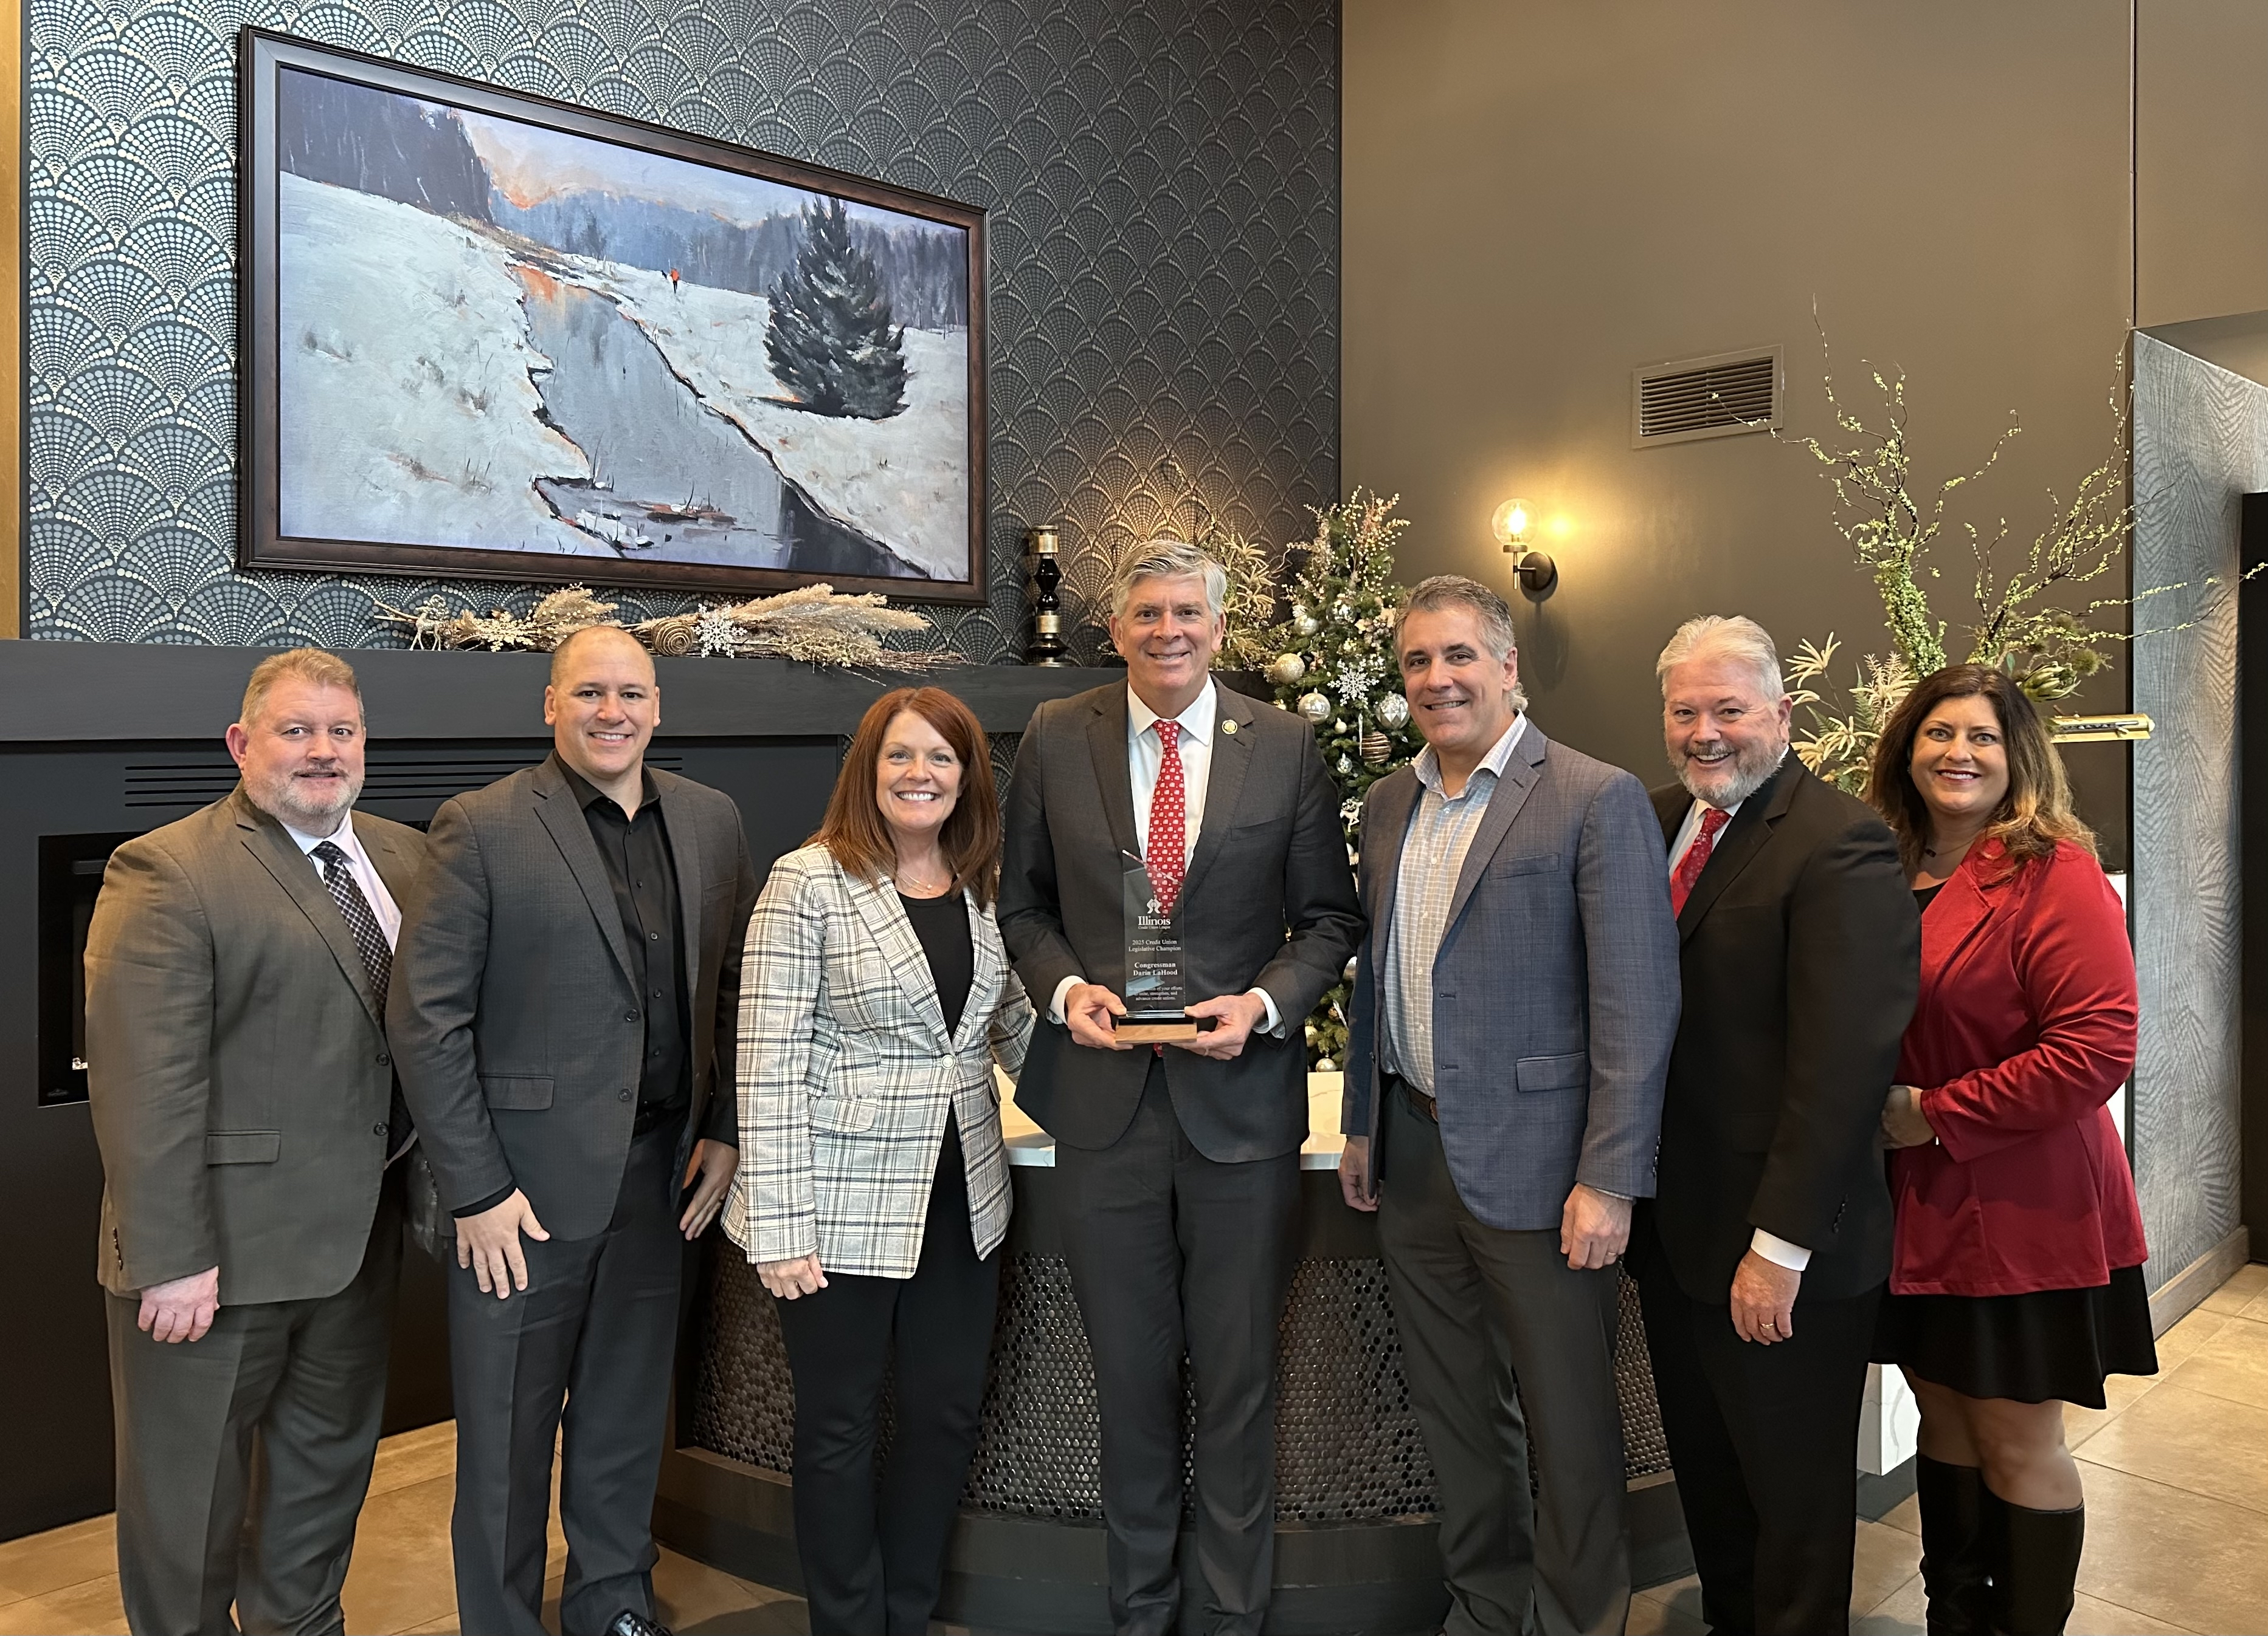
Peoria, Illinois – December 23, 2025 – The Illinois Credit Union League (ICUL) is proud to announce that Congressman Darin LaHood (R-16, Peoria), has been named ICUL’s first Federal Credit Union Legislative Champion for his exceptional leadership, dedication, and significant contributions to the credit union movement.
Over the past year, Congressman LaHood has played a key role in advancing issues critical to credit unions, including efforts to protect the industry’s tax-exempt status and ensure credit unions can continue serving their members and communities.
“We are truly grateful for Congressman LaHood’s leadership in Congress. We appreciate his knowledge and understanding of issues important to the credit union industry,” said Libby Calderone, CEO & President, Illinois Credit Union League. “The strong support of leaders like Congressman LaHood will ensure that credit unions can continue to meet the financial needs of consumers across Illinois.”
As a member of the House Ways and Means Committee, Congressman LaHood has consistently advocated for policies that preserve access to affordable financial services. According to America’s Credit Unions, more than 300,000 credit union members live within Congressman LaHood’s congressional district, underscoring the significant impact of his advocacy on the communities he represents.

“Congressman LaHood has been a champion for credit unions,” said Matt Mamer, President & CEO of CEFCU. “His service on the Ways and Means Committee and the leadership he has provided in furthering credit union initiatives has ensured affordable financial options remain available for his constituents.”
“Congressman LaHood has always been a strong voice for credit unions and the members we serve. From supporting our tax status and modernizing boards to championing legislation that expands financial access for our community, he has made a real impact,” said Joe Webb, President/CEO of Cooperative Choice Network Credit Union. “With a substantial portion of our membership residing within his district, we are thrilled to learn he will be Illinois’s first-ever Federal Credit Union Champion.”

Illinois credit unions are not-for-profit, member-owned financial institutions guided by the philosophy of helping people. They provide consumers with competitive rates, lower fees, and a strong commitment to community. The Illinois Credit Union League continues to advocate for a legislative and regulatory environment that allows credit unions to thrive and meet the evolving needs of their members.
"It is an honor to be named Illinois' first-ever Federal Credit Union Legislative Champion," said Rep LaHood. “Credit unions play a vital role in communities throughout the 16th District, strengthening small businesses, supporting families' financial goals, and reinvesting directly in the communities they serve. I look forward to continuing to work with the Illinois Credit Union League to help deliver financial certainty and security for Illinoisans."

###

About the Illinois Credit Union League
The Illinois Credit Union League is the trade association for over 200 state and federal credit unions in Illinois. It focuses on providing legislative and regulatory advocacy, compliance assistance and information, and a wide range of educational and training services to those credit unions, who in turn serve approximately 4.1 million members. More information can be found at www.icul.com.

