SchoolsFirst FCU Brings Holiday Cheer to Rady Children’s Health

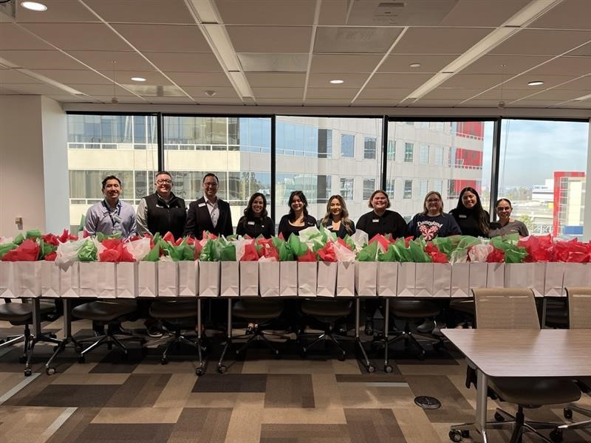

This holiday season, SchoolsFirst Federal Credit Union supported Rady Children’s Health (formerly Children’s Hospital of Orange County) with a $10,000 contribution to help sponsor holiday gift bags for patients in the NICU and Mental Health unit.

With this support, SchoolsFirst FCU volunteers assembled 145 gift bags for children and families, including 125 bags for infants in the NICU and 20 bags for patients in the Mental Health unit. Each bag included toys, activities and items designed to bring comfort during a challenging time. This initiative reflects SchoolsFirst FCU’s ongoing commitment to the well-being of the communities it serves, especially during the holidays.

Insured by NCUA.

