Los Angeles Mid-City Branch Extends SchoolsFirst FCU’s Footprint to 72 Branches Across California


On December 22, SchoolsFirst Federal Credit Union opened a new branch in Los Angeles, extending its footprint to 72 branches in California. The branch team celebrated by welcoming their first Member, Brett. Located in the heart of the city, the Credit Union is making it more convenient for Members to do business within the communities where they live and work.
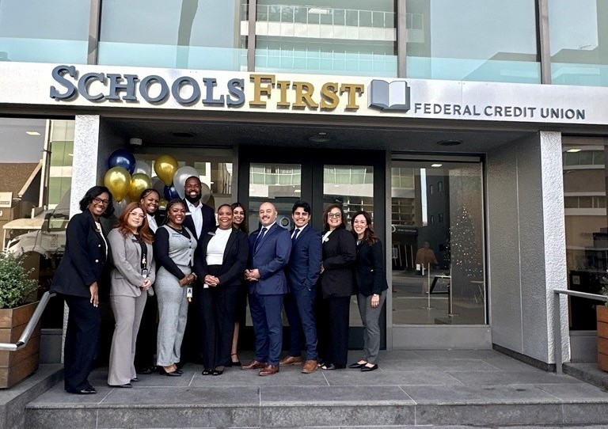

The Los Angeles Mid-City Branch team opened their doors on Dec. 22. The team celebrated the holiday season welcoming Members to its 72nd branch location, conveniently situated within a community where SchoolsFirst FCU Members live and work.

Insured by NCUA.

