

PRESS RELEASE
FOR IMMEDIATE RELEASE

Contact: December 5, 2025

Carla Keister

Phone: 866-56-TOWER, ext. 7144

Email: carla.keister@towerfcu.org

TowerCares Foundation Surpasses $4 Million in Donations, Grants and Scholarships to Support Military Heroes and Children in Need

The TowerCares Foundation has provided over $4 million dollars to over 140 charitable organizations supporting active military, Veterans, and children in need since its inception in 2015.
[Laurel, Md.- December 5, 2025] The holidays got a little brighter recently for Neighbor Ride, a charity based in Howard County, Md., that provides rides for elderly Veterans in need through a reliable network of volunteers, many of whom are also Veterans. Neighbor Ride received a special $10,000 donation from the TowerCares Foundation, the philanthropic arm of Tower Federal Credit Union.
“We are deeply grateful to the TowerCares Foundation for their award of $10,000 to Neighbor Ride,” said Bruce Fulton, Executive Director. “Over the past year alone, Veteran passengers received nearly 1,000 free trips, while Veteran volunteers provided almost 500 trips for local seniors—connecting Veterans in our community to care, groceries, and social activities. [The TowerCares donation] not only helps us serve Veterans today but also inspires us to expand this vital program for tomorrow. Together, we are reducing isolation, ensuring access to essential resources, and creating meaningful ways to serve.”
$4 Million In Giving to Help Military, Veterans, and Children in Need
The donation was part of a $40,000 donation to four local charities to celebrate TowerCares reaching a major milestone—over $4 million in grants, donations, and scholarships supporting military heroes, Veterans, and children in need across the Baltimore/Washington community.
Along with Neighbor Ride, the Boys & Girls Clubs of Annapolis & Anne Arundel County, the Fort Meade Alliance Foundation, and Horizon Day Camp, each received $10,000 from TowerCares.
“We are honored to support these outstanding local charities that embody our mission,” said Rick Stafford, TowerCares Foundation President. “All four of these inspiring organizations are making a real difference in our community and this donation will help them continue the amazing work they do.”
Supporting Local Children and Families
Upon learning of the special donation, the Boys & Girls Club of Annapolis & Anne Arundel County Director of Resource Development Loren Weisman expressed gratitude for TowerCares’ ongoing support through the years.
“[We] are truly grateful for the longtime support of TowerCares,” she said. “Thanks to your generosity, BGCAA can provide safe, welcoming places where kids can be supported, build positive friendships, explore new interests, and grow in confidence. Your support helps every one of our members discover their potential through academic support, career readiness, and programs that build character and leadership. And every family in our community has a partner, standing with them as they raise thriving children.”
Tower Employees Picked the Winners!
Stafford said Tower employees played a vital role in reaching the $4 million milestone through volunteerism, fundraising, and ongoing support. In recognition of these contributions, employees were given the opportunity to vote for the four charities to receive the special donation.
“Tower employees have been enthusiastic champions of TowerCares from the start,” Stafford said. “Giving them the opportunity to select the winning charities is our way of saying ‘thank you’ for their support and helps ensure our giving reflects the compassion and commitment of the people who make our mission possible.”
Founded in 2015, TowerCares has provided support for over 140 charitable organizations and awarded over $700,000 in college scholarships to students pursuing careers in STEM fields. To learn more about TowerCares and the charities we support, visit towercaresfoundation.org.
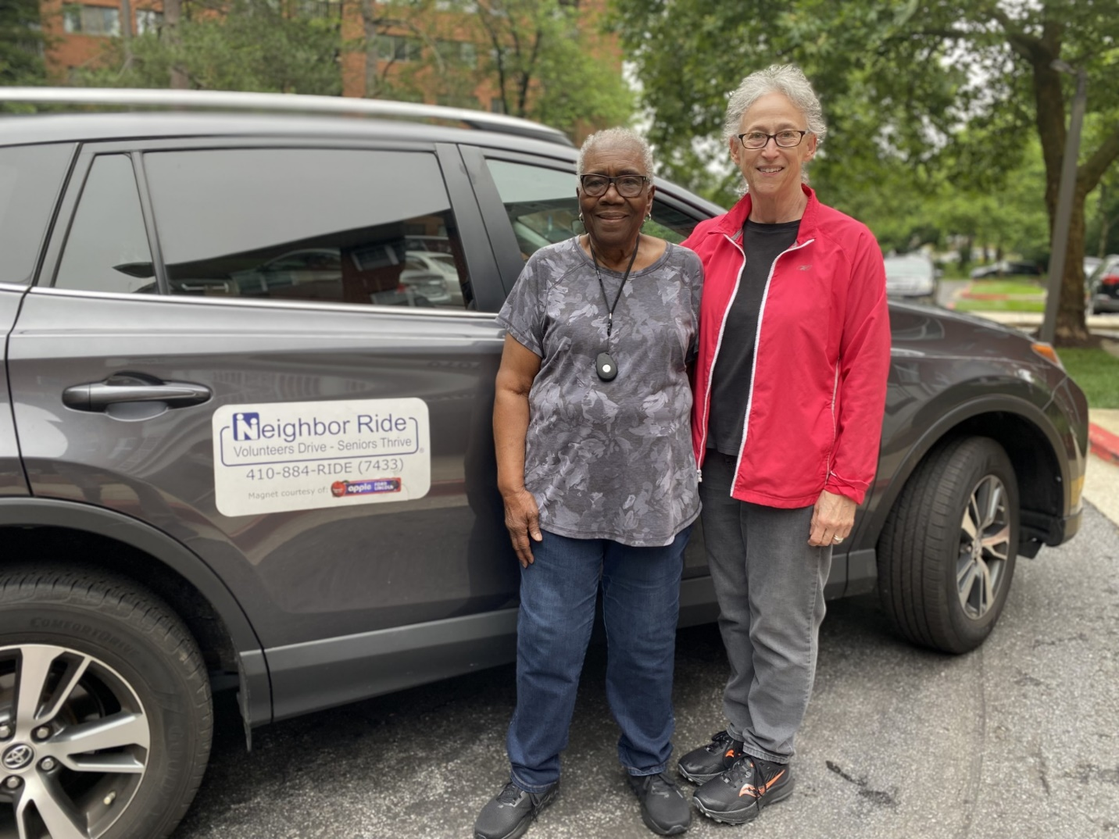
Photo Caption: The TowerCares Foundation helped brighten the holidays for four Maryland charities with a special $40,000 donation. Neighbor Ride (pictured)—a nonprofit that provides rides for elderly Veterans in Howard County through a reliable network of volunteers, many of whom are also Veterans—along with the Boys & Girls Clubs of Annapolis & Anne Arundel County, the Fort Meade Alliance Foundation, and Horizon Day Camp each received $10,000 from the TowerCares Foundation, the philanthropic arm of Tower Federal Credit Union. The special donation was in celebration of TowerCares’ charitable giving surpassing the $4 million mark in donations, grants, and scholarships to support military heroes, Veterans, and children in need. Even more special, Tower employees selected the charities to receive the special donation. To learn more, visit towercaresfoundation.org. [Photo credit: Neighbor Ride]

About the TowerCares Foundation:
Headquartered in Laurel, Md., the mission of the TowerCares Foundation is to support children in need as well as the brave and heroic individuals who have sacrificed while protecting our freedom. TowerCares creates programs and supports well-vetted charities that are in alignment with our mission. Since our inception in 2015, the TowerCares Foundation has provided over $4 million in grants, donations, and scholarships. The TowerCares Foundation is a 501(c)(3) charitable organization, and a participating charity in the Combined Federal Campaign (#23594) and Maryland Charitable Campaign (#47-4164006). Donations are tax-deductible. We are a platinum-level GuideStar participant, demonstrating our commitment to transparency. For more information, visit towercaresfoundation.org.

###

