FOR IMMEDIATE RELEASE
TAPP Engine’s 9Squid Private Markets: First to Democratize Securitization for All Credit Unions*
Sub-Header:
9Squid Private Markets* by TAPP Engine expands access to institutional capital for credit unions and community finance institutions, targeting a market opportunity exceeding $5.8 trillion^{1,2} through an AI-driven securitization platform.
[QUINCY, MA] | [February 5, 2026]
9Squid Private Markets, a subsidiary of TAPP Engine, today announced the launch of an AI-powered private markets platform built for credit unions and community finance institutions of all asset sizes, including community and regional banks. The platform delivers loan securitization, providing a streamlined and lower-friction path to institutional investors through a private distribution framework.
Securitization for All
U.S. credit unions hold approximately $2.4 trillion in assets and more than $1.7 trillion in consumer loans, according to the latest report on federally insured credit unions from National Credit Union Administration (NCUA)¹. Community finance institutions, including community and regional banks, hold an additional $6 trillion in assets and over $4.1 trillion in consumer, small business, and commercial loans, according to the Independent Community Bankers of America (ICBA)². Despite this scale, securitization remains underutilized due to cost, structural complexity, and minimum size thresholds. As a result, many institutions have historically been excluded from institutional private credit markets. 9Squid is designed to reduce these barriers and enable faster, more efficient access to institutional capital. To view platform details visit https://www.9squid.ai
“Community institutions play a central role in capital formation, yet many have been priced out of securitization markets,” said Tosin Osunsanya, Founder and CEO of TAPP Engine. “9Squid brings securitization, balance sheet modeling, in AI-powered platform built for credit unions and community finance institutions of all sizes. It provides a repeatable and efficient path to institutional capital while preserving cooperative governance and relationship banking.”
Securitization Simplified
A core capability of the platform is balance sheet impact simulation and optimization. Institutions can evaluate securitization scenarios prior to execution, including projected impacts on liquidity, capital ratios, earnings, and concentration exposure. This enables disciplined decision-making, and positions securitization as an ongoing balance sheet management tool rather than a one-time transaction.
“What stood out was the ability to understand balance sheet outcomes before committing to a transaction,” said Michael Massey, President of TDECU Holdings. “That level of visibility allows credit unions to evaluate securitization as a practical and repeatable balance sheet strategy.”
9Squid also offers a programmatic alternative to traditional loan participation. Instead of relying on resource-intensive bilateral or club-based participations, credit unions and community finance institutions can use repeatable securitization to manage liquidity, growth, and risk, with direct distribution to institutional investors through the platform.
The platform currently supports securitization of personal loans, auto loans, and home equity lines of credit using regulator-aligned structures.
Five credit unions are in the initial pipeline, with broader onboarding planned for credit unions and community finance institutions of all sizes.
For information regarding a partnership, please contact Joel Vanovitch at joel.vanovitch@tappengine.com.

About 9Squid Private Markets
Website: https://www.9squid.ai
9Squid Private Markets is a private credit and securitization platform built for credit unions and community finance institutions of all sizes. As a subsidiary of TAPP Engine, it combines asset-backed securitization, balance sheet optimization, and direct institutional investor access to support faster and more efficient capital formation in community finance.
*9Squid Private Markets, LLC. is in the process of seeking registration as a broker-dealer with FINRA. During this period, all traditional securities are offered through TAPP Engine Securities, LLC, a registered broker-dealer and member FINRA and SIPC.
About TAPP Engine
Website: https://www.tappengine.com/
TAPP Engine modernizes capital formation, wealth management, and liquidity infrastructure for credit unions, community finance institutions, and regional financial institutions.
Website:
https://www.9squid.ai
Media Contact:
Deanne Figueras
deanne@tappengine.com
Partnership Contact:
Joel Vanovitch
joel.vanovitch@tappengine.com
Sources:
1. National Credit Union Administration (NCUA). (2025, September), Q3 call report data. https://ncua.gov/analysis/credit-union-corporate-call-report-data
2. Independent Community Bankers of America (ICBA). (2026) ICBA About Community Banking. https://www.icba.org/about
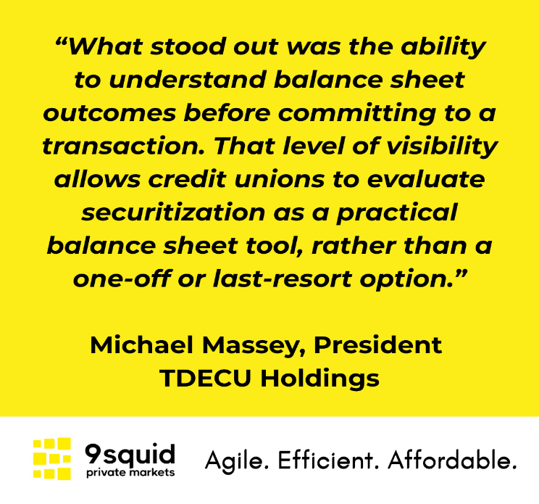

SOCIAL MEDIA RELEASE
🚀 Securitization, Reimagined for Credit Unions
The landscape for institutional capital access is evolving. We're proud to share insights into how TAPP Engine’s 9Squid Private Markets is set to redefine efficiency in this space. We're working to remove traditional barriers, fostering a more streamlined and faster path to institutional funding. This initiative aims to truly empower growth and accelerate opportunities for all credit unions regardless of size.
👉 Discover the full story behind this exciting development.
Securitization no longer has to be complex, expensive, or out of reach.
#CreditUnions #Securitization #PrivateMarkets #BalanceSheetStrategy #FinTech #FutureOfFinance
