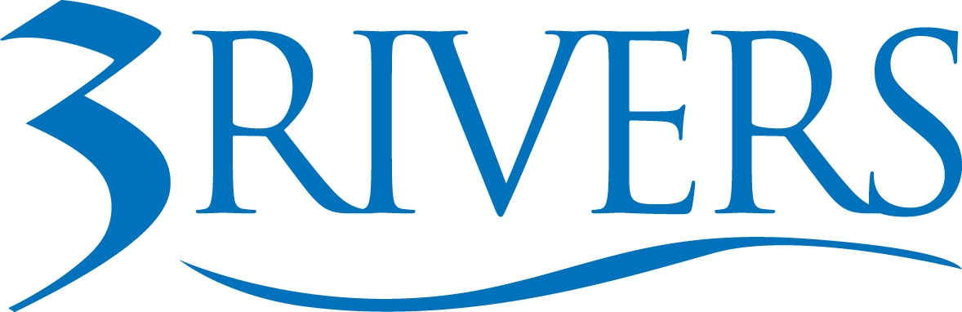 ***PRESS RELEASE***

Date: March 20, 2026
Contact: Aly Hess
Marketing Content Manager
Phone: 260.224.5697
Email: ahess@trfcu.org
For Immediate Release
Women Make Up 60% of Workforce at 3Rivers Federal Credit Union
Credit union highlights mentorship programs, leadership development, and family-friendly benefits that help women grow and lead.
Fort Wayne, Ind. — Women make up 60% of the workforce at 3Rivers Federal Credit Union, serving in roles across the organization from frontline team members to leadership and governance. The credit union was recently recognized for the second consecutive year by the Women’s Fund of Greater Fort Wayne, earning Bronze status on the 2025 Women in the Workplace Employer Scorecard.
The recognition reflects the role credit unions play in creating workplaces where women can build careers, advance into leadership, and contribute to stronger communities. The announcement also comes during Women’s History Month, which highlights the contributions and achievements of women in workplaces and communities across the country.
The annual scorecard evaluates employers across four key areas tied to gender equity: leadership representation, compensation practices, workplace benefits and policies, and equitable recruitment and retention strategies. 3Rivers met or exceeded criteria in several key areas, including benefits and workplace policies, where the credit union achieved full marks.
Women represent a significant presence across roles at 3Rivers—from interns and frontline team members to leadership and governance positions, including 33% representation on the credit union’s Board of Directors today. Women also hold 57% of middle management roles across the organization, reflecting a strong pipeline for future leadership.
“Organizations are stronger when women have opportunities to grow and lead,” said Lyndsey Emerick, SVP of Financial Strategy at 3Rivers. “At 3Rivers, we invest in mentorship, leadership development, and benefits that support employees at work and at home so they can build meaningful careers while serving our members and communities.”
Supporting Career Growth and Development
3Rivers offers a range of programs and workplace policies designed to support career advancement, financial stability, and work-life balance for employees.
Initiatives include a range of programs and benefits that align with or exceed scorecard criteria, including:
- Mentorship programs that connect employees with experienced leaders for guidance and career development
- High-potential leadership development programs and Individual Development Plans (IDPs) designed to help employees build skills and prepare for leadership opportunities
- Tuition reimbursement and continuing education support to help employees pursue further education or professional certifications
- Financial wellness resources and retirement planning support, helping employees build long-term financial stability
- Conducted a race and gender wage gap analysis within the past five years as part of an ongoing commitment to equitable compensation practices
- Paid parental leave and caregiving support, including dependent care flexible spending accounts, helping employees balance career growth with caregiving responsibilities
- Workplace policies that prioritize safety, respect, and inclusion, including strong protections against harassment and discrimination

Together, these efforts support an environment where all employees can build meaningful careers while contributing to the credit union’s mission of serving members and strengthening communities.

These efforts reflect 3Rivers’ broader commitment to creating a workplace where employees can grow professionally, pursue leadership opportunities, and balance the responsibilities of work and life.

“Supporting women in the workplace means creating real opportunities for growth and balance,” said Jennie Gerken, AVP of Talent Development at 3Rivers. “Through professional development programs and benefits like paid parental leave and dependent care FSAs, we help employees build meaningful careers while balancing the responsibilities of work and life.”

Investing in People Strengthens Communities

Organizations that prioritize equitable workplaces contribute not only to employee well-being but also to stronger communities and local economies.

“Serving on the board as a woman is meaningful because different perspectives strengthen the decisions organizations make,” said Britny Berndt, a member of the 3Rivers Board of Directors. “Seeing women represented throughout 3Rivers—from the workforce to leadership and governance—reflects a culture that values opportunity and strengthens the communities we serve.”

Leaders say investing in employees ultimately strengthens the credit union’s ability to serve members and communities.

By prioritizing career growth, leadership development, and family-friendly workplace benefits, the credit union continues to create opportunities for employees to thrive while delivering meaningful impact across Indiana and Ohio.

About 3Rivers: 3Rivers Federal Credit Union empowers our community to achieve financial wellness through personalized service, tools, and education. Founded in 1935, 3Rivers is a member-owned, not-for-profit, cooperative that serves over 135,000 members with 24 branches and over 500 employees. 3Rivers offers a complete line of financial services, including mortgages, business services, college funding, and retirement planning. For more information, including how we give back and invest in our community, visit www.3riversfcu.org/community.

