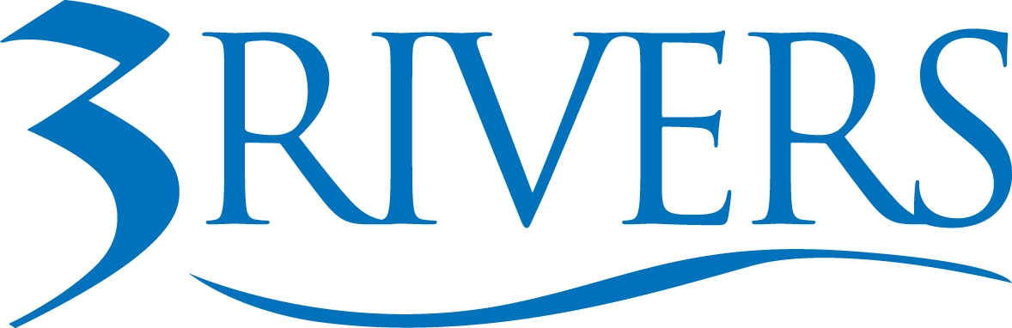 ***PRESS RELEASE***

Date: March 5, 2026
Contact: Aly Hess
Marketing Content Manager
Phone: 260.224.5697
Email: ahess@trfcu.org
For Immediate Release
3Rivers Credit Union Foundation Awards $69,400 to 22 Nonprofits
Funding supports programs focused on financial literacy, education, and health across Indiana and Ohio.
Fort Wayne, Ind. — The 3Rivers Credit Union Foundation has awarded $69,400 in grants to 22 nonprofit organizations across northeast and central Indiana and Ohio.
The funding will help expand programs serving individuals and families across the region. For example, Blue Jacket helps individuals reenter the workforce after incarceration and build financial stability, Healthier Moms and Babies supports maternal and infant health, and Science Central provides hands-on STEM learning opportunities for youth.
“When local nonprofits have the resources to expand their work, the entire community benefits,” said Tim Sheppard, President of the 3Rivers Credit Union Foundation and CFO of 3Rivers Federal Credit Union. “Supporting organizations that help people learn, stay healthy, and strengthen their financial well-being is one of the most meaningful ways we can invest in the communities we serve.”
Organizations receiving funding in this cycle include:
- Alternatives Incorporated
- Blue Jacket, Inc.
- Camp Red Cedar
- Cancer Services of Northeast Indiana
- Communities In Schools of Wayne County
- Covenant Concepts, Inc.
- Fort Wayne Dance Collective
- Good News Habitat for Humanity
- Healthier Moms and Babies
- History Center (Allen County – Fort Wayne Historical Society)
- Homebound Meals, Inc.
- House of Pins Adaptive Recreational Venue Company
- Judy A. Morrill Recreation Center
- Lutheran Social Services of Indiana
- McMillen Health
- Mental Health America of Northeast Indiana
- Science Central
- Servants at Work (SAWS)
- Teach Our Children Fund Inc. dba Fort Wayne Center for Learning
- Women's Fund of Greater Fort Wayne
- Wood Block Press
- Yorktown Community Schools Foundation
The 3Rivers Credit Union Foundation, established in 2015, awards quarterly grants to nonprofit programs aligned with its focus areas of financial literacy, education, and health and wellness.
Since its founding, the Foundation has awarded more than $2 million to over 142 nonprofit organizations, supporting programs that strengthen communities across Indiana and Ohio.
Organizations interested in applying for future funding opportunities or learning more about the Foundation can visit 3riversfcu.org/foundation.
About 3Rivers: 3Rivers Federal Credit Union empowers our community to achieve financial wellness through personalized service, tools, and education. Founded in 1935, 3Rivers is a member-owned, not-for-profit, cooperative that serves over 135,000 members with 24 branches and over 500 employees. Offering a complete line of financial services, including mortgages, business services, college funding, and retirement planning. For more information, including how we give back and invest in our community, visit www.3riversfcu.org/community.

