Illinois Credit Union League Announces Board of Directors and Officers

Naperville, IL. April 21, 2026 – The Illinois Credit Union League (ICUL) today announced the results of its 2026 Board of Directors election following the League’s Annual Delegates Meeting held April 14, 2026. These leadership updates reflect ICUL’s ongoing commitment to strong governance, statewide representation, and the development of future leaders within the credit union movement.

2026 Board Election Results
The following directors were elected to the ICUL Board:
- Chris Harlan, University of Illinois Community Credit Union (District 1, Class C)
- Suzie Bell, Elite Community Credit Union (District 2, Class A)
- Deborah Fears, Chicago Post Office Employees Credit Union (District 2, Class D)
- Darlyne Keller, Rock Valley Credit Union (District 3, Class B)
- Michael Abraham, Great Lakes Credit Union (District 3, Class D)
Suzie Bell and Darlyne Keller will continue their service as incumbent directors. Chris Harlan and Deborah Fears were elected to fill vacancies created by retiring directors, while Michael Abraham was elected to a one-year term.

The terms of Harlan, Bell, Fears, and Keller will run through the League’s 2029 Annual Meeting. Abraham’s term will run through the 2027 Annual Meeting.
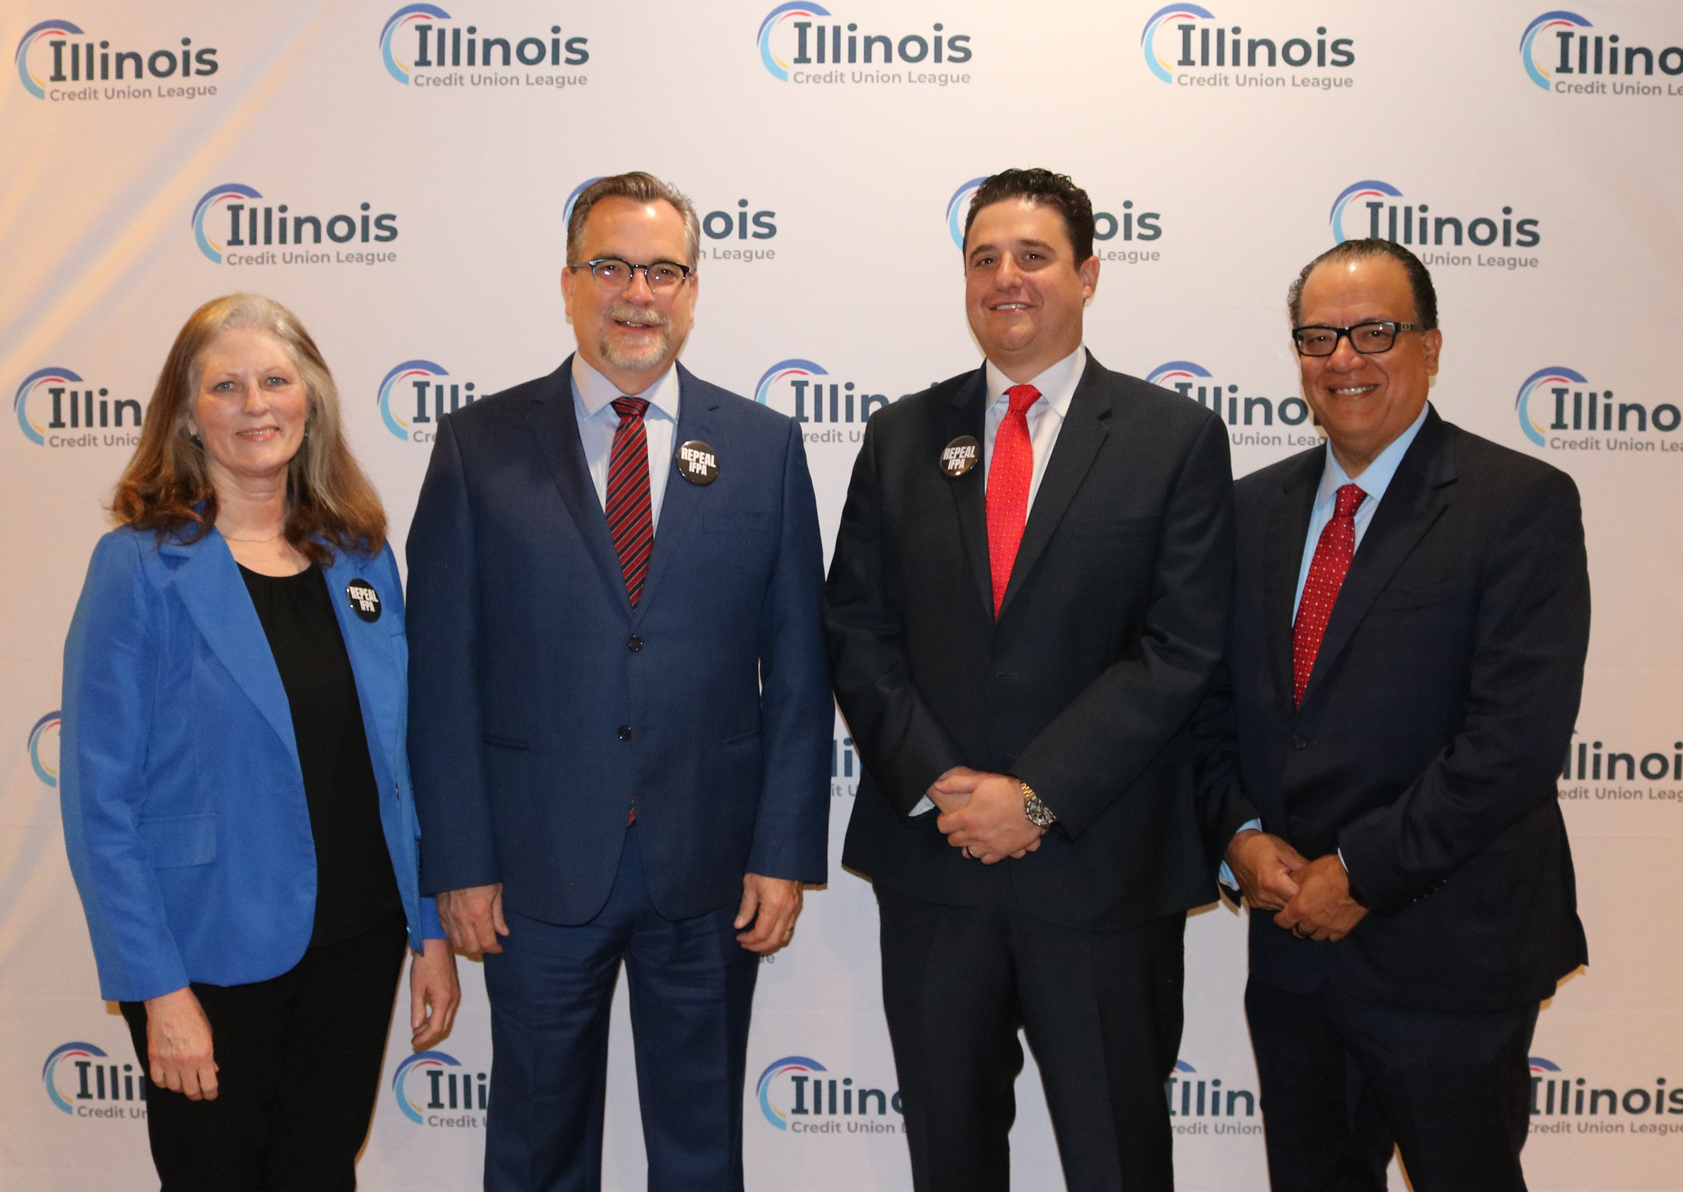
2026 Board Officers
For the 2026 term, the ICUL Board will be led by Chair Michael Abraham, alongside Vice Chair Jose Garcia, Treasurer Pete Fauth, and Secretary Darlyne Keller.

“Strong, engaged leadership is essential to advancing the mission of Illinois credit unions,” said Libby Calderone, President/CEO of ICUL. “This Board represents a diverse mix of experience, perspectives, and passion for our movement. We are especially proud to welcome new directors and to introduce our first Young Professional Associate Director—an important step in strengthening the future of credit union leadership in Illinois.”
Leadership Additions and Board Highlights
Jordan Harcharik, Training & Development Manager at Streator Onized Credit Union, has been named ICUL’s first-ever Young Professional Associate Director - an important milestone in the League’s commitment to developing future leaders.

Chris Harlan, CEO of University of Illinois Community Credit Union, and Deborah Fears, President/CEO of Chicago Post Office Employees Credit Union, join the ICUL Board as newly elected directors, each bringing strong leadership experience and a deep commitment to the credit union movement.

Joe Webb, CEO of Cooperative Choice Network Credit Union, joins the Envisant Board as a newly appointed director, bringing valuable industry perspective and strengthening alignment between the League and its service corporation.

Appreciation for Outgoing Directors
ICUL extends sincere appreciation to outgoing directors Joseph Kregul of HealthCare Associates Credit Union and Alan Meyer of 1st MidAmerica Credit Union. Their leadership and dedication have made a lasting impact on the League and the broader credit union community across Illinois.
With fresh perspectives, continued leadership, and a shared commitment to collaboration, ICUL looks forward to another impactful year serving Illinois credit unions and their members.
###

About the Illinois Credit Union League
The Illinois Credit Union League is the trade association for nearly 200 state and federal credit unions in Illinois. It focuses on providing legislative and regulatory advocacy, compliance assistance and information, and a wide range of educational and training services to those credit unions, who in turn serve approximately 4.1 million members. More information can be found at www.icul.com.

