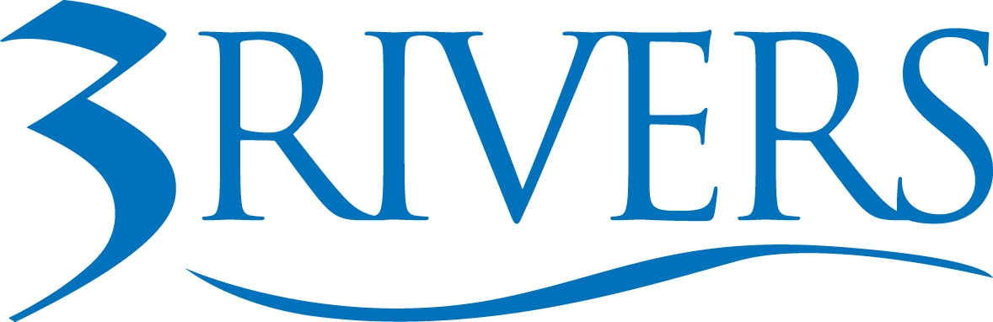 ***PRESS RELEASE***

Date: April 10, 2026
Contact: Aly Hess
Marketing Content Manager
Phone: 260.224.5697
Email: ahess@trfcu.org
FOR IMMEDIATE RELEASE
3Rivers Federal Credit Union, Junior Achievement, and Fort Wayne Community Schools Collaborate to Expand Real-World Financial Education Across Indiana
FORT WAYNE, Ind. — As Indiana moves toward a 2028 graduation requirement for personal financial responsibility, one challenge has become clear: while financial literacy is now mandated, no dedicated state funding was provided to support it.

In response, 3Rivers Federal Credit Union partnered with Junior Achievement of Northern Indiana and Fort Wayne Community Schools (FWCS) to help develop and implement a financial literacy curriculum designed to bring real-world money management into the classroom—before students need to rely on it.

Together, the organizations are working to close the gap between policy and practice, ensuring students have access to meaningful, relevant financial education.

A Collaborative Model Built to Work in the Classroom

Through a multi-year collaboration, 3Rivers, Junior Achievement, and FWCS combined their expertise to create a curriculum grounded in real-life application:

- Junior Achievement’s established financial education frameworks
- 3Rivers’ subject-matter expertise, content development, and ongoing access to financial professionals
- FWCS educators’ leadership in curriculum design, classroom integration, and real-world testing
As the implementing partner, FWCS played a critical role in bringing the curriculum to life—helping shape, test, and refine it to ensure it works for both educators and students.

3Rivers contributed not only financial expertise, but also a library of real-world content—including articles, videos, and educational resources—along with ongoing access to team members who support classroom instruction, lead sessions, and provide subject-matter insight as needed.

In addition to meeting Indiana’s graduation requirements, the program also offers students the opportunity to earn college credit through Purdue University Fort Wayne. Students who meet academic proficiency standards are eligible to earn three credit hours for BUS 26000: Personal Finance.

Alongside its hands-on involvement, 3Rivers recently committed an additional $300,000 in support of Junior Achievement’s mission—helping expand access to financial education across the region and accelerate efforts ahead of the 2028 requirement.

Over the past year, the curriculum has been successfully piloted in Fort Wayne Community Schools and other area classrooms, with growing interest from districts across the region. As the program continues to evolve, it is well-positioned to expand in alignment with district needs and the state requirement.

The result is a model that works locally—and can scale.

“Confidence doesn’t come from a single lesson. It comes from consistent exposure and the chance to apply what you’ve learned in real situations,” said Don Cates, President & CEO at 3Rivers. “We often think about education in terms of what’s taught, but what sticks is what’s used. When financial concepts are introduced early and reinforced through real-life context, they become something students can carry with them long after the classroom.”

At a recent press conference, Cates emphasized the importance of relevance in education, asking how many in the room had taken advanced math courses in high school, and how many could still apply them today. Most hands dropped.

What people retain, he noted, is what they actually use.

Proven Impact and Growing Urgency

The need for accessible, effective financial education is not theoretical—it’s measurable.

Through JA Financial Literacy for Indiana, students are already showing significant gains in understanding key financial concepts. In Fall 2025 impact data, the percentage of students who understood the Rule of 72—a concept used to estimate how quickly money can double through compound interest—increased from 18% to 59%.

Early exposure to concepts like these can meaningfully influence long-term financial outcomes.

At the same time, the broader challenge remains: without dedicated funding, schools across Indiana are relying on partnerships like this one to meet the state’s requirement in a way that is both sustainable and effective.

“This is about more than meeting a requirement,” said Lena Yarian, President of Junior Achievement serving Northern Indiana. “It’s about making sure every student has access to financial education that truly prepares them for what’s ahead. When students can connect what they’re learning to real decisions, the impact is immediate and lasting.”

From Early Exposure to Real-World Application

3Rivers’ partnership with Junior Achievement has long included hands-on involvement in classrooms through programs like JA in a Day, where employees volunteer for a full school day to lead structured lessons on budgeting, earning, saving, and decision-making.

For many students, it’s their first meaningful exposure to financial concepts delivered through conversation, real-life examples, and direct interaction with professionals.

That learning is reinforced through immersive experiences like JA BizTown®, where students step into a simulated economy—earning paychecks, managing expenses, and making financial decisions in real time.

Junior Achievement’s long-standing expertise in experiential learning played a key role in shaping how the broader curriculum comes to life, bridging the gap between understanding and application.

Supporting Different Paths Forward

In recent years, 3Rivers has also expanded its partnership with FWCS through support of the district’s Amp Lab at Electric Works, where students explore career pathways through hands-on, real-world learning.

Amp Lab reflects a shift already happening among students. While four-year college remains one path, more students are exploring alternatives, including trade programs, certifications, or entering the workforce directly.

Through its Youth & College Support Team and subject-matter experts, 3Rivers works with students to connect financial education to those decisions—what it means to pay for school, manage income, or weigh different paths based on both personal goals and financial realities.

The focus isn’t on steering students toward a single outcome, but on helping them make informed decisions that align with their lives.
“Student success doesn’t follow one path… and it shouldn’t,” said Riley Johnson, Principal at Amp Lab. “Amp Lab gives students the opportunity to explore what’s right for them, and this partnership helps ensure they’re prepared for what comes next.”

“We’re seeing students ask different questions than they did even a few years ago—about trade careers, certifications, or going straight into the workforce,” said Jordan Hersey, Youth & College Advisor at 3Rivers. “Our role is to meet them there and help them understand what those choices mean financially, so they can move forward with confidence.”

Reframing Financial Education

For 3Rivers, the work reflects a broader belief: financial education is most effective when it starts early, feels relevant, and is reinforced over time.

“We think of financial literacy as something people need, but too often, it shows up after the moment they needed it most,” said Aly Hess, Marketing Content Manager at 3Rivers.

“This is about shifting that and giving students something to hold onto before the first paycheck, the first decision, the first ‘I wish I had known.’ And just as importantly, it’s about making sure what we’re teaching reflects real life—how money feels, how it functions, and how it shows up in everyday decisions. That’s where it becomes something lasting.”

A Model Others Can Build On

As financial literacy requirements expand, the partnership between 3Rivers, Junior Achievement, and FWCS offers a clear example of what’s possible when financial institutions, nonprofits, and school systems work together.

It’s a model designed to turn a requirement into something real.

About 3Rivers Federal Credit Union: 3Rivers Federal Credit Union empowers our community to achieve financial wellness through personalized service, tools, and education. Founded in 1935, 3Rivers is a member-owned, not-for-profit, cooperative that serves over 135,000 members with 24 branches and over 500 employees. Offering a complete line of financial services, including mortgages, business services, college funding, and retirement planning. For more information, including how we give back and invest in our community, visit www.3riversfcu.org/community.

