

PRESS RELEASE FOR IMMEDIATE RELEASE: April 14, 2026

MEDIA CONTACT:
Carla Keister
Senior MarCom Writer
301-497-7000, ext. 7144
carla.keister@towerfcu.org

Tower Federal Credit Union Hosts Free Shred Day

To Fight Fraud & Prevent Identity Theft

[April 14, 2026 – Laurel, MD] Tower Federal Credit Union hosted a free Shred Day on April 11, 2026, at its Laurel, Maryland branch, giving members and the community a secure way to dispose of sensitive documents and help prevent identity theft. The event drew a strong turnout, with more than 18,000 pounds of paper shredded—filling two large shred trucks.

“Shredding documents is a simple and effective way to protect against fraud and identity theft,” said Rick Stafford, Tower’s President & CEO. “Our annual Shred Days help our members safeguard their personal information in a fun and convenient way while raising awareness about fraud prevention.”

Attendees enjoyed free on-site shredding along with complimentary food, games, prizes, and giveaways. Representatives from Tower’s Real Estate Lending, Car Buying Service, and Wealth Management teams were also on-site to connect with members and share information about available services.

“Fraud prevention is a top priority for Tower and for our members,” Stafford added. “They showed up in a big way, and we’re proud to provide opportunities like this that have a meaningful impact.”

To learn more, visit towerfcu.org.

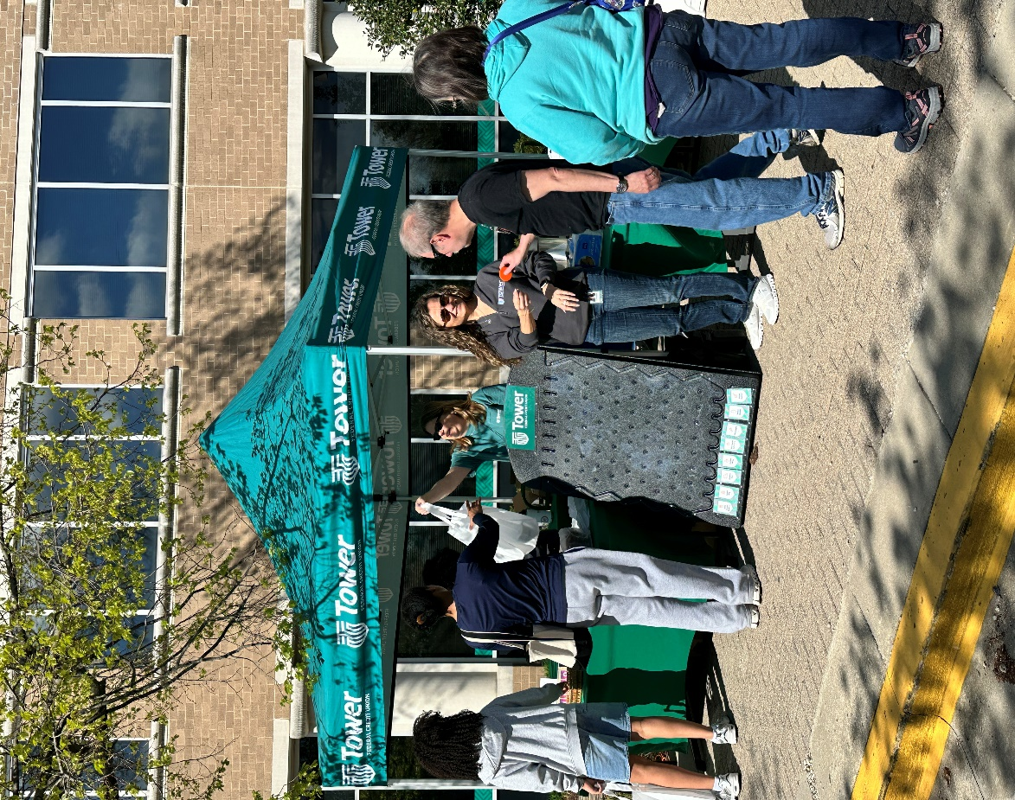
Photo Caption: Tower Federal Credit Union hosted a free Shred Day for members and the community on April 11, 2026 at its Laurel, Maryland branch to help raise awareness about fraud prevention and identity theft. Attendees enjoyed free on-site shredding along with complimentary food, games, prizes, and giveaways. More than 18,000 pounds of paper were shredded during the free event, filling two large shred trucks. [Photo credit: Tower Federal Credit Union]
###

About Tower Federal Credit Union
Tower Federal Credit Union is a member-owned, not-for-profit financial institution headquartered in Laurel, Maryland. Founded in 1953, Tower serves more than 215,000 members worldwide and manages over $5 billion in assets, making it one of the largest credit unions in Maryland. Tower offers a full range of financial products and services, with convenient access through local branches, online banking, and top-rated mobile app. Learn more at towerfcu.org.

