


Greater Texas|Aggieland Credit Union Earns
Three National Diamond Awards for Innovative Marketing

Austin, April 29, 2026 – Greater Texas|Aggieland Credit Union has been recognized for national excellence in marketing, earning three Diamond Awards from America’s Credit Unions Marketing, PR & Development Council. The credit union was honored for two distinct initiatives: the “Howdy Hunt” virtual reality experience and the “Operation Howdy” community branding campaign.

The Diamond Awards are prestigious honors in the credit union industry, recognizing creative excellence and strategic results. This year’s competition saw a record 1,481 entries from across the country, with only 181 organizations selected as winners.
Aggieland Credit Union received two awards for its "Reinventing Engagement: the Howdy Hunt VR Experience." The campaign won in the Cutting Edge category for its innovative use of augmented reality to engage Texas A&M students, and in the Community Partnerships and Endorsements category for its successful collaboration with local businesses and influencers.
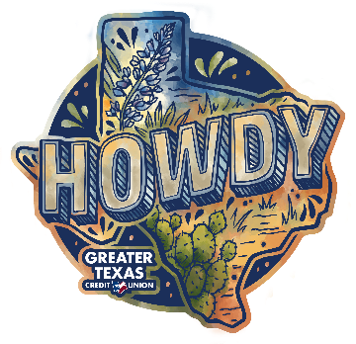
Greater Texas Credit Union earned its Diamond Award in the Logos category for "Drawing Connection: Operation Howdy & Community-First Branding." The logo was developed to anchor a community outreach initiative surrounding the opening of the credit union's newest branch. Featuring hand-drawn elements and watercolor textures inspired by the Texas landscape, the design was created to establish an immediate, authentic connection with residents and local businesses.
“These awards reflect our commitment to pushing the boundaries of how we connect with our members and the communities we serve,” said Sidney Henderson, Senior Vice President, Marketing for Greater Texas|Aggieland Credit Union. “Whether we are using virtual reality to welcome students to campus or using hand-crafted design to introduce ourselves to a new neighborhood, our goal is always to be meaningful, innovative, and authentically Texan.”
The Howdy Hunt transformed the Texas A&M campus into an interactive scavenger hunt via the Marbleverse app, allowing participants to discover university history and win prizes from local vendors. Meanwhile, the Operation Howdy logo proved so successful in building brand affinity during the Austin branch launch that the credit union now plans to use it as a recurring brand element for future community development across all branches statewide.
“We are proud to recognize Greater Texas|Aggieland Credit Union and this year’s Diamond Award winners for their entries that deliver both creativity and results,” said Lorrell Bellotti, Diamond Awards co-chair and chief marketing officer at Western Vista FCU. “These entries demonstrate an understanding of the people we serve and strategic execution that delivers measurable impact.”
About Greater Texas Credit Union
Greater Texas Credit Union, founded in 1952, is a financial cooperative that emphasizes community stewardship, charitable giving, and employee volunteerism through its Greater Good initiative. Together with its subsidiary, Aggieland Credit Union – which serves the Brazos Valley – the credit union offers a wide variety of consumer-oriented banking services to its 80,000 members across the state of Texas. Greater Texas has locations in Austin, Houston, San Antonio, Bryan-College Station, Edinburg, and the Arlington market with assets of nearly $1 billion.

###

