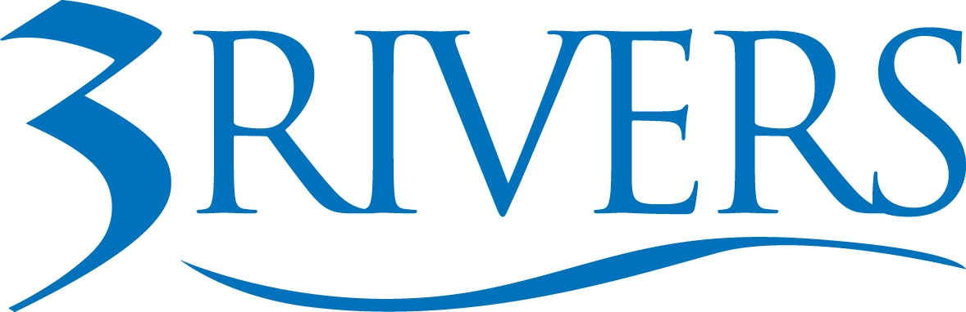 ***PRESS RELEASE***

Date: May 5, 2026
Contact: Aly Hess, Marketing Content Manager
Phone: 260.224.5697
Email: ahess@trfcu.org
FOR IMMEDIATE RELEASE
Employee-Led Giving at 3Rivers Drives More Than $1.5 Million in Community Impact

Fort Wayne, Ind. — Since 2016, team members at 3Rivers Credit Union have led a voluntary payroll giving program supporting United Way— generating more than $1.5 million in total community impact, with corporate contributions extending the impact of employee giving.

Today, 54% of employees participate in the program, with many choosing to continue their support year after year. Giving levels vary by individual, and team members can direct their dollars within the United Way network, supporting local communities and key initiatives where it’s needed most.

The program has supported several partner organizations across Indiana and Ohio, advancing efforts in food security, housing stability, mental health, and educational opportunities.

A Decade of Collective Impact

The 2025–2026 employee campaign marked a record year, generating more than $100,000 in employee contributions, matched by an additional $100,000 from the credit union. The prior campaign saw similarly strong participation, with employees contributing approximately $97,000, alongside a $96,000 corporate match.

Since launching in 2016, employees have contributed nearly $900,000—forming the foundation of more than $1.5 million in total community impact.

“This isn’t a single campaign or one-time effort,” said Don Cates, President & CEO of 3Rivers. “It’s our people choosing, year after year, to invest in the communities they’re part of. For many, it’s a first step into philanthropy—one that often grows into a lifelong commitment to giving time, talent, and resources.”

The program reflects a broader belief that community impact is strongest when it is shared. At 3Rivers, team members take part in that responsibility directly.

What Sustains the Program

Participation has remained strong over time, with 47-54% of employees participating annually and employee giving consistently approaching $100,000 in recent years.

The program’s longevity comes down to a few consistent design choices.

Participation is personal.
Team members decide if and how they give, which adds another level of connection to each gift.

The structure is consistent.
The campaign returns each year with clear options for participation, tiered giving levels, and simple ways to engage—paired with small incentives that help reinforce participation over time.

In recent years, the credit union has introduced a corporate match, further extending the impact of employee contributions.

Participation is further supported by an internal campaign committee that helps lead and sustain engagement each year.

Giving is part of a broader culture.
3Rivers supports employee involvement beyond payroll contributions. Team members receive two paid volunteer days each year and take part in community events like United Way’s Day of Caring. Each fall, those efforts expand through an all-employee Give Back Day, when teams volunteer at nonprofits across the organization’s footprint.

The organization also invests in long-term engagement through its internal Community LEADERS program, preparing employees to serve in nonprofit leadership roles across the region.

Over time, the program has shown that when giving is easy, consistent, and employee-directed, participation follows.

“We’ve seen that when people feel connected to where their time and money are going, they stay engaged,” said AiJana’e Hardy, Total Rewards Manager at 3Rivers. “Team members give because they see how our United Way support benefits local partners and programs, often ones they or people they know are directly connected to. That ability to direct their gift makes each contribution more meaningful.”

Recognition Along the Way

3Rivers has received a Spirit of Giving award from United Way, along with multiple Campaign of the Year recognitions highlighting its employee giving efforts.

Those honors reflect the consistency of the program and the level of team engagement.

“For more than a decade, 3Rivers has demonstrated what it means to lead with purpose,” said Brandi Buck, Executive Director of United Way of Allen County. “Their investment in our community extends beyond dollars to a genuine commitment to understanding and addressing its most pressing needs. Their leadership reflects a powerful commitment to action, not just intention.”

Cates also serves as Treasurer on the Board of United Way of Allen County and has previously served as both Campaign Chair and Board Chair, underscoring the depth of the organization’s long-standing partnership.

What Financial Institutions Can Take Away

For financial institutions looking to strengthen community impact, this model offers a clear, repeatable starting point.

Make participation accessible.
Give employees a voice in where support goes.
Keep the structure consistent year over year.

At 3Rivers, those elements have helped create a program that sustains itself. Participation remains steady, engagement builds over time, and impact continues across the communities it serves.

The takeaway is straightforward: when employees have simple, consistent ways to contribute—and a say in where support goes—giving becomes part of the culture.

About 3Rivers Credit Union: 3Rivers Federal Credit Union empowers our community to achieve financial wellness through personalized service, tools, and education. Founded in 1935, 3Rivers is a member-owned, not-for-profit, cooperative that serves over 135,000 members with 24 branches and over 500 employees. Offering a complete line of financial services, including mortgages, business services, college funding, and retirement planning. For more information, including how we give back and invest in our community, visit www.3riversfcu.org/community.

