FOR IMMEDIATE RELEASE

CONTACT:
Julie Woloszyn, PCM®, CWCUL, CCUFC
Marketing Manager
Corporate Central Credit Union
(414) 425-5555

Chris Felton Receives One of the Credit Union Industry’s Highest Honors

MILWAUKEE, WI – May 18, 2026 – Corporate Central is proud to announce that Chris Felton, President/CEO, has been named a 2026 Credit Union House Hall of Leaders honoree, one of the highest distinctions within the credit union industry. The national recognition honors individuals whose leadership and service have made a lasting impact on the credit union movement at the local, state, and national levels.

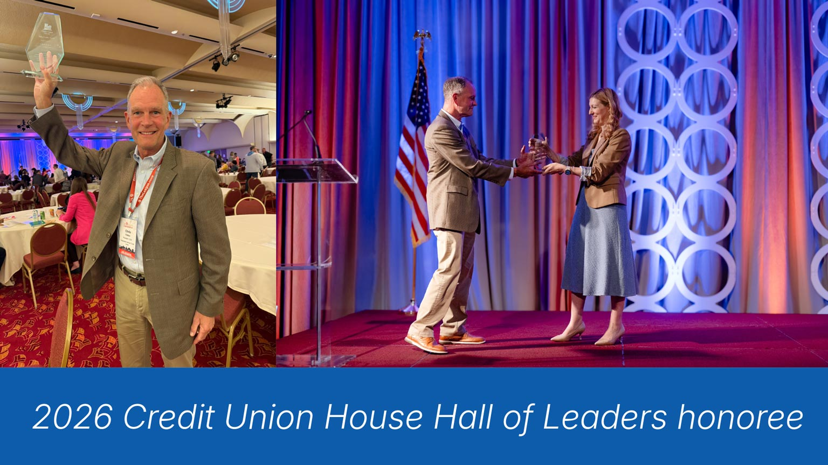

Felton was formally recognized by The Wisconsin Credit Union League during The Cooperative Spirit Awards and Recognition session on Friday, May 15, held as part of The League’s Annual Convention and Exposition. The event brought together credit union leaders from across the region to celebrate excellence in leadership, advocacy, and cooperative impact.
The Credit Union House Hall of Leaders recognizes distinguished individuals who have demonstrated extraordinary dedication to advancing the credit union industry through leadership, collaboration, innovation, and advocacy. Felton was selected for his visionary leadership, commitment to people centered culture, and continued efforts to strengthen and evolve the credit union movement.

As President/CEO of Corporate Central, Felton is known for a leadership style that is future-focused and grounded in the cooperative values that define the credit union industry. Under his leadership, Corporate Central has strengthened its role as a strategic partner to credit unions through innovation, collaboration, education, and forward-looking solutions.

“Those who work alongside Chris know that his leadership extends far beyond strategy and results,” said Heather Ristow, CCUE, SVP/Chief Experience Officer. “He leads with authenticity, appreciation, and a genuine commitment to people. This recognition reflects the profound impact he has made not only within Corporate Central, but across the entire credit union movement.”

“Chris has made a remarkable impact at Corporate Central, across Wisconsin, and throughout the credit union movement,” said Sarah Wainscott, President/CEO of The Wisconsin Credit Union League. “He builds community within his organization, champions meaningful collaboration, and represents the industry with credibility and heart. This honor is a fitting recognition of his leadership and advocacy.”

Located on Capitol Hill in Washington, D.C., Credit Union House serves as a national symbol of advocacy, cooperation, and unity within the credit union system. Induction into the Hall of Leaders celebrates individuals whose careers have helped shape the future of the industry and strengthen its mission of “people helping people.”

Helping Members to be Wildly Successful

About Corporate Central Credit Union
Corporate Central Credit Union is a federally insured financial cooperative built on the values of commitment to service, fiscal responsibility, and respect for the individual. We cultivate a culture of respect, ethics, teamwork, and innovation. We are "Helping Members to be Wildly Successful" by delivering industry knowledge and expertise to help credit unions achieve their strategic objectives and compete in today’s evolving financial services industry. We are motivated to passionately serve our members and strive to learn, create, and innovate daily. Please visit corpcu.com to learn more, and follow us on LinkedIn, Facebook, and YouTube.

