


Greater Texas|Aggieland Credit Union Sweeps
Pinnacle Awards With Six Wins

Austin, June 17, 2026 – Greater Texas|Aggieland Credit Union took home six prestigious Pinnacle Awards at the annual Cornerstone League marketing competition, demonstrating outstanding creative excellence and strategic impact across multiple marketing disciplines.
The Pinnacle Awards recognize the best marketing and communications initiatives within the credit union industry across a five-state region. This year’s highly competitive program featured 139 total entries representing credit unions from Arkansas, Kansas, Missouri, Oklahoma, and Texas. Greater Texas|Aggieland Credit Union's awards highlights its ability to deliver innovative, community-focused campaigns that resonate deeply with members and regional partners.
The credit union was recognized with Pinnacle Awards in six distinct categories:
- Special Event: "Building Community One Branch at a Time: Mopac Debut" (Mopac Branch Grand Opening)
- Logos: "Drawing Connection: Operation Howdy & Community-First Branding" (Operation Howdy Logo)
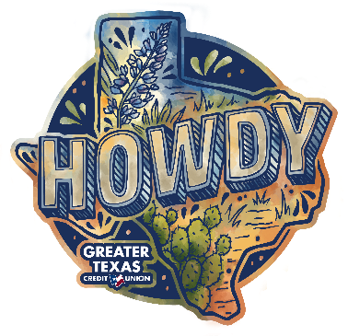
- Retail Merchandising: "Engaging Bobcats: The Texas State Outreach Activation" (Texas State Tabling Set-up)
- Brand Awareness: "Unboxing the Spirit: First Impressions That Last" (Howdy Box)

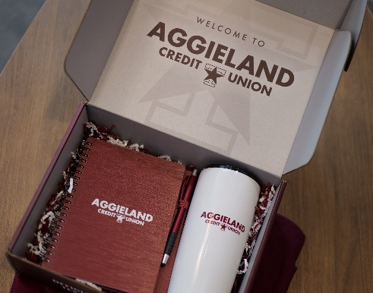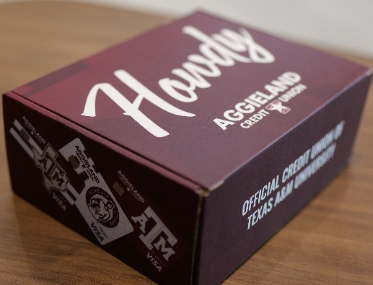

- Digital Marketing: "Reinventing Engagement: The Howdy Hunt VR Experience" (Howdy Hunt Scavenger Hunt)
- Business/SEG/Community Development: "NSC Reimagined: A Modern Approach to Student Outreach" (NSC Revamp)
"Winning six Pinnacle Awards is a tremendous honor and a testament to our team's effectiveness in impactful storytelling," said Sidney Henderson, Senior Vice President of Marketing for Greater Texas|Aggieland Credit Union. "Whether we are leveraging augmented reality to connect with university students or designing custom outreach for our branches, our goal is to build authenticity in everything we do. These awards validate our commitment to serving our Texas communities with creativity, innovation, and purpose."

By blending modern technology with local community development Greater Texas|Aggieland Credit Union continues to set a benchmark for retail merchandising, digital engagement, and brand awareness statewide.

About Greater Texas Credit Union
Greater Texas Credit Union, founded in 1952, is a financial cooperative that emphasizes community stewardship, charitable giving, and employee volunteerism through its Greater Good initiative. Together with its subsidiary, Aggieland Credit Union – which serves the Brazos Valley – the credit union offers a wide variety of consumer-oriented banking services to its 80,000 members across the state of Texas. Greater Texas has locations in Austin, Houston, San Antonio, Bryan-College Station, Edinburg, and the Arlington market with assets of nearly $1 billion.

###

