


Texas A&M IBE Students Raise $54,000 for Local Nonprofits

Aggieland Credit Union Funds Student-Led Startups Driving Charitable Donations

Bryan-College Station, Texas, June 29, 2026 – The 2025-2026 Integrated Business Experience (IBE) class of Texas A&M Mays Business School generated substantial community impact this year, with total profits of $54,925 donated directly to Brazos Valley charities.
Nine student-led IBE company teams pitched their unique business concepts to a panel of financial experts from Aggieland Credit Union. The credit union awarded essential start-up funding to each business based on the judges’ assessment of product concept, manufacturing viability, and sales and marketing strategy.
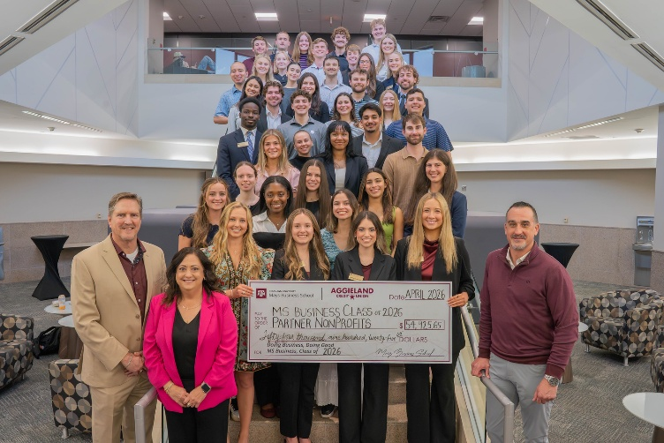
“The exceptional creativity behind this year’s groups' merchandise ideas directly fueled their strong financial returns,” noted Blake Petty, Executive Director of the McFerrin Center for Entrepreneurship at Texas A&M University and instructor for the IBE course. “Our leading business this year set two team records never before accomplished in the class, surpassing total team revenues captured of $47,601, and generating a record $22,227 donation for its local charity. All of the teams once again impressed by demonstrating the incredible drive and business acumen of our Aggie entrepreneurs.”
The ultimate winners of these IBE entities were the nine local nonprofits that received the total earnings from each individual student operation. Donations ranged from $1,830 to $22,227:
- Scotty's House received a donation of $22,227 from Off the Wood (custom A&M domino sets)
- Read by 3rd received a donation of $10,021 from Rev & Co Publishing (children's book featuring Reveille and promoting Aggie values)
- Team Red, White & Blue - Bryan/College Station received a donation of $5,435 from Preserve Tradition (Texas A&M Wine Stoppers)
- Boys & Girls Clubs of the Brazos Valley received a donation of $4,873 from The Aggieland ABCs (children's book focused on Aggie traditions)
- Bluebonnet Equine Humane Society received a donation of $4,157 from Step'N Store (leather boot wallets)
- Brazos Valley Cares received a donation of $2,229 from The 12th Stand (Ol Army Ring Stand)
- Voices for Children, Inc. received a donation of $2,229 from Ringing in Tradition (12th Toss game)
- OnRamp received a donation of $1,922 from The 12th Plate (license plate frames)
- REACH Project received a donation of $1,830 from Travelers & Co (Who Let the Horns In social deduction game)
Leveraging the power of the Texas A&M brand allowed the student teams to design appealing products tailored to the Aggie community. Off the Wood led the group, earning twice as much as the second-highest earning company, Rev & Co Publishing, thanks to its custom A&M domino sets.
“Our involvement extends beyond offering upfront seed funding for the program. We coach these emerging professionals in fiscal management so they can grasp the foundational elements of corporate achievement," stated Tina Muth, Market President of Aggieland Credit Union. "As the official credit union of Texas A&M, we have the unique chance to work alongside the campus community, through tangible experiences such as developing, and operating a business.”
About Aggieland Credit Union
Aggieland Credit Union was founded in 1985 by Aggies as a financial cooperative to support fellow Aggies and their families. The credit union is now a subsidiary of Greater Texas Credit Union and emphasizes community stewardship, charitable giving, and employee volunteerism. The credit union offers a wide variety of consumer-oriented banking services to its 80,000 members across the state of Texas and has locations in Bryan-College Station, Austin, Houston, San Antonio, Edinburg, and the Arlington market with assets of nearly $1 billion.

###

Photo caption: The 2025-2026 Texas A&M Mays School of Business Integrated Business Experience class donated nearly $55,000 in earnings to local nonprofits serving the Brazos Valley. Pictured are Joe James (bottom left corner), Tina Muth (next to James) and Jason Endsley (bottom right corner), from Aggieland Credit Union and the students representing the nine student-run businesses.

