
FOR IMMEDIATE RELEASE
Clearview Expands Pittsburgh-Area Presence with Flagship Financial Center, First Ground-Up Location in Nearly a Decade

Pittsburgh, PA – June 16, 2026 – Clearview Federal Credit Union is expanding its presence in the Pittsburgh area with a new flagship financial center in Green Tree, marking the credit union’s first ground-up standalone location in over a decade and reinforcing its long-term investment in serving members across Southwestern Pennsylvania.
Construction is expected to begin in mid-June on Clearview’s newest financial center, a contemporary location designed to become a recognizable addition to the Pittsburgh landscape while providing convenient access for members throughout the region. Situated along the highly traveled Green Tree Hill corridor, the project combines strategic accessibility with a strong visual presence, reflecting Clearview’s focus on accessible, relationship-driven banking.
Developed in collaboration with LGA Partners, the new financial center was intentionally designed to balance visibility, accessibility, functionality, and member experience. The building’s contemporary design features a dramatic two-story glass façade and an open interior layout filled with natural light, creating a warm and inviting atmosphere for both members and employees.
“Building our first ground-up financial center in nearly a decade marks a significant milestone in Clearview’s growth and reflects our ongoing commitment to serving members across the region,” said Lisa Florian, President & CEO of Clearview. “Green Tree Hill is one of the most recognizable corridors in the Pittsburgh region, and we saw a unique opportunity to create a flagship location that reflects both who we are and where we’re headed. More than a building, this location represents the next evolution of how we serve our members, combining personal guidance, modern convenience, and a welcoming space designed for the communities we call home.”
The new financial center is expected to open in the summer of 2027 and will become Clearview's 28th location in the region. The project reflects the credit union's continued growth and commitment to delivering accessible, community-focused financial services throughout Western Pennsylvania.
Designed as more than a traditional branch location, the Green Tree Financial Center will feature a translucent glass exterior that transforms throughout the day, welcoming natural light during the day and creating a striking illuminated presence at night. The placement, height, and architectural expression of the building were carefully considered to maximize visibility while responding to site, highway, and operational requirements.
“Our vision for the building was to create a contemporary architectural expression that not only responds to Clearview’s operational needs but also presents itself as a unique and recognizable form,” said Gerrod Winston, Senior Project Architect at LGA Partners. “The translucent building envelope fills the interior with natural light during the day and transforms the building into a glowing presence at night, reinforcing a sense of openness, connection, and identity.”
Inside, the financial center will feature an open floor plan designed to support personalized financial conversations, flexible meeting spaces, a member lounge, and modern conveniences including drive-up lanes with Clearview Live® and ATM access. Acoustic materials, elevated finishes, and collaborative spaces have been integrated throughout the design to create a comfortable environment for both members and employees.
Construction of the new financial center will be led by Lombardo Industries, a long-term Clearview partner with extensive experience delivering commercial projects throughout the region. Additional project details and opening information will be shared as construction progresses.
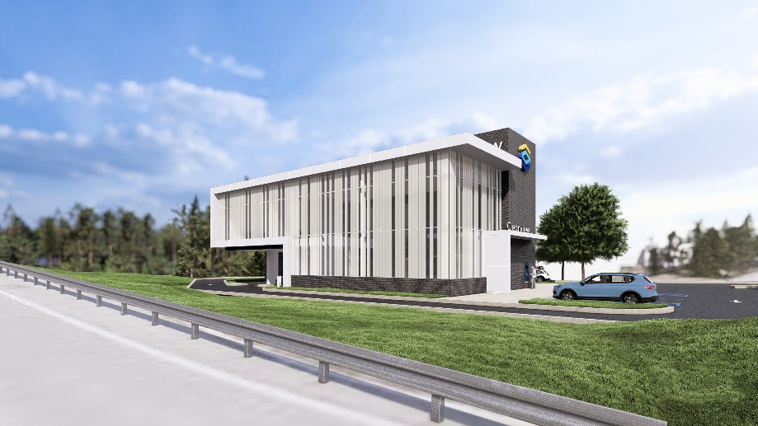
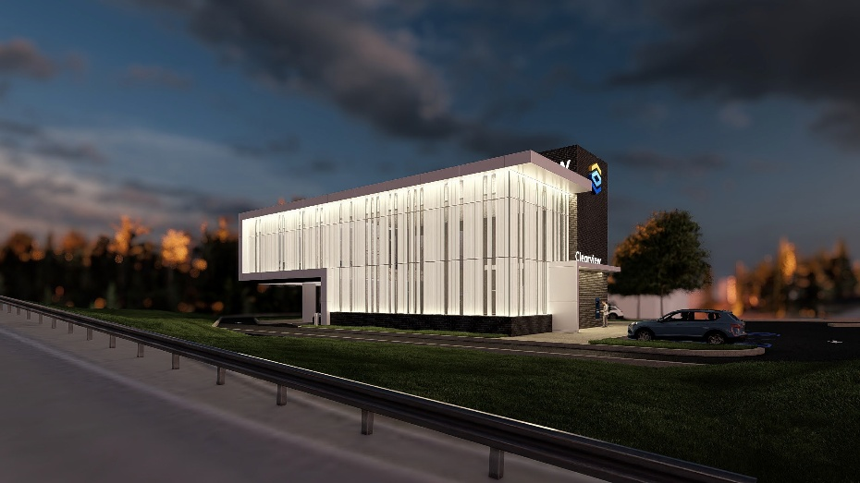
Renderings of the future Green Tree Financial Center.
Additional renderings and images are available here.

About Clearview Federal Credit Union
Clearview Federal Credit Union has been in operation since 1953 and serves 140,000 members with reported assets valued at more than $2 billion as of May 2026. Recognized as one of America's Best Regional Credit Unions 2025 by Newsweek, Clearview is committed to building a financially empowered community by helping individuals, families, and businesses make confident financial decisions through personalized financial solutions, trusted guidance, and accessible support. Membership is open to individuals throughout the communities Clearview serves, as well as immediate family members of current members. Clearview Federal Credit Union is federally insured by the National Credit Union Administration and is an Equal Housing Lender. For more information, visit clearviewfcu.org

Media Contacts
Erin Forrester
AVP, Public Relations & Community Engagement
Clearview Federal Credit Union
412-719-0215
press@clearviewfcu.org
Krysten Casabielle
Chemistry
786-514-3633
press@clearviewfcu.org

# # #

