

PRESS RELEASE FOR IMMEDIATE RELEASE: June 8, 2026

Tower Federal Credit Union Welcomes Darena Merdzhanova as New Vice President of Compliance

Darena Merdzhanova, Tower’s newly hired Vice President of Compliance brings to the credit union over 20 years of enterprise compliance leadership across the financial services industry.
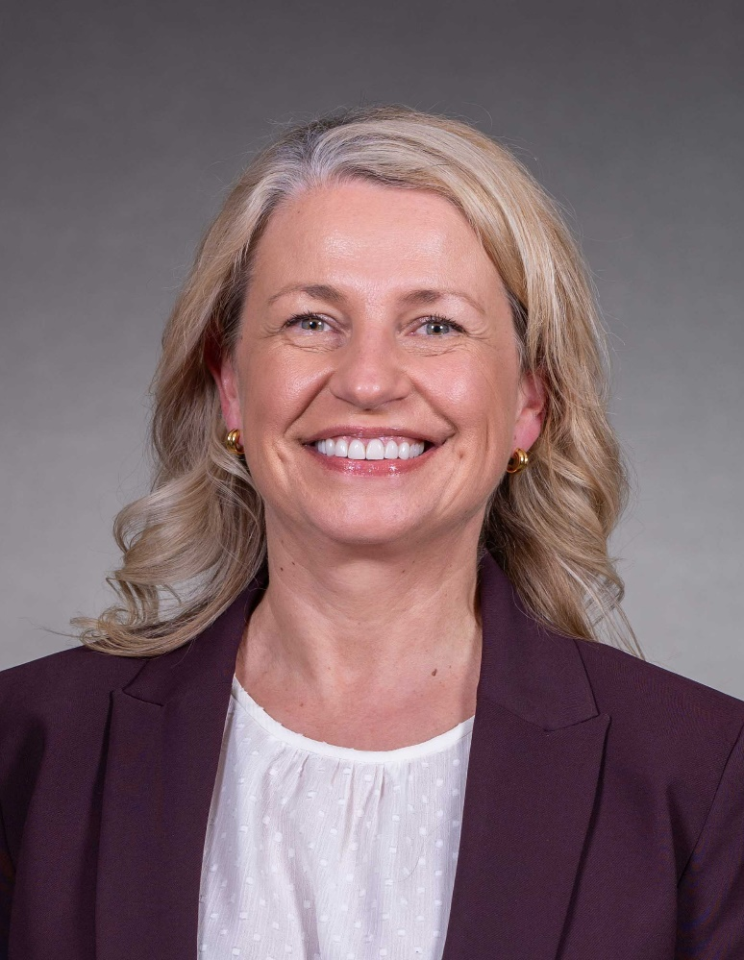
[June 8, 2026 - Laurel, MD] Tower Federal Credit Union, one of Maryland’s largest credit unions, announces the hiring of Darena Merdzhanova, JD, MBA, CRCM as new Vice President of Compliance. A seasoned compliance executive, Merdzhanova brings more than 20 years of leadership experience across banking, credit union, and fintech.

In her new role, Merdzhanova oversees Tower's Compliance Management System, leading efforts related to regulatory compliance, risk assessments, policy and procedure development, monitoring and testing, training, complaint management, and reporting to Tower’s leadership and Board. Her team plays a critical role in identifying and managing risk while ensuring compliance with evolving regulatory requirements.
Pictured: Darena Merdzhanova is the new Vice President of Compliance for Tower Federal Credit Union, one of the largest credit unions in Maryland. [Photo credit: Michael Ciesielski]

“We are thrilled to welcome Darena to our management team,” said Rick Stafford, Tower’s President and CEO. “She is a trusted advisor known for building strong, scalable compliance programs that balance regulatory expectations with business strategy and an outstanding member experience.”

Before joining Tower, Merdzhanova led regulatory risk and compliance initiatives for financial institutions nationwide, with expertise in deposit, lending, payments, and fintech partnerships. She has also served as a Chief Compliance Officer and held several senior advisory roles.

Merdzhanova holds a Juris Doctor and an MBA in Risk Management. She is also a Certified Regulatory Compliance Manager (CRCM), and a Six Sigma black belt.

“I am honored to join Tower and contribute to our mission of serving members with integrity and excellence,” Merdzhanova said. “Compliance is most effective when it is embedded in the culture, and I look forward to partnering with every department across Tower to strengthen the Compliance Management System in a way that empowers our teams and upholds the trust members have placed in us.”

To learn more about Tower, visit towerfcu.org.
###

About Tower Federal Credit Union
Tower Federal Credit Union is a member-owned, not-for-profit financial institution headquartered in Laurel, Maryland. Founded in 1953, Tower serves more than 220,000 members worldwide and manages over $5 billion in assets, making it one of the largest credit unions in Maryland. Tower offers a full range of financial products and services, with convenient access through local branches, online banking, and top-rated mobile app. Learn more at towerfcu.org.

MEDIA CONTACT:

Carla Keister
Senior Writer, Tower Federal Credit Union
301.497.7000, ext. 7144
carla.keister@towerfcu.org

