
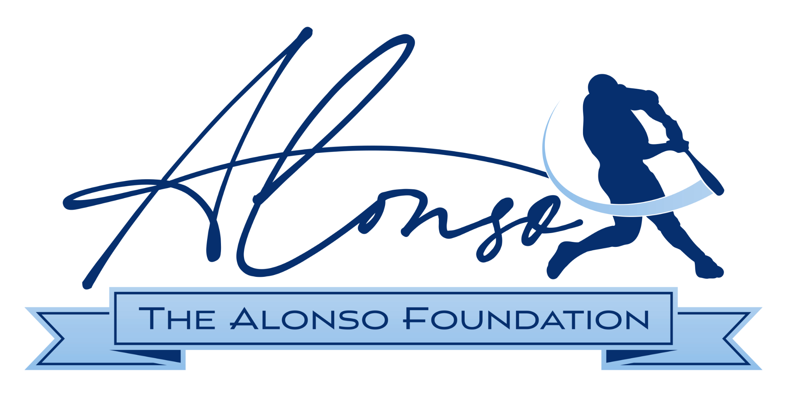

FOR IMMEDIATE RELEASE

Every Pete Alonso Home Run Will Support Maryland Veterans Through New 'Homers for Heroes' Initiative

Tower Federal Credit Union, through its TowerCares Foundation, is partnering with The Alonso Foundation to donate $2,500 for every Pete Alonso home run in support of Maryland veterans

▶ Watch Pete Alonso Introduce Homers for Heroes
Hear directly from Pete about why supporting veterans is so important to him and Haley, and how every Pete Alonso home run this season will make an impact far beyond the ballpark. [Embedded Video]

LAUREL, Md. (June 30, 2026) — When Pete Alonso arrived in Baltimore earlier this year, he came ready to contribute on and off the field. The Orioles' first baseman and his wife Haley have long championed veterans and military families — and now they've found the right partner in Maryland to make that mission count.

Tower Federal Credit Union, through its TowerCares Foundation, has partnered with The Alonso Foundation to launch Homers for Heroes, a new initiative that turns every Pete Alonso home run into meaningful support for Maryland veterans and military families.

The TowerCares Foundation is donating $2,500 for every home run Alonso hits for the remainder of the 2026 season, a tribute to the No. 25 he wears on his Orioles jersey. The Alonso Foundation will direct those contributions to veteran-serving organizations across Maryland.

The initiative is already making an impact. Since launching on June 8, Alonso has hit six home runs, generating $15,000 in support for Maryland veterans and their families.

Together, TowerCares and The Alonso Foundation are turning every Pete Alonso home run into an opportunity to honor and support Maryland's military heroes.

The partnership brings together two organizations with deep and longstanding commitments to those who serve. Tower Federal Credit Union and its TowerCares Foundation have spent decades supporting active-duty military members, veterans and their families through community initiatives, including more than $4 million in charitable donations and the Baltimore Orioles Military Cap program. Likewise, The Alonso Foundation, led by Pete and Haley Alonso, has made veteran support a cornerstone of its charitable work, helping service members, veterans and military families through programs and opportunities that improve their quality of life.

“Haley and I are absolutely thrilled that the Alonso Foundation is teaming up with TowerCares for the 'Homers for Heroes' initiative,” said Pete Alonso, co-founder of The Alonso Foundation. “Every time I step into the batter's box, I’m playing to win, but knowing that each home run will directly support our veterans adds a whole new level of purpose to every swing. Our servicemen and women have given so much, and it’s a true honor to partner with TowerCares to give back to those who have sacrificed the most.”
"Homers for Heroes reflects the shared values that unite Tower and the Alonsos in supporting those who have served and sacrificed so much for our country," said Rick Stafford, President & CEO of Tower Federal Credit Union and President of the TowerCares Foundation. "We're honored to team up with Pete and Haley Alonso to turn every home run into meaningful support for veterans and military families in communities across Maryland."

Nonprofit organizations that would like to learn more about Homers for Heroes are encouraged to connect with The Alonso Foundation through its website, alonsofoundation.org. The foundation will share additional information about the initiative and future grant opportunities as they become available.

About the TowerCares Foundation
Headquartered in Laurel, Md., the mission of the TowerCares Foundation is to support children in need as well as the brave and heroic individuals who have sacrificed while protecting our freedom. TowerCares creates programs and supports well-vetted charities that are in alignment with our mission. Since our inception in 2015, the TowerCares Foundation has provided more than $4 million in grants, donations and scholarships. The TowerCares Foundation is a 501(c)(3) charitable organization, and a participating charity in the Combined Federal Campaign (#23594) and Maryland Charitable Campaign (#47-4164006). Donations are tax-deductible. We are a platinum-level GuideStar participant, demonstrating our commitment to transparency. For more information about TowerCares, visit towercaresfoundation.org.

About Tower Federal Credit Union
Tower Federal Credit Union is a member-owned, not-for-profit financial institution headquartered in Laurel, Maryland. Founded in 1953, Tower is one of the largest credit unions in Maryland with more than $5 billion in assets and over 225,000 members worldwide. Tower provides a full range of financial products and services, including savings, lending, mortgages, and digital banking solutions, and serves members across Maryland, Virginia and Washington, D.C., as well as around the world. Learn more at towerfcu.org.

About the Alonso Foundation
Founded in 2020 by MLB All-Star Pete Alonso and his wife, Haley, The Alonso Foundation is dedicated to stepping up to the plate for those who need it most. Born from a shared calling to give back and create lasting change, the foundation actively serves as a powerful voice for the vulnerable. Guided by the personal motto to "stand up for those who cannot stand up for themselves," The Alonso Foundation combines advocacy, grant-making, and direct program creation to lessen hardships and create a brighter, more equitable future. The foundation focuses its impact across three core giving pillars of animal welfare, veterans support and youth and community development. Through grant-making and partnerships with extraordinary organizations, The Alonso Foundation aims to build legacy relationships that drive systemic change, one community at a time. For more information visit www.alonsofoundation.org.

###

