



**Greater Texas|Aggieland Adds New AVP Roles**

**to Strengthen Branch Operations**

**AUSTIN, Oct. 20, 2022** – [Greater Texas Credit Union](http://www.gtfcu.org) reinforced its retail strategy by creating new market management roles to help advance growth of its branches. The credit union promoted one veteran employee from within and hired two new staff members to fill three newly created positions of Assistant Vice President, Market Development & Operations.

Tina Muth, a 29-year employee, was promoted to oversee the growth of branches operating under the Aggieland Credit Union subsidiary of Greater Texas Credit Union. Muth has held a variety of managerial positions at the credit union and has had a significant impact on the credit union’s development in the Bryan-College Station market. Muth has a business degree from American InterContinental University.

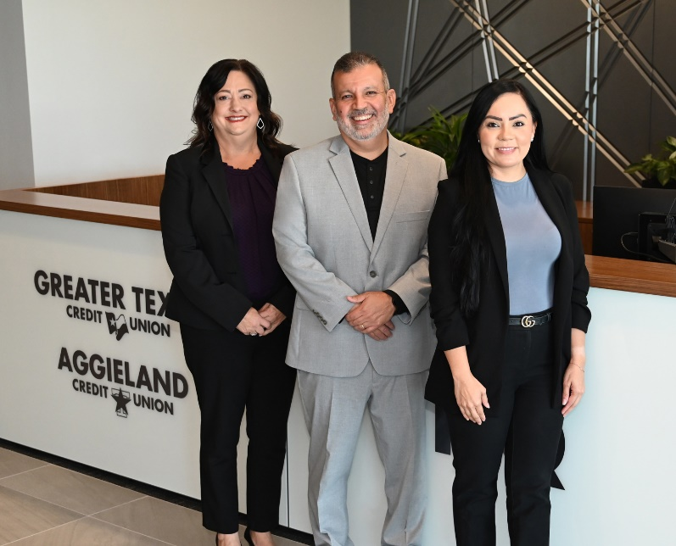

Lole Nuñez joined Greater Texas to support branches in Austin, Kyle, San Marcos, and Bastrop. Nuñez has more than 20 years experience managing branch operations for both credit unions and banks, focusing on all consumer-oriented services, as well as coaching and developing branch associates.

Based in San Antonio, Cynthia Olivares brings 17 years experience in consumer financial services to Greater Texas, where she will oversee the operations of branches in Edinburg, San Antonio, Arlington, Dallas, and Houston. Olivares has a business administration degree from The University of the Incarnate Word in San Antonio.

“Our branches represent the foundational relationship with our members,” said Jason Goodman, COO of Greater Texas|Aggieland Credit Union. “With this team of leaders that we have put in place, we now have even greater hands-on engagement of key operations in our communities. By strengthening our retail strategy and branch networks, we are working to ensure we deliver top-tier banking experience for every member.”

**About Greater Texas**

[Greater Texas](http://www.gtfcu.org) Credit Union, founded in 1952, is a financial cooperative that emphasizes community stewardship, charitable giving, and employee volunteerism through its Greater Good initiative. Together with its subsidiary, Aggieland Credit Union – which serves the Brazos Valley – the credit union offers a wide variety of consumer-oriented banking services to its 80,000 members across the state of Texas. Greater Texas has locations in Austin, Houston, San Antonio, Bryan-College Station, Edinburg, and the Dallas-Ft. Worth market with assets of nearly $1 billion.

###

**Photo caption (left to right):** Tina Muth, Lole Nuñez, and Cynthia Olivares were promoted to Assistant Vice President, Market Development & Operations at Greater Texas|Aggieland Credit Union.