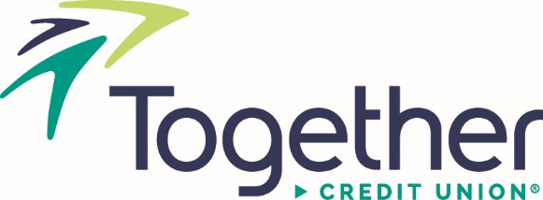
Press Release | Contact: Julie Linder
For Immediate Release  10/27/2022 | (573)268-0639  JLinder@TogetherCU.org
Together Credit Union Welcomes New Head of Marketing
Saint Louis, MO – Together Credit Union has named Nathan “Nate” Scudieri as the organization’s new Head of Marketing. In this role, he will lead the marketing, public relations, and community outreach teams to ensure that their tactics align with the credit union’s four core values and strategic priorities.
“Nate’s thoughtful leadership style and proven ability to connect strategy with execution made him a natural choice for elevating our brand to the next level,” said Tom Kraus, Chief Operating Officer.
Together Credit Union’s new brand name launched in 2019, amidst its 80th-anniversary celebration, replacing the credit union’s three former brand names, Anheuser-Busch Employees’ Credit Union, American Eagle Credit Union, and Purina Credit Union. Since then, the credit union’s new brand has earned awards from the Marketing Association of Credit Unions, the Association of Marketing and Communication Professionals, and CUNA’s Marketing & Business Development Council.
“Together Credit Union has done a wonderful job generating brand awareness in the St. Louis market. The next step to the credit union’s ongoing brand development is creating a consistent and memorable brand experience for current and prospective members,” noted Scudieri.
Together Credit Union has worked to distinguish itself as a trusted financial partner, launching several new products in the market focused on improving an individual’s financial wellbeing. The most popular products in the market now are Achieve It Checking, which rounds up purchases to the nearest dollar and deposits the change into the member’s savings account, and Zogo, a “gamified” financial literacy app that provides cash rewards for completing bite-sized lessons in personal finance.
“Nate’s diverse background in portfolio management will bring fresh ideas to the organization and help us get the right products to the right consumers,” added Kraus.
Scudieri is leading the marketing efforts around Together Credit Union’s new CITY Debit Card, which offers exclusive St Louis CITY SC benefits, such as express entry to the stadium and discounts on food, beverages, and merch in the stadium on matchdays. The product launched on September 21, with over 1,500 CITY debit cards issued to date.
Before joining Together Credit Union, Scudieri led branding initiatives for HLK Health and Centene Corporation, as the Vice-President of Marketing-Medicare; Energizer Holdings as the Director of Global Marketing- Auto Care; Vi-Jon as the Director of Marketing; and various marketing leadership roles at Anheuser-Busch including brands such as Budweiser, Michelob Ultra, Shock Top, and the Busch, Natural Light and Rolling Rock portfolios. He holds a Bachelor of Science in Marketing from Ferris State University in Big Rapids, MI.
For more information regarding this announcement, please contact Julie Linder, PR & Events Strategist, by calling (573) 268-0639.
###
About Together Credit Union: With more than $2.6 billion in total assets, Together Credit Union is an independent financial institution, chartered by the state of Missouri, and federally insured by the National Credit Union Administration (NCUA). For additional information, visit TogetherCU.org.

