AFFCU Welcomes Five New Leaders to Management Team

SAN ANTONIO– Air Force Federal Credit Union (AFFCU) is pleased to announce the addition of new management team members.

Ricardo (Rick) Ledezma joins AFFCU as Vice President - Chief Financial Officer. In his role, Ledezma will oversee the Accounting Department and develop the Credit Union’s investment strategy. Ledezma offers the organization over 17 years of experience in treasury management, corporate compliance, and sustainable lending efforts. He holds a Bachelor’s in Business Administration from Texas A&M International University and a Master of Business Administration from The University of Texas at San Antonio. Prior to joining AFFCU, Ledezma served as Treasury Manager and Director of Sustainable Lending at Credit Human Credit Union.

Eric Sanchez has been hired as Assistant Vice President - Sales & Service Performance. Sanchez will spearhead a consultative sales and service culture while driving member engagement within AFFCU’s seven Financial Centers. He is pursuing a Master of Science in Organizational Development and Leadership from the University of the Incarnate Word and holds an MBA in Human Resources and a B.S. in Business Administration from UIW. His over 15 years of development, training, and leading financial services organizations come from his time with Credit Union Student Choice, Generations FCU, and Wells Fargo.

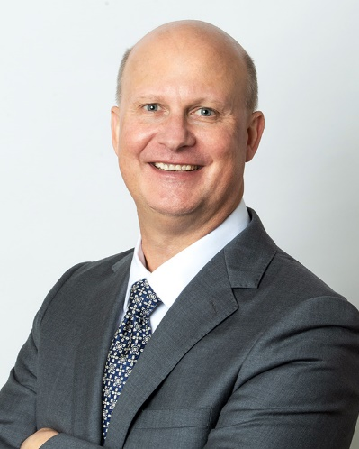

David Lancaster is now the Senior Vice President - Chief Lending Officer. Lancaster will oversee the Lending and Asset Recovery departments, where he will develop and execute lending strategies while creating innovative loan promotions. He holds a B.S. in Business Administration from Birmingham Southern College and has 30-plus years of experience. Previously, Lancaster served as the Vice President of Lending at Pen Air Federal Credit Union.

--MORE--

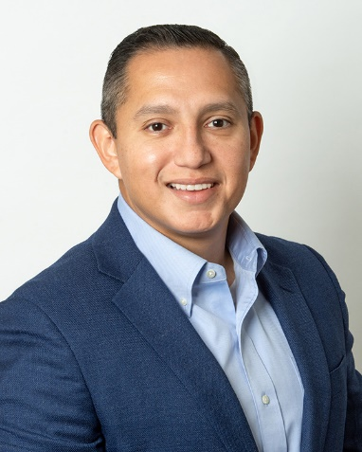
Andrew Ramos is AFFCU’s new Vice President - Digital & Product Integration. Under his leadership of the Account Services department, his team will focus on digital, credit, and debit products, deposit strategy, and project management. Ramos joins the organization with more than 18 years of leadership experience in consumer lending, and digital and product management. He holds a B.A. in Business Administration from UIW and is a UTSA MBA Finance graduate candidate. Most recently, Ramos was the Vice President - Consumer and Private Bank Product Manager for Broadway Bank.

Yvonne De La Rosa-Flores has been hired as the new Director of Compliance and Risk Management. She will oversee the organization’s compliance programs and focus on enhancing risk strategies. De La Rosa-Flores has over 30 years of experience in audit, corporate compliance, governmental and legislative affairs. She holds a B.A in Business Administration and an MBA from UIW. Before her time at AFFCU, De La Rosa-Flores served as the Senior
Compliance and Legislative Affairs Officer at Credit Human Credit Union.

“We're honored to welcome these talented leaders to AFFCU’’s leadership team,” said Ryan Ross, President and Chief Executive Officer of AFFCU. “Their combined education, experience, and knowledge will help AFFCU to continue to advance and innovate to better serve our membership base. Our staff and members are excited to see the collaboration and ideas that will develop from these individuals.”

About AFFCU: Established in 1952 by 10 airmen on JBSA-Lackland, AFFCU has grown to serve the diverse needs of almost 52,000 members worldwide with a full array of financial services, seven branch locations, and the strength of more than $610 million in assets. As a member-owned and not-for-profit organization, AFFCU is passionate about assisting the communities it serves through volunteer work, scholarships, and sponsorships. For more information about AFFCU, visit GoAFFCU.com.

###

