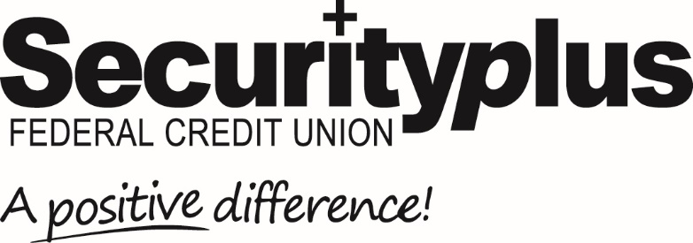
For Release: Immediate Contact: Lisa Allender
410-281-6248
lisa.allender@securityplusfcu.org

Securityplus Federal Credit Union
Announces 4.85% APY Share Certificate

Baltimore, MD (November 21, 2022) Securityplus Federal Credit Union is excited to announce the return of high returns: a new Share Certificate earning a guaranteed 4.85% APY, one of the highest rates in the country. The Certificate has a 23-month term, with a $10,000 minimum of new money being deposited.

The 4.85% APY Share Certificate is also available for IRA accounts. And SPFCU is also offering other Share Certificates with a variety of attractive interest rates and minimums. Accounts can be opened at branch locations or by calling (410) 281-6200. Securityplus reserves the right to end or modify this offer or update the stated Annual Percentage Yield (APY) at any time.

"After years with a low-interest rate environment, we're thrilled to offer consumers a safe place to earn a high yield on their savings," stated Brian Holloway, Chief Marketing Officer.
Securityplus wants members to know that Share Certificates are a safe, insured investing option that can help to achieve long-term financial goals. We exist to serve members by offering financial solutions that make sense. Members are more than just a number at Securityplus. Because we are local and tied to our community, we have the sincere desire to help others succeed.
For more information on opening a Share Certificate account and becoming a member of Securityplus Federal Credit Union, call (410) 281-6200 or visit any branch.
Securityplus Federal Credit Union is a $535⁺ million not-for-profit, member-owned, financial institution serving the Greater Baltimore Area and beyond. Founded in 1938, Securityplus is one of the largest full-service credit unions in Maryland, with over 34,000 members. With a focus on making a positive difference, Securityplus is a leader in digital banking, offering 24/7 access to inclusive easy-to-use banking products and services for consumers, families, businesses and non-profits. For more information, visit securityplusfcu.org.
# # # #

