United Federal Credit Union – Press Release
December 1, 2022

Contact: Diana Wake
Phone: (888) 982-1400 ext. 6891
Email: dwake@UnitedFCU.com
United Federal Credit Union, 150 Hilltop Road, St. Joseph, MI 49085

United Federal Credit Union and American Red Cross
Partner for Blood Drive in Southwest Michigan
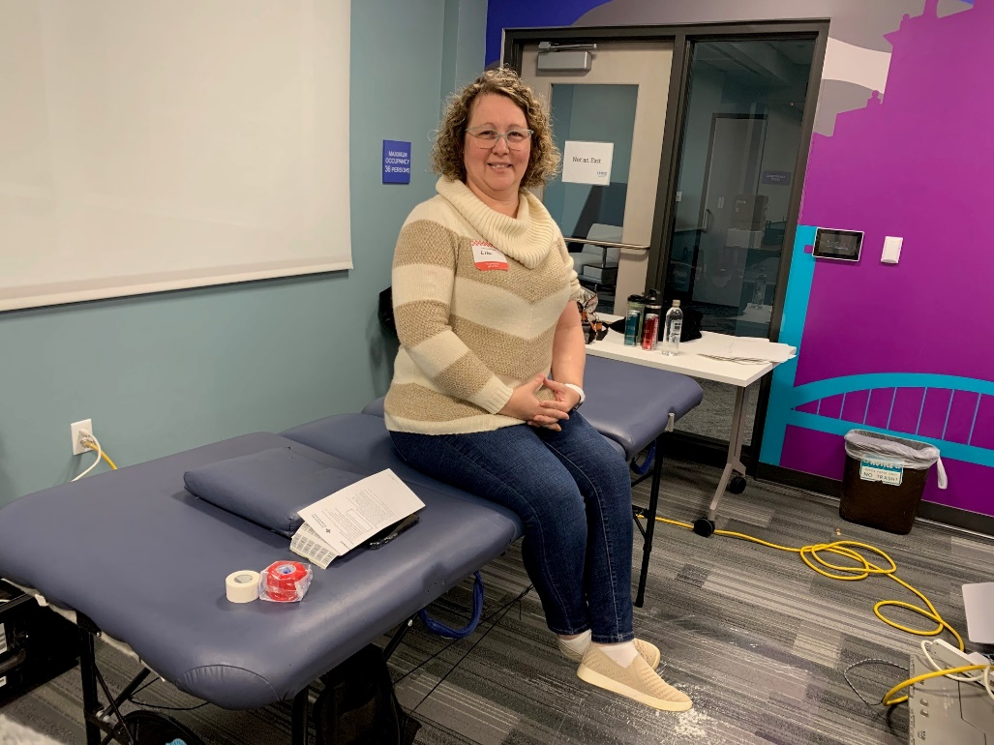
United Federal Credit Union employee, Lisa DeRosa, prepares to donate blood
ST. JOSEPH, Mich. – Every two seconds, someone in the United States needs blood. Despite calls from the American Red Cross for donors, there is an ongoing urgent need for blood donations.

The entire process of giving blood takes less than an hour. For United Federal Credit Union employee, Lisa DeRosa, a recent blood drive at the credit union’s headquarters on November 30 helped her hit a milestone of three gallons (24 units) of blood donated.

“I donate blood because I’ve seen first-hand how donations impact families,” said DeRosa. “My sister received blood transfusions from other caring souls, and the selflessness of others encourages me to continue donating. There are so many things I can’t do to help others, and while I’m not a fan of needles, donating blood is something easy I can do to give back.”

DeRosa said the one thing she looks forward to every time she donates: receiving the text from the American Red Cross letting her know where her donation went.

“Getting the information of how my donation is helping is my “why” for continuing to donate blood,” explained DeRosa. “One that text hits my phone, it warms my heart and solidifies my commitment to continue donating.”

Through the generosity of employees and individuals from the community, 29 pints of blood were donated at United’s recent blood drive which will help save 87 lives.
“This is the second blood drive this year United has partnered with the Red Cross to host,” said Joshua Pratt, Senior Relationship Development Manager. “There is a crucial need in our community for blood donations, and we are thankful to once again have the support of Team United, our Members, and the community for showing up. United is proud to live the credit union philosophy of people helping people, especially in times of need.”

The American Red Cross said the need for blood is constant. One donation can potentially save up to three lives. It provides about 40% of our nation’s blood and blood components, all from generous volunteer donors. Donations from blood drives help patients of all ages: accident and burn victims, heart surgery and organ transplant patients, and those battling cancer.
____________
About United
United Federal Credit Union has served its Members since 1949 by helping them to build a sound financial future. United consists of more than 191,000 Member/owners worldwide and manages assets in excess of $3.8 billion. Its corporate offices and main branch are in St. Joseph, Mich., with additional branches in Arkansas, Indiana, Michigan, Nevada, North Carolina, and Ohio. Federally insured by NCUA. Equal opportunity lender. Equal housing lender. For more information visit www.UnitedFCU.com
# # #

