

**United Federal Credit Union – Press Release**

December 5, 2022

Contact: Diana Wake

Phone: (888) 982-1400 ext. 6891

Email: [dwake@UnitedFCU.com](mailto:dwake@UnitedFCU.com)

United Federal Credit Union, 150 Hilltop Road, St. Joseph, Michigan, 49085

**United Federal Credit Union Donates $29,000 During Giving Tuesday**

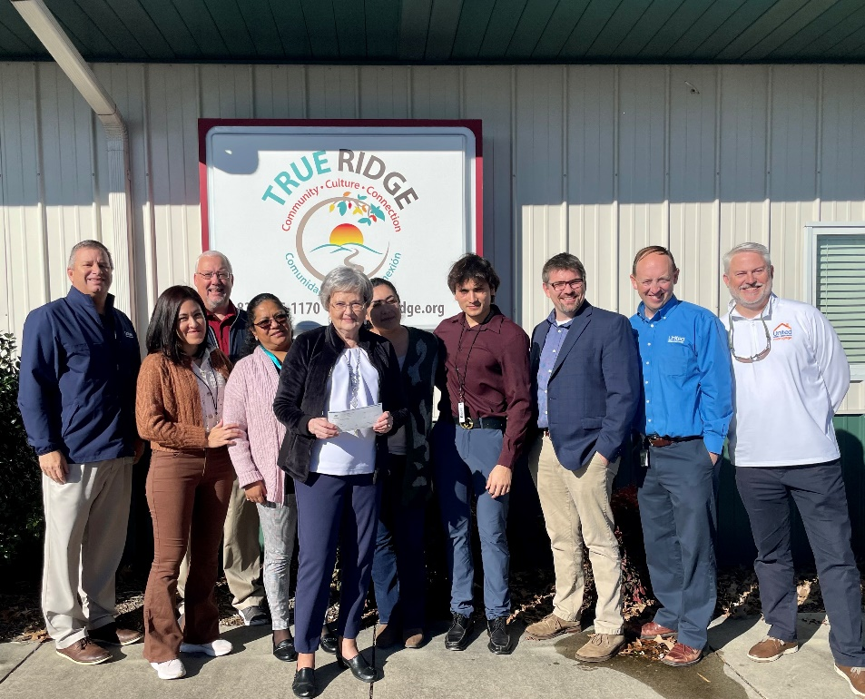

*Team United donates $1,000 to True Ridge in Hendersonville, North Carolina*

**ST. JOSEPH, Mich. –** United Federal Credit Union (United) donated a total of $29,000 during Giving Tuesday on November 29, 2022. The funds were given to 16 organizations in Arkansas, Indiana, Michigan, Nevada and North Carolina.

In Indiana, Michigan and Nevada, United partnered with local Boys & Girls Clubs to match donations given by the public on Giving Tuesday up to a certain amount. United was able to match a combined $17,500 in donations that will benefit the Boys & Girls Clubs of St. Joseph County (Indiana), Boys & Girls Club of Greater Holland (Michigan), and Boys & Girls Club of Western Nevada.

“United is a long-time partner of the Boys & Girls Club in all of the communities where we have branches. We were so excited to work with these clubs to help raise money to support their important missions,” said Carla Fazio-King, District Manager in Indiana. “We work with The Club all year offering our support, whether it is volunteering or donating. It just made sense on Giving Tuesday to match these donation campaigns and help the youth in our communities across the country.”

In Arkansas, United donated $1,500 to three organizations. Northwest Arkansas Children’s Shelter in Bentonville, Arts on Main and CASA of Crawford County in Van Buren each received $500.

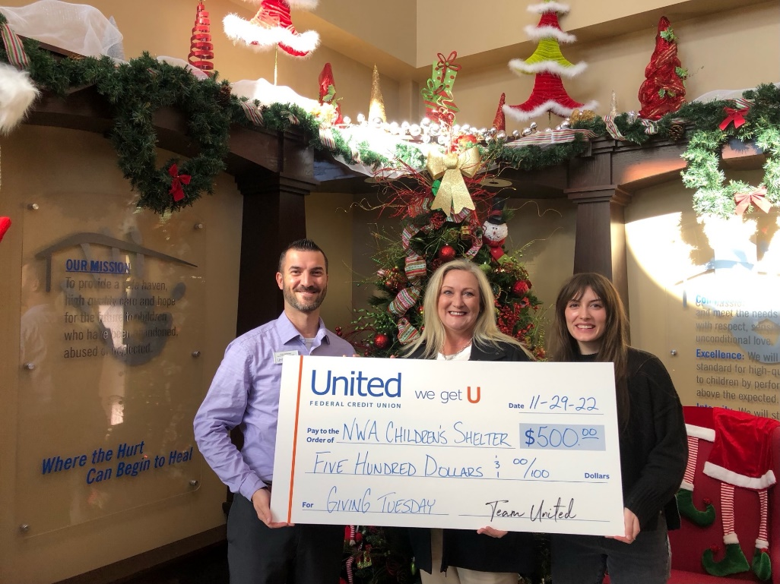

*United donates $500 to the Northwest Arkansas Children’s Shelter*

In North Carolina, United also donated $1,000 to 10 non-profit organizations. Those donations went to Purple Heart Homes and Drug-Alcohol Coalition of Iredell (DACI) in Statesville, Bounty of Bethlehem in Horse Shoe, St. Gerard House, Council on Aging, Women Helping Women, Meals on Wheels and True Ridge in Hendersonville, Meals on Wheels – Asheville Buncombe County in Asheville, and FABA Snack Pack in Fletcher.

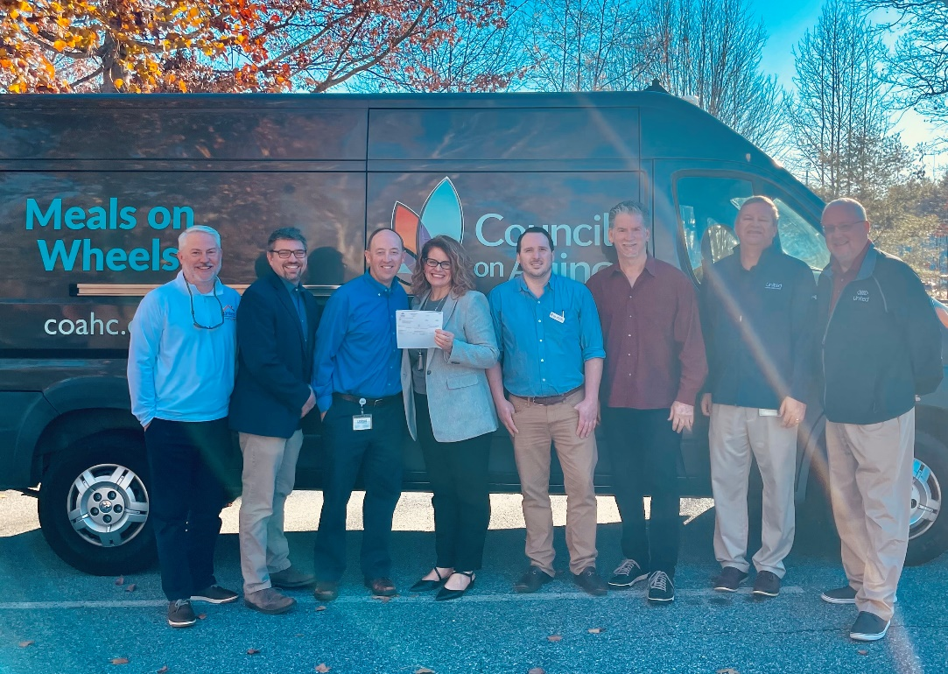

*United donates $1,000 to Council on Aging and Meals on Wheels in Asheville*

“We were proud to be able to help so many organizations in our North Carolina communities,” said Matt Sorrells, Senior Relationship Development Manager. “Our team wanted to impact a wide range of organizations as part of this year’s Giving Tuesday. We value the trust our communities place in us, and we are committed to the success of our neighbors and the Members we serve. We encourage not just our team and Members, but everyone in the area to join us in making a difference for others this holiday season.”

**____________**

**About United**

United Federal Credit Union has served its Members since 1949 by helping them to build a sound financial future. United consists of more than 191,000 Member/owners worldwide and manages assets in excess of $3.8 billion. Its corporate office and main branch are in St. Joseph, Mich., with additional branches in Arkansas, Indiana, Michigan, Nevada, North Carolina, and Ohio. Federally insured by NCUA. Equal opportunity lender. Equal housing lender. For more information visit [UnitedFCU.com](http://www.unitedfcu.com)

# # #