United Federal Credit Union – Press Release
December 14, 2022

Contact: Diana Wake
Phone: (888) 982-1400 ext. 6891
Email: dwake@UnitedFCU.com
United Federal Credit Union, 150 Hilltop Road, St. Joseph, Michigan, 49085

United Federal Credit Union Names Director of Payments
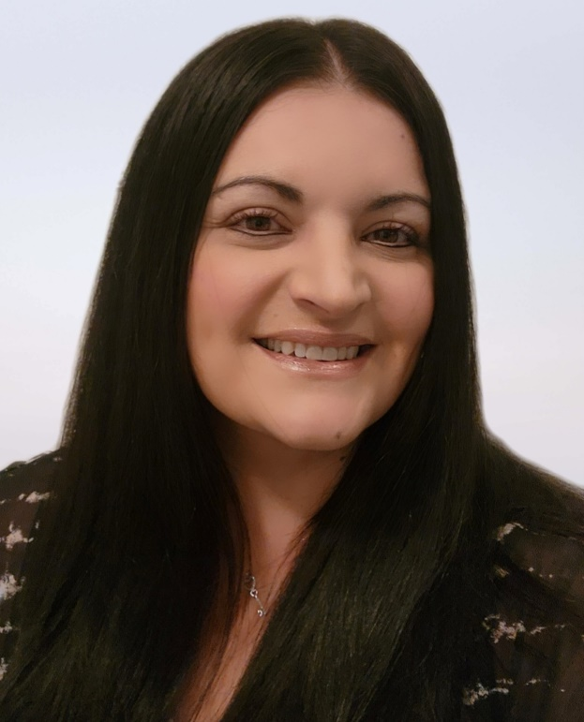
Marilyn Bentley, Director of Payments

ST. JOSEPH, Mich. – United Federal Credit Union (United) has appointed Marilyn Bentley Director of Payments.

Bentley brings more than 20 years of financial industry experience in creating new products and features, and managing payment products to her new role with United. Most recently, more than three years at Fiserv as Senior Product Manager in Treasury Management and Senior Product Manager with Card Services.

In the position of Director of Payments, Bentley will be responsible for payment strategy and leadership for payment operations. She will also oversee electronic transfer of funds and card operations for United.

Bentley is an Accredited ACH Professional (AAP) through Nacha. She studied Business Administration Management at Rockland Community College. Bentley is also involved with her community and volunteers at First Coast No More Homeless Pets and the Jacksonville Humane Society.

____________
About United
United Federal Credit Union has served its Members since 1949 by helping them to build a sound financial future. United consists of more than 191,000 Member/owners worldwide and manages assets in excess of $3.8 billion. Its corporate office and main branch are in St. Joseph, Mich., with additional branches in Arkansas, Indiana, Michigan, Nevada, North Carolina, and Ohio. Federally insured by NCUA. Equal opportunity lender. Equal housing lender. For more information visit UnitedFCU.com

# # #

