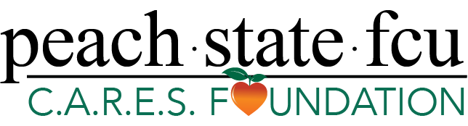
Contact:
Kristen Patton, SVP of Marketing
770.580.6015 | kpatton@peachstatefcu.org

Over $225k in Scholarships and Educational Grants to be Awarded by Peach State FCU C.A.R.E.S. Foundation

LAWRENCEVILLE, GA (December 1, 2022) – The Peach State FCU C.A.R.E.S. Foundation has announced it is now accepting applications for its 2023 scholarship program. This year, the foundation will be awarding over $225,000 in scholarships and educational grants to emerging professionals and graduating high school seniors attending post-secondary studies.
There are several new additions to this year’s program:
- A second scholarship honoring retired Superintendent Dr. John Jackson of Oconee County Schools. The scholarship will be granted to a graduating senior pursuing a degree in business.
- Four scholarships will also be awarded to graduating seniors from the following northwest Georgia area high schools:
  - Chattooga County High School
  - Lafayette High School
  - Ridgeland High School
  - Trion High School
“We’re committed to helping our neighbors improve their financial well-being. This includes being able to afford attending or sending a child to college in pursuit of building a better future,” remarked Demitra Houlis, Peach State’s Chief Administrative Officer and Foundation President. “It is our hope that our annual scholarship program alleviates some of the financial barriers that parents, students, professionals, and their families are faced with so they may embark on their academic journeys with a little less financial worry. “

Peach State’s FCU C.A.R.E.S. Foundation is also proud to support the following organizations and their students with a combined total of more than $56,000 in scholarships and educational grants:

- Georgia Gwinnett College Foundation
- Georgia Northwestern Technical College
- Gwinnett County Public Schools Foundation
- Gwinnett Technical College Foundation
- Hart County Schools Education Pathway Scholarship
- North Georgia Technical College Foundation
- Paine College
- REACH Georgia Scholarships | Barrow County Schools
- REACH Georgia Scholarships | Burke County Middle School
- REACH Georgia Scholarships | Franklin County Schools
- REACH Georgia Scholarships | Habersham County Schools
- REACH Georgia Scholarships | Oconee County Schools
- REACH Georgia Scholarships | Social Circle City Schools
- REACH Georgia Scholarships | Stephens County Schools
- REACH Georgia Scholarships | Trion City Schools

To view the complete list of available scholarships, eligibility criteria and to apply, please visit www.peachstatefcu.org/scholarships. Recipients of the annual program will be announced Spring of 2023.

About the Peach State FCU C.A.R.E.S. Foundation
Peach State Federal Credit Union’s passion for helping their members and community guided them to create the Peach State FCU C.A.R.E.S. Foundation. The Foundation is funded by the credit union’s Visa Debit Card program and private donors. Since the inception of the Peach State C.A.R.E.S. Visa Debit Card program in July 2019, Peach State has donated more than $1.8 million to charitable organizations, school systems and the arts in the communities that we serve. The C.A.R.E.S. program was created to put these contributions on a sustainable path for the future. To learn more about how Peach State cares, visit peachstatefcu.org/CARES. Peach State is an $820 million not-for-profit financial cooperative that serves more than 75,000 members in Georgia and South Carolina with a mission to provide quality financial services that meet the needs and exceed the expectations of its member-owners. For more information about products and services, visit peachstatefcu.org.
###

