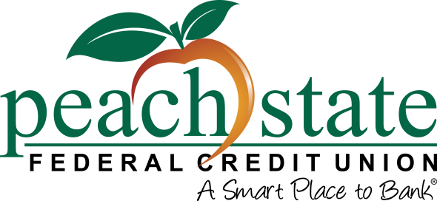

Contact: Kristen Patton

SVP, Marketing   
770.580.6015 | [kpatton@peachstatefcu.org](mailto:kpatton@peachstatefcu.org)

**Abbeville Community Federal Credit Union Members Approve Merger with Peach State Federal Credit Union**

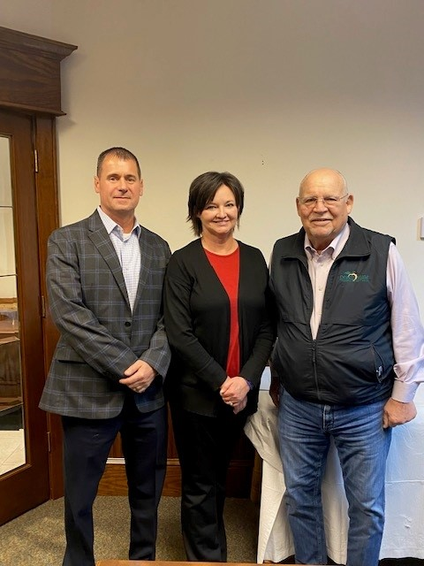

*Pictured: Chuck Nash, Abbeville Community FCU Board Chairman, Trish Fuller, Abbeville Community FCU Manager and Marshall Boutwell, Peach State FCU President/CEO.*

**Lawrenceville, GA (November 29, 2022)** – The members of Abbeville Community Federal Credit Union have approved a merger with Peach State Federal Credit Union. This announcement follows a vote that was held on November 28th at the credit union’s Abbeville, SC branch during a Special Meeting of Members. The financial merger, which has been approved by the National Credit Union Administration, is effective December 1, 2022.

The merger is the result of Peach State and Abbeville’s shared values, mission, and corporate culture. There is a shared commitment on the part of both credit unions’ Boards and management to continue to grow while remaining highly competitive in today’s financial marketplace.

Abbeville was founded in 1971 to serve the needs of local railroad employees and their immediate families in Abbeville, Greenwood, Anderson, and McCormick counties. In January 2004, Abbeville was granted a community charter, and in July 2011, they became federally chartered. Their field of membership includes service to anyone who lives, works, worships, or attends school in Abbeville County, SC, as well as any businesses.

“There is no better time than the present to bring about positive changes for our members,” said Trish Fuller, Manager at Abbeville Community FCU. “Our focus remains on our members and understanding their needs. We’re excited about this merger as it will create more opportunities to expand services and deepen relationships for the communities we serve.”

“This partnership will allow us to provide increased accessibility, more financial products, services, and additional resources that will make a positive impact on the Abbeville community,” said Marshall Boutwell, President/CEO of Peach State. "This is a great example of a cooperative unity but more importantly, it demonstrates a strong commitment to the credit union philosophy of ‘people helping people’.”

**About Peach State Federal Credit Union**

Peach State is an $820 million credit union that serves more than 75,000 members in Georgia and South Carolina. Operating as a not-for-profit financial cooperative, Peach State’s mission is to provide quality financial services that meet the needs and exceed the expectations of its member-owners. For more information about our products and services, visit [peachstatefcu.org](http://www.peachstatefcu.org). The credit union’s passion for helping their members and community continue to grow guided them to create the Peach State FCU C.A.R.E.S. Foundation. To learn more about how Peach State *cares*, visit [peachstatefcu.org/CARES](http://www.peachstatefcu.org/CARES).

###