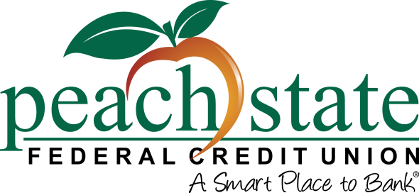

Contact: Kristen Patton
SVP, Marketing
770.580.6015 | kpatton@peachstatefcu.org
Pickens Federal Credit Union Members Endorse Merger with Peach State Federal Credit Union

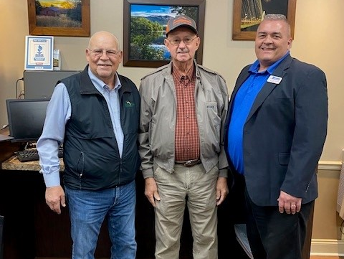

Pictured: Marshall Boutwell, Peach State FCU President/CEO, Phil Reece, Pickens Federal CU Board Chairman and Clayton Kerr, Pickens FCU President/CEO.

Lawrenceville, GA (November 30, 2022) –The members of Pickens Federal Credit Union have voted in favor of a merger with Peach State Federal Credit Union. A vote was held during a Special Meeting of Members at the credit union’s Pickens, SC branch on November 29th. The financial merger has been approved by the National Credit Union Administration and is effective December 1, 2022.

The Boards and management of both credit unions are committed to remaining highly competitive in today’s financial marketplace, with a shared goal of providing exceptional member service and quality financial products to their members.

Pickens Federal Credit Union was founded in 1961 as the Diehl-Poinsett Federal Credit Union and provided services to all Singer Company employees. In 2001 the credit union was approved for a community charter, expanding their field of membership to include service to anyone who lives, works, worships, or attends school in Pickens County, SC. They also welcomed the teachers and employees of the School District of Pickens County into their field of membership in 2011, which ties in with Peach State’s start as an education-based credit union.

“Our Board and staff are elated about the endless possibilities created for our members through this union with Peach State. We will continue to focus on serving the members in our community with the highest level of care, but now with even more products and support,” said Clayton Kerr, President/CEO of Pickens Federal.

“We are excited to join forces with a like-minded credit union, one who’s Board and management share a similar vision and has ties to the local education system. It is our hope that combining our resources will enhance the financial well-being of both the community and lives of those in Pickens County.” said Marshall Boutwell, President/CEO of Peach State.

About Peach State Federal Credit Union
Peach State is an $820 million credit union that serves more than 75,000 members in Georgia and South Carolina. Operating as a not-for-profit financial cooperative, Peach State’s mission is to provide quality financial services that meet the needs and exceed the expectations of its member-owners. For more information about our products and services, visit peachstatefcu.org. The credit union’s passion for helping their members and community continue to grow guided them to create the Peach State FCU C.A.R.E.S. Foundation. To learn more about how Peach State cares, visit peachstatefcu.org/CARES.

###

